SOFTWARE REQUIREMENT SPECIFICATIONS (SRS)
FOR

REVAMPING THE BI DASHBOARD WEB APPLICATION DESIGN & DEVELOPMENT
SUBMITTED TO
IVTECH COMPUTER SYSTEMS LLC

Version: 1.0

23rd MAY 2025

Prepared By:
SPEC INDIA

Revision History

Date | Version | Author | Created / Updated / Reviewed / Verified / Approved By
23-05-2025 | 1.0 | Parth Jotangiya | Initial Draft
23-05-2025 | 1.0 | Yaman Kavishwar | Reviewed and approved

Table of Contents
Contents
1. Introduction 5
1.1. Project Scope and Objectives 5
1.2. Items outside the Project Scope 8
1.3. Project Deliverables 8
1.4. Definitions, Acronyms, and Abbreviations 9
1.5. References 10
1.6. Project Approach 10
1.7. Security, Best Practices & Supported versions 11
2. User Descriptions 11
3. System Requirements 12
3.1. Settings > Manage Users Page 12
3.2. Settings > Roles & Permissions Page 15
3.3. Settings > Manage Users > Role Assignments to a Specific User 20
3.4. Settings > Multisite Setup Page 21
3.5. Settings > General Page 27
3.6. Settings > License 29
3.7. Login Page 32
3.8. Menu Items for BI Dashboard Web Application 34
3.9. Header Section > Profile Page 36
3.10. Header Section > Change Password Page 37
3.11. Header Section > Preferences Page 38
3.12. Header Section > Notifications 39
3.13. Configurations > Manage Devices Page 41
3.14. Configurations > Floor Plans & Zones Page 47
3.15. Events > Event Logs Page 54
3.16. Reports > My Reports Page 57
3.17. Monitoring > Monitoring Page 63
3.18. Dashboards > Dashboard Creation 66
3.18.1. Dashboards > Dashboard Page > Add Widget Screen 67
3.18.2. Dashboards > Dashboard Page > Filters & Export Option 70
3.18.3. Dashboards > Dashboard Page > Widgets 73
3.18.4. Dashboards > Dashboard Page > Widget > Setup Page 143
3.18.5. Dashboards > Dashboard Page > Widget > Export as CSV Option 145
3.18.6. Dashboards > Dashboard Page > Widget > Duration Selection Filter Option 146
3.18.7. Dashboards > Dashboard Page > Widget > Expand Option 147
4. System Architecture 149
5. Assumptions, Dependencies and Constraints 151

Introduction

Project Scope and Objectives

- The purpose of this project is to revamp an existing BI Dashboard Web Application by enhancing the user interface & experience which will require minimal user’s inputs to perform the required steps.
- This requirement includes enhancing the current application with existing features and functionalities as specified by the client.
- These enhancements will help their customers to view widgets & manage their site wise configurations effectively.
- This application is tailored for their customers. It will be web-based and accessible exclusively through web browsers. Additionally, it will provide the capability to be installed on a customer’s local machine via a single executable file (e.g.: .exe / .msi).
- The executable file will host the application on IIS of the local machine for the specific client environment. The application will then be accessible within the client’s environment via the LAN network.
- The .exe or .msi file will handle the automatic installation of all necessary files, configurations, and dependencies on the customer's local machine. Once installed, the BI Dashboard Web Application will be executed through the customer's web browser, operating within their local environment only.
- This document outlines the requirements for BI Dashboard Web Applications to be developed for IVTECH COMPUTER SYSTEMS LLC.
- The Requirement is present in the “Technical Requirements Doc R2” document shared by IVTECH COMPUTER SYSTEMS LLC, which contains information for BI Dashboard Web Application modules related to the following:
- User Login:
  - Users can log in using their credentials.
  - An admin user can reset any user’s password (Forgot password).
  - Admin users can change passwords for any specific user.
- User Management:
  - Add/Update/Delete users.
  - Assign Role - Permissions to Users to access camera/floor/zone/reports.
- Camera Management:
  - Add/Update/Delete camera.
  - Listing of Cameras with search/filter.
- Settings:
  - Upload Customer Logo.
  - License Management.
- Site and Zone Management:
  - Add/Update/Delete Site.
  - Add/Update/Delete Floor Plan.
  - Add/Update/Delete Zone on Floor Plan.
  - Add cameras to zones.
  - Camera rotation.
  - Map integration with static map images.
    - Imp Note:
      - For the Map Integration, the user needs to be online once, maybe while creating the Site to download the map images. Otherwise, we cannot identify which country/region/area images need to be downloaded to make the map work with static images.
      - For now, we will go for Open source to achieve the functionality of Offline maps. This is the subject of exclusive R&D; hence the final selection of the open-source solution will be done post R&D and discussion with the client team.
- Dashboard:
  - Report Filtering
  - Export to PDF/excel/csv.
  - Camera – No. of Camera Installed
  - Camera – No. of Camera Online/Offline
  - Camera - Online vs Offline Ratio
  - Camera – No. of Camera by Model Type
  - Camera – No. of Camera by Feature type
  - Site - Total Capacity
  - Site - Capacity Utilization (%)
  - Site - Most vs. Least Day for Capacity Utilization
  - Site - Zone-wise details for Max Capacity, Utilization, % (Table)
  - People Counting - People In
  - People Counting - People Out
  - People Counting - Avg. People In/Out in Day with Min and Max Count
  - People Counting - Cumulative People Count for Time
  - People Counting - Zone wise.
  - People Counting - Gender-wise.
  - People Counting - People with and without Mask/Helmet
  - People Counting - Most and Least Count Day for Specific Male and Female
  - People Counting - Slip and Fall Count for People with Gender
  - People Counting - New vs Total Visitors
  - Retail & Business AI Pack - Shopping Cart Counting
  - Retail & Business AI Pack - Heatmap for shopping cart
  - Retail & Business AI Pack - Queue events for shopping cart
  - Retail & Business AI Pack - Queue events for people
  - Retail & Business AI Pack - Blocked exit detection
  - Vehicle (Traffic (ITS) AI pack) - Vehicle Count (Min, Max, Avg. per Day)
  - Vehicle (Traffic (ITS) AI pack) - Vehicle by Type
  - Vehicle (Traffic (ITS) AI pack) - Vehicle In/Out
  - Vehicle (Traffic (ITS) AI pack) - Vehicle in Wrong Direction
  - Vehicle (Traffic (ITS) AI pack) - Stopped Vehicle Count Time
  - Vehicle (Traffic (ITS) AI pack) - Speed Detection by Vehicle
  - Vehicle (Traffic (ITS) AI pack) - Avg. Speed for Vehicle
  - Vehicle (Traffic (ITS) AI pack) - Traffic Jam by Day
  - Vehicle (Traffic (ITS) AI pack) - Day-wise Traffic (Most and Least)
  - Vehicle (Traffic (ITS) AI pack) - Speed Violation by Vehicle
  - Vehicle - Vehicle U Turn detection
  - Vehicle (Traffic (ITS) AI pack) - Pedestrian detection
  - Vehicle (Traffic (ITS) AI pack) - Vehicle Turning Movement counts
  - Vehicle (Traffic (ITS) AI pack) - Vehicle Queue Analysis
  - Vehicle (Traffic (ITS) AI pack) - Vehicle Detection Heatmap
  - Factory & Safety AI pack - Detect Forklifts
  - Factory & Safety AI pack - Proximity detection (between people, forklifts, between a person and a forklift)
  - Factory & Safety AI pack - Forklift speed detection
  - Factory & Safety AI pack - Counting & Heatmap for forklift and people
  - Factory & Safety AI pack - Queue events for forklift and people
  - Factory & Safety AI pack - Blocked exit detection
- The list of dashboard widgets specified above includes existing APIs related to Crowd Management, Queue Management, Traffic (Vehicle), Retail, and Factory AI Pack. Which will be provided by the client only.
- Package creation:
  - Create a package to install the web application on Windows PC only.
- Data Ingestion:
  - Scheduled calling of Camera APIs to ingest data in the database.
- Camera API Understanding and Integration:
  - Details of the Solar Power and Battery Utilization will be shown on the dashboard through SNMP/API integration with the BMS and MPTT Controller (calling of camera API and just displaying the data available from API).
- Configuration:
  - Standard Backup and Restore.
- AI Box Integration:
  - AI Box integration, considering the addition of multiple cameras in a single AI Box and considering the cameras added in the AI Box to display Dashboard widgets data.
- Alexa Integration:
  - Integration with Alexa, so that when the Alexa device is connected, it will open the specific widget on voice command.
- 7 other key features:
  - Provide data for multiple lanes (8 lanes).
  - Show heat maps on the floor plans and particular zones.
  - Multisite-wise dashboard widget reports.
  - For Multisite should be filtered to select the widgets and show the difference between Full site, single-zone, and Multizone.
  - SSL / HTTPS set up, (The SSL certificate will be purchased by client only).
  - Need to have Event reporting details with filtration with separate widgets or separate pages for this, and when the event is reported, need to have pre- and post-video of 5 seconds each.
  - SMTP server setup for email reporting with scheduled job (Required credentials will be provided by client only).

- The technology used to develop web applications will be:
Front-end | React.js
Back-end | .NET Core + Web Api (using C#)
Database | MongoDB

Items outside the Project Scope

- Creation of APIs which will be directly interacted with AI camera managed by Hanwha.
- SPEC INDIA will only utilize camera APIs managed by Hanwha and will replicate/ingest the necessary information in the database (if required) & display that required information on the web application.
- Multilingual support for web application. Application will be only in English language.
- Responsiveness to Tablet & Mobile. Application will be supported to desktop computer screen only.
- The development of Mobile Application for Android and iOS native integration will be out of scope.
- QA Testing is out of scope because client team will do it from their end.
- Failover plan for the database in case of any future failures.

Project Deliverables

- SPEC INDIA will be delivering below items as part of project deliverables:
  - System Requirements Specification (SRS) Document.
  - UI/UX (Figma) Design.
  - Source Code files.

Definitions, Acronyms, and Abbreviations

Definitions, Acronyms and Abbreviations
React.js | A JavaScript library for building user interfaces, particularly single-page applications (SPAs) with component-based architecture.
JSX | JavaScript XML, a syntax extension for JavaScript used in React to describe UI elements in a syntax like HTML.
Component | A reusable UI element in React that can be a class-based or functional component.
State | An object that stores dynamic data in a React component, influencing its rendering.
Props | Short for "Properties," used to pass data between React components.
MongoDB | A NoSQL database that stores data in JSON-like documents, known for its flexibility and scalability.
Collection | A group of MongoDB documents, like a table in relational databases.
Document | A single record in a MongoDB collection, stored in BSON format.
Schema | A structure defining the shape of documents in MongoDB, typically enforced using Mongoose in Node.js applications.
.NET Core Web API | A cross-platform, open-source framework for building RESTful web services using C# and .NET Core.
Controller | A class in .NET Core Web API that handles HTTP requests and responses.
Middleware | Software components in .NET Core that process HTTP requests and responses in a pipeline.
Entity Framework (EF) Core | An Object-Relational Mapper (ORM) for .NET Core, enabling database operations using C#.
DTO (Data Transfer Object) | A design pattern in .NET used to transfer data between layers of an application.
REST API | Representational State Transfer API, a web service architecture used for communication between clients and servers.
JWT (JSON Web Token) | A compact, URL-safe token used for authentication and authorization in web applications.

References

- Based on discussions and conclusions regarding the BI Dashboard Web Application with Bala & Team, the SPEC Team has applied their expertise to create a fresh and modern Figma design which is also approved by Bala & Team.
- Please find the attached link below for the Light Theme:
  - Click here to Open newly created Figma for Light Theme
- Please find the attached link below for the Dark Theme:
  - Click here to Open newly created Figma for Dark Theme

Project Approach

- The proposed approach for executing this project is the Waterfall approach, in which requirements will be gathered, analyzed, and baselined to form the system's scope:
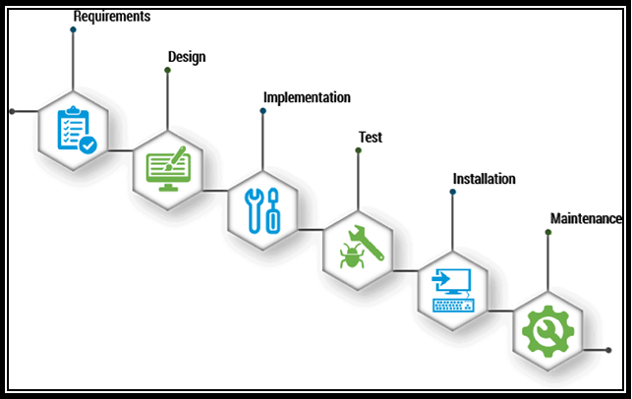

Security, Best Practices & Supported versions
  - The BI Dashboard Web Application will be protected by cyber security and vulnerability.
  - The BI Dashboard Web Application will work on desktop and laptop screens; it is not mobile & tablet responsive. It will work on the latest versions of Google Chrome, Mozilla Firefox & Safari.
  - The browser version at the time of UAT release will be considered as the latest support version.

User Descriptions

Sr. No | User Type | Activities in the system
1 | System User | - This user will exist only in the database, and the system will utilize this user's ID for data insertion or modification from the backend only.  - This user will not display in the BI Dashboard Web Application.  Example: Data Ingestion
2 | Super Admin | - This user will be the main user for the BI Dashboard Web Application. The source code will automatically configure the required information for this user, including roles and permissions, when deploying the application in a specific environment.  - This user will have full access.
3 | Sub-user | - A sub-user is a user created by an authorized user within the system.  - This user can be assigned any existing or newly created role by an authorized user.  - This user will have access to the application and its features based on the assigned permissions.

System Requirements

Settings > Manage Users Page

There is a provision in the system for the Super Admin or authorized users to create and manage users. The Super Admin has system-level access and can manage all sub-users, their roles, and assigned permissions.

The system provides functionality for Super Admin or authorized users to create and update sub-user profiles and their associated information. This includes all basic and essential details required for managing sub-user access within the system.

Prototype:

- The screen below illustrates the list of all created users, including options for Search, Add, Edit, and Delete:
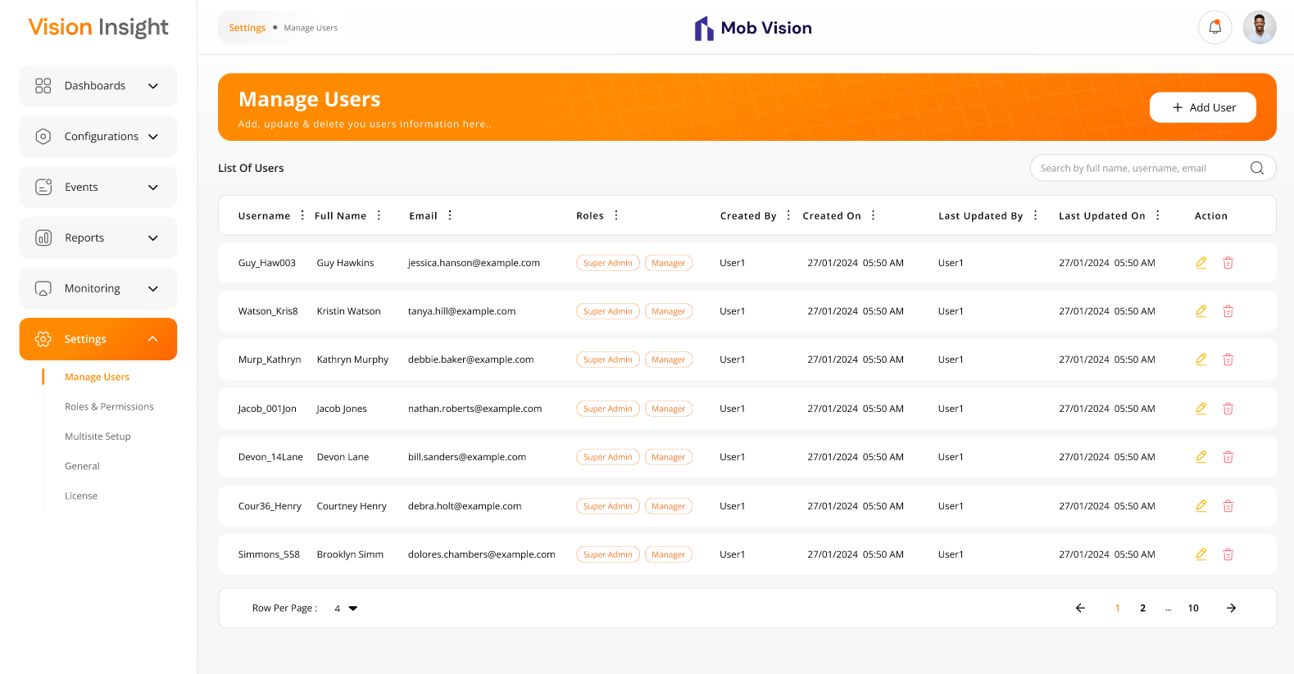

- The screen below represents the form for creating a new user in the BI Dashboard Web Application, allowing users to enter relevant details and submit the information:
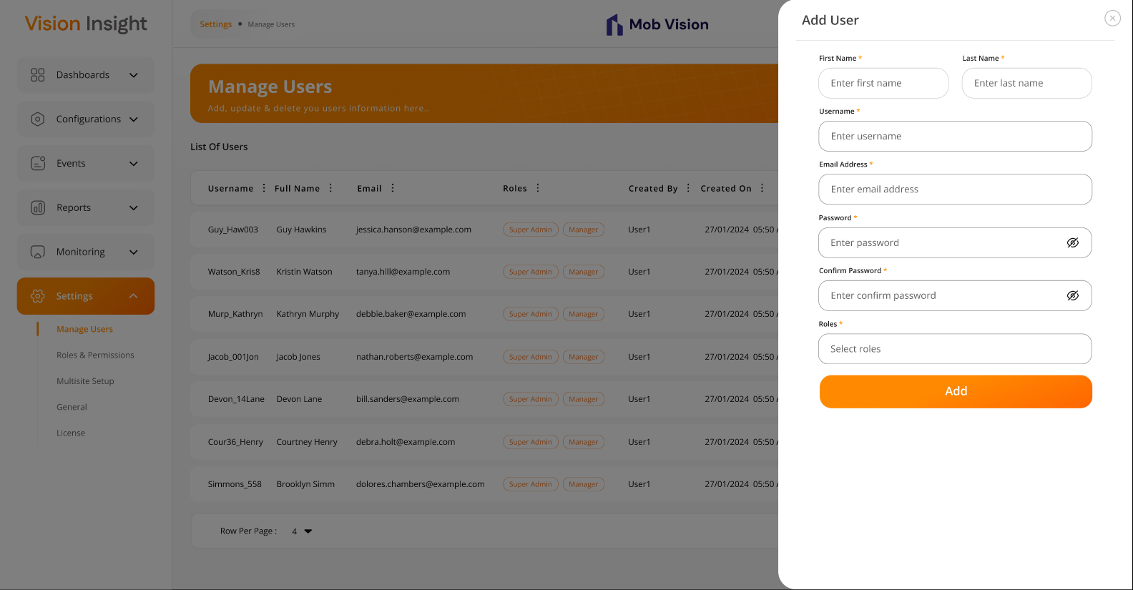
- The screen below displays the form for editing an existing user in the BI Dashboard Web Application, allowing users to modify relevant details and update the information. Since all users cannot change/reset their passwords independently, the "Password" and "Confirm Password" fields will be visible while editing user details & the authorized user can edit the information of specific user:
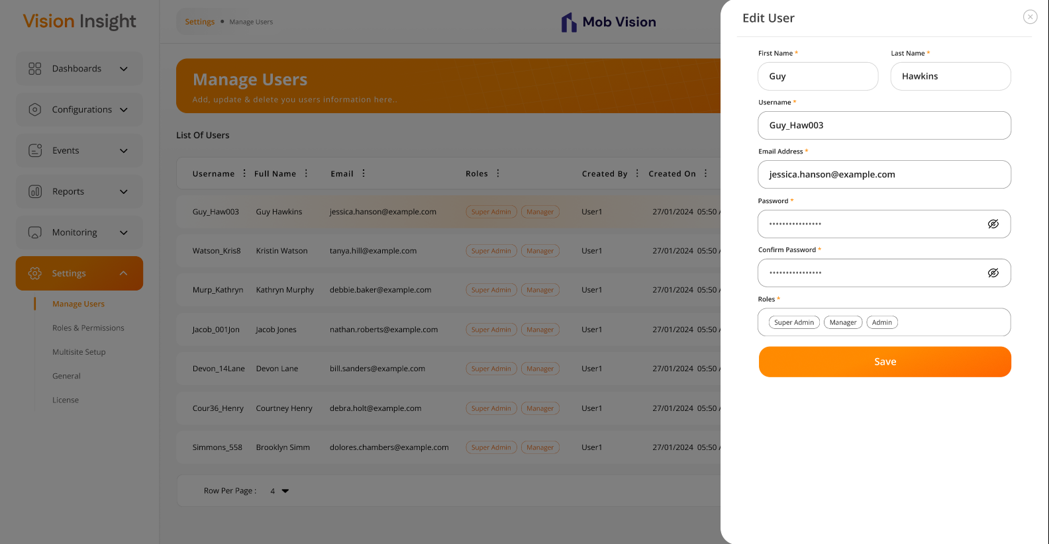

- The system will request confirmation when a logged-in user attempts to delete any authorized user:
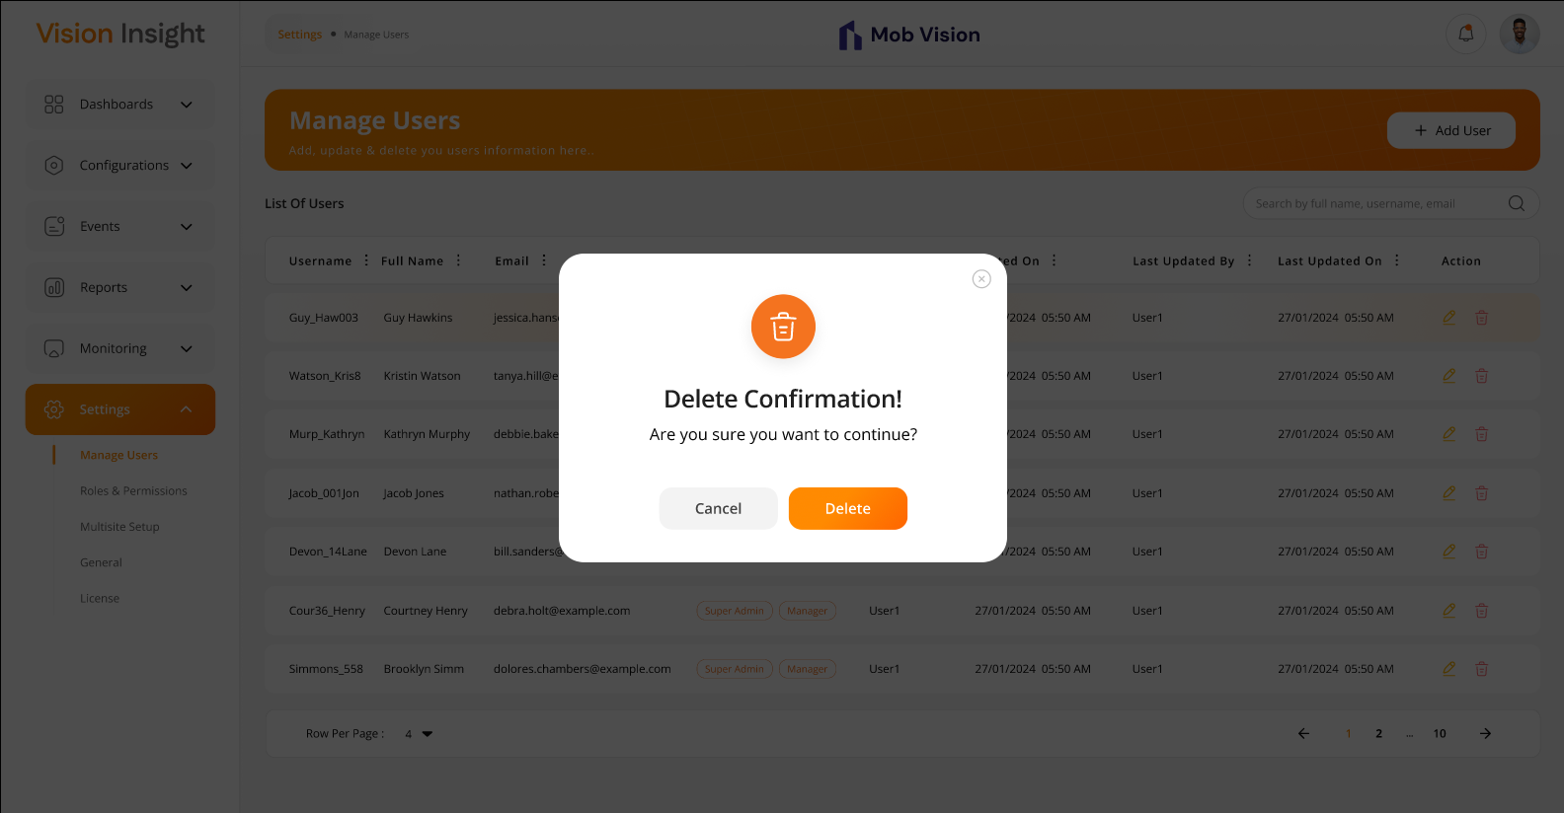

Business Rules:
- The authorized user will have the ability to create and update sub-users.
- Password field will include following criteria:
  - Minimum password length: 8 characters
  - At least 1 uppercase letter
  - At least 1 lowercase letter
  - At least 1 numeric digit
  - At least 1 special character (excluding *)
- Authorized users will be able to assign multiple roles to the specific user.
- The “Add User” & “Edit User” screen will include following fields:
  - First Name*
  - Last Name*
  - Username*
  - Email Address*
  - Password*
  - Confirm Password*
  - Roles*
- Since the super user or authorized user can change the password of any specific sub-user, the "Password" and "Confirm Password" fields should be displayed when editing user details for them only.
- The asterisk (*) indicates a mandatory field only.
- The system will not allow duplicate email addresses or usernames, as they must always be unique. These identifiers are essential for user authentication within the system.
- When a logged-in user (super user or authorized) attempts to delete another user, the system will prompt for confirmation. Once confirmed, the system will soft delete the user, meaning the record will remain in the database but will no longer be visible in the web application.
- The system will offer filter options (like Sort By ASC, Sort by DESC, Filter, Hide Column, Manage Columns) on specific columns using the MUI library, which is integrated into the entire web application. These filters will reset when the user reloads the page or navigates to another page.

Data Dictionary:

Settings > Roles & Permissions Page

The system allows super admins or authorized users to create and manage sub-user roles and permissions via the BI Dashboard Web Application.

Permissions can be assigned at the screen level with access types such as add, update, delete, and view, as well as for zones, floors, and widgets. Authorized users can define roles with specific permissions and assign them to sub-users. Upon login, users will be able to access only those functionalities permitted by their assigned role. This screen enables authorized users to update role-based permissions for screens, actions, zones, floors, and widgets.

Regarding Floor Plans & Zones Permissions:

- The system will maintain permissions at the Floor Plan and Zone levels only.
- It will be the responsibility of the admin user (who configures the application, users, and user permissions) to assign appropriate permissions for specific floor plans and zones to each user - especially in cases where a single camera is configured in multiple zones.
- As per Bala’s request, the system will not handle this scenario automatically.
- The system will display information strictly based on the assigned permissions at the Zone and Floor Plan levels.

Prototype:
- The screen below displays the list of all created roles, with options for Search, Add, Edit, and Delete:
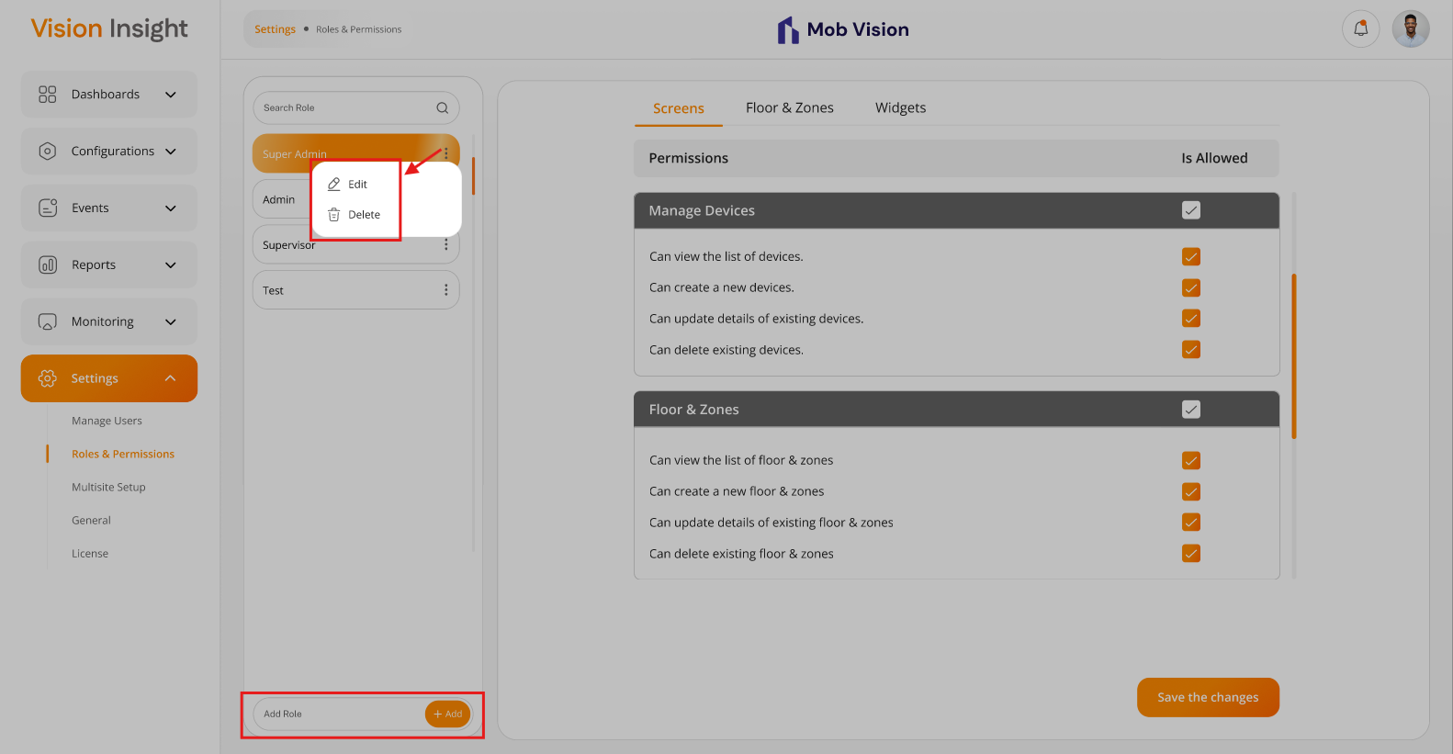

- The screen below represents the screen-level permissions for the selected role:
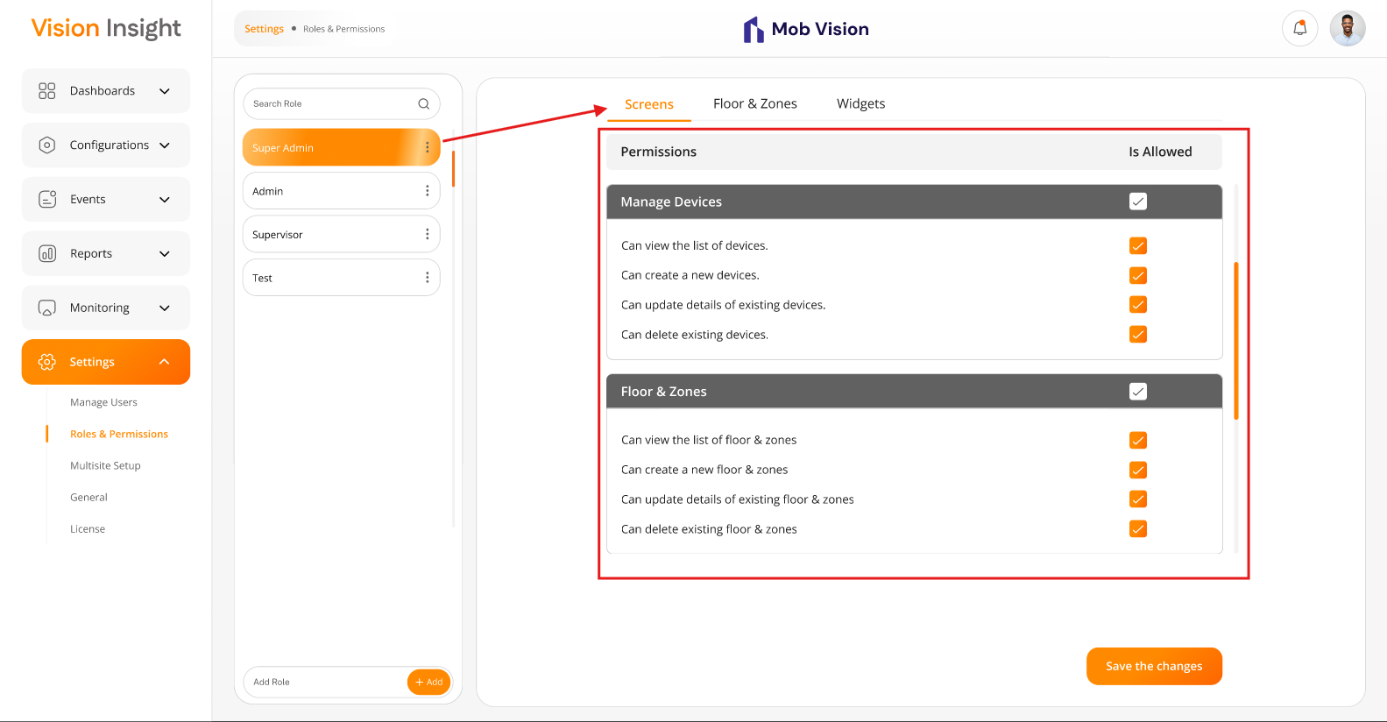

- The screen below represents the Floor & Zone-level permissions for the selected role:
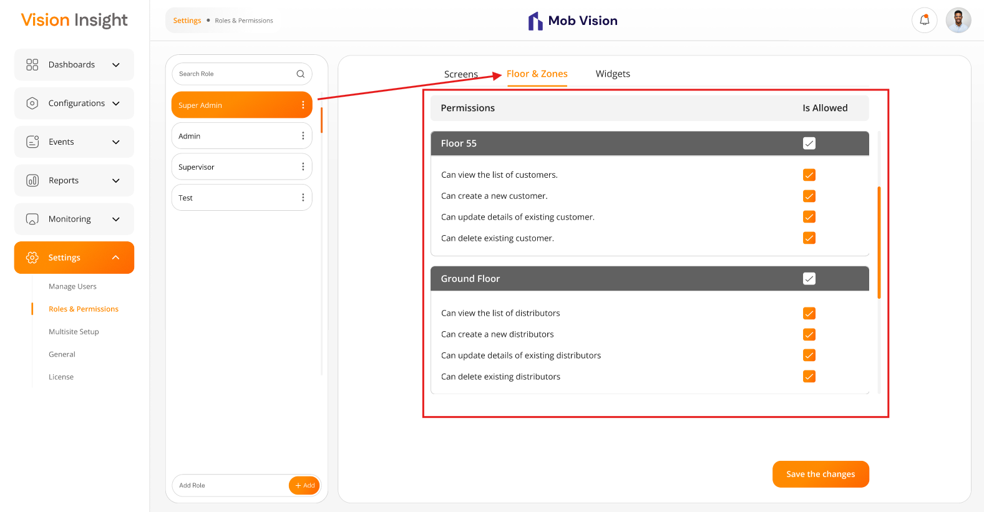
- The screen below represents the widgets-level permissions for the selected role:
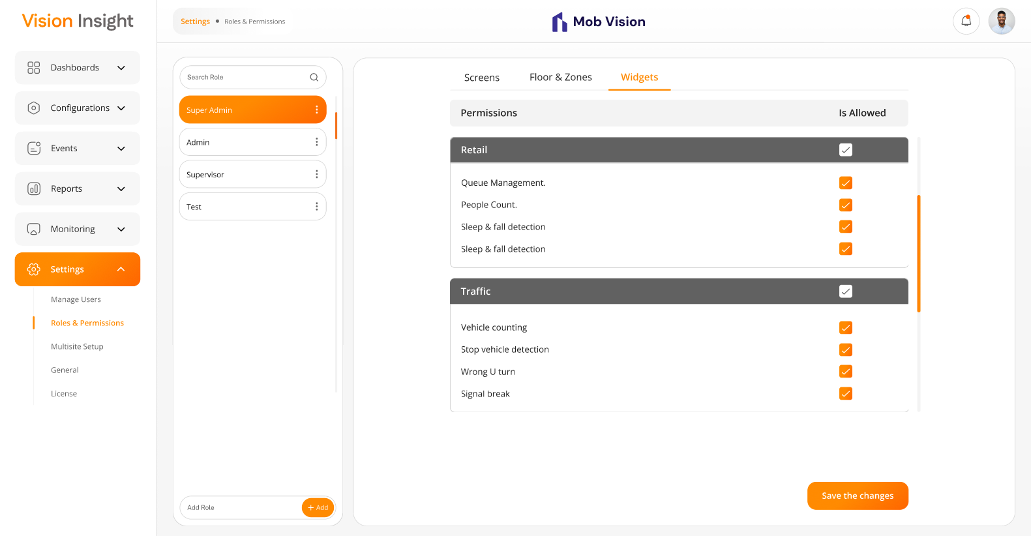

- The system will request confirmation when a logged-in user attempts to delete any role:
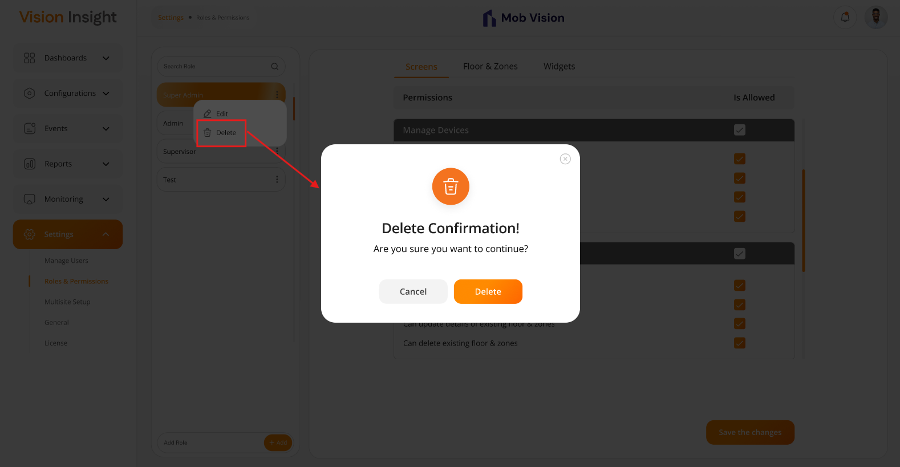

Business Rules:
- Authorized users will have the ability to create, update & delete the roles within the system.
- The system will not allow the deletion of a role if it is already associated with any user.
- The system will prevent duplicate entries for roles or user-role assignments.
- When a logged-in user attempts to delete role, the system will prompt for confirmation. Once confirmed, the system will soft delete the user, meaning the record will remain in the database but will no longer be visible in the web application.
- The “Add Role” & “Edit Role” will include below field:
  - Role Name*
- The asterisk (*) indicates a mandatory field only.
- Authorized users can assign or update permissions for specific roles, defining access to various system functionalities.
- The system will ensure that permissions are role-based and cannot be assigned to individual users directly.
- The system should allow access only on those screens / actions / floor plans / zones / widgets which are allowed against the assigned role for logged in sub user.
- By Default, the super admin user will have full access to the admin application.
- The super admin / authorized user can assign screen-level permissions and corresponding actions (e.g., add, update, delete, view) to roles. However, the super admin / authorized user cannot assign permissions to actions that are not applicable to specific screens (For example, Insert/Update/Delete rights are not applicable to screens like Profile, Change Password and Preferences. Therefore, the system should restrict the super admin / authorized user from assigning these permissions to roles for such screens).
- The system will maintain the history of each change in the permissions.
- Any updates to role permissions will take effect only after users associated with that role login again.
Data Dictionary:

- An example of the screenMaster table is attached below to provide better clarity on the backend implementation:
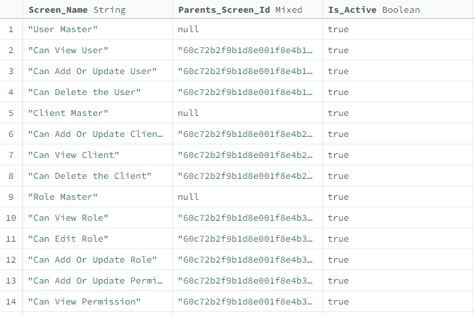
The above table lists all permissions available in the system, categorized by pages and their respective actions, floors and zones, and associated widgets.

For example, the User Creation screen will have View, Add, Edit, and Update actions. Therefore, the following entries will exist in the table for the Users screen:

User Master
-> Can view user list
-> Can edit user details
-> Can add or update user details
-> Can delete user

Role & Screen Mappings: The table below provides details on screen-wise, floor & zone-level, and widget-wise permissions assigned to specific roles:

Settings > Manage Users > Role Assignments to a Specific User

There is a provision in the system for Super Admin or authorized users to manage role assignments for specific users through the BI Dashboard Web Application.

Once a role is defined, it can be assigned to users based on their designation and responsibilities. This role assignment process will be handled by Super Admin or authorized users.

The system will allow access strictly based on the role assigned to the logged-in user, ensuring that users can access only the functionalities permitted by their assigned role.

Prototype:

- The screen below illustrates how an authorized user can assign one or multiple roles to a specific user while creating or editing a user from the Users page:
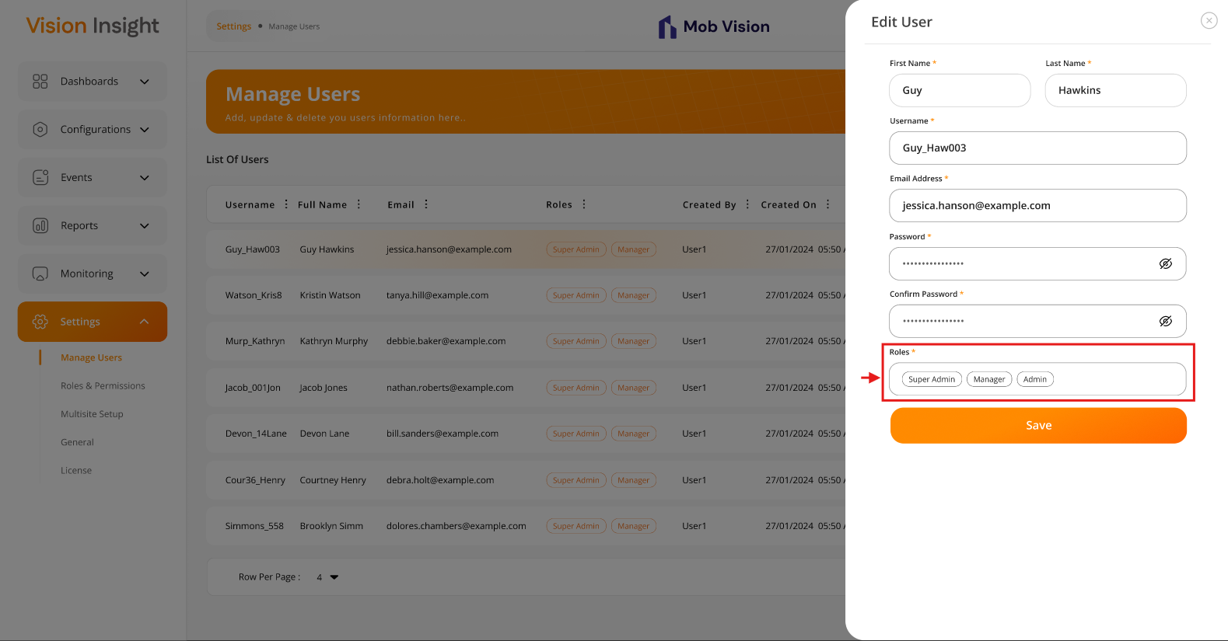

Business Rules:
- Authorized users can select and assign specific roles from a dropdown list to any sub user.
- Authorized users can assign one or multiple roles to a specific user from the Users Page.
- Authorized users can update or modify user roles assignment from the Users Page only.
- Any changes to the role assignment will immediately be reflected after relogging to the user after they log out and log back into the system.

Data Dictionary:
- The system will store the selected unique roleId(s) from the roleMaster table in the userMaster table.

Settings > Multisite Setup Page

The system allows the parent site’s authorized / super admin users to manage single or multiple child and sub-child site configurations through the BI Dashboard Web Application.

The system will support multisite configuration up to three levels (Parent, Child & Sub-Child only).

This screen will be accessible by the parent site’s authorized user only. This means that a Child or sub-child site users cannot configure their own child sites.

Regarding Permissions for this Page:

- It is entirely the responsibility of the Super Admin user to manually grant screen-level permissions to the parent site’s user during the initial configuration of the application on the customer site. The system will not handle this scenario automatically.

Prototype:

- The screen below illustrates the list of all created child sites, along with options to search, add, edit, and delete them:
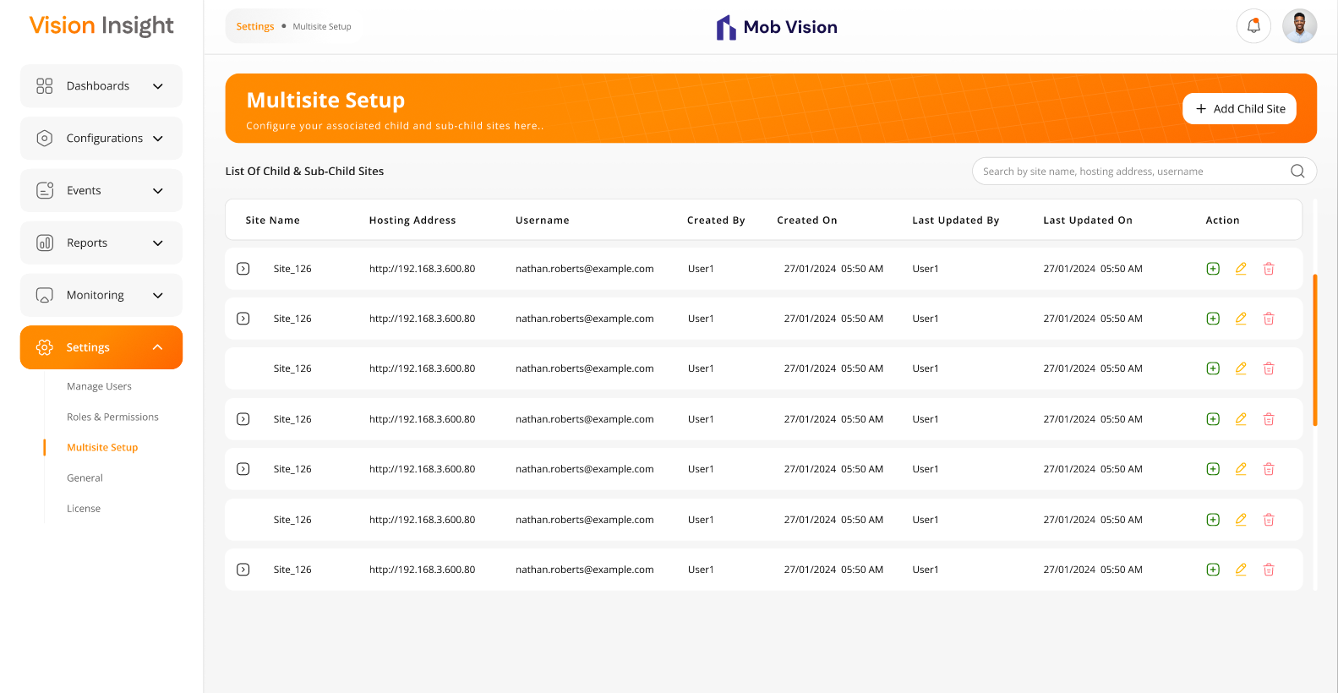

- The screen below illustrates the list of all created sub-child sites, along with options to add, edit, and delete them:
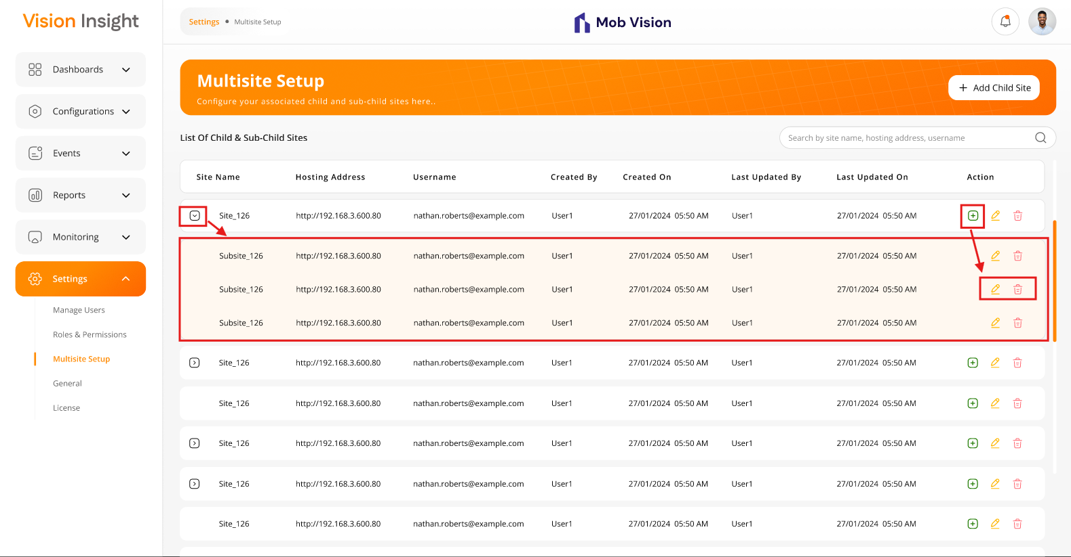
- The screen below represents the form for creating a new child site, allowing users to enter relevant details and submit the information:
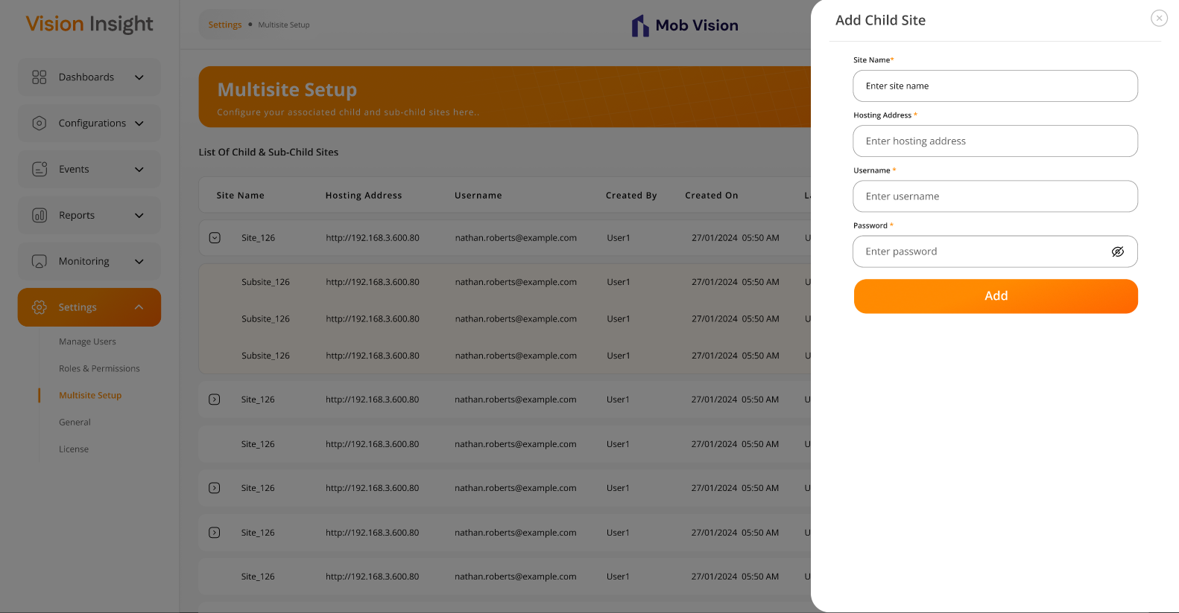

- The screen below displays the form for editing an existing child site, allowing users to modify relevant details and update the information:
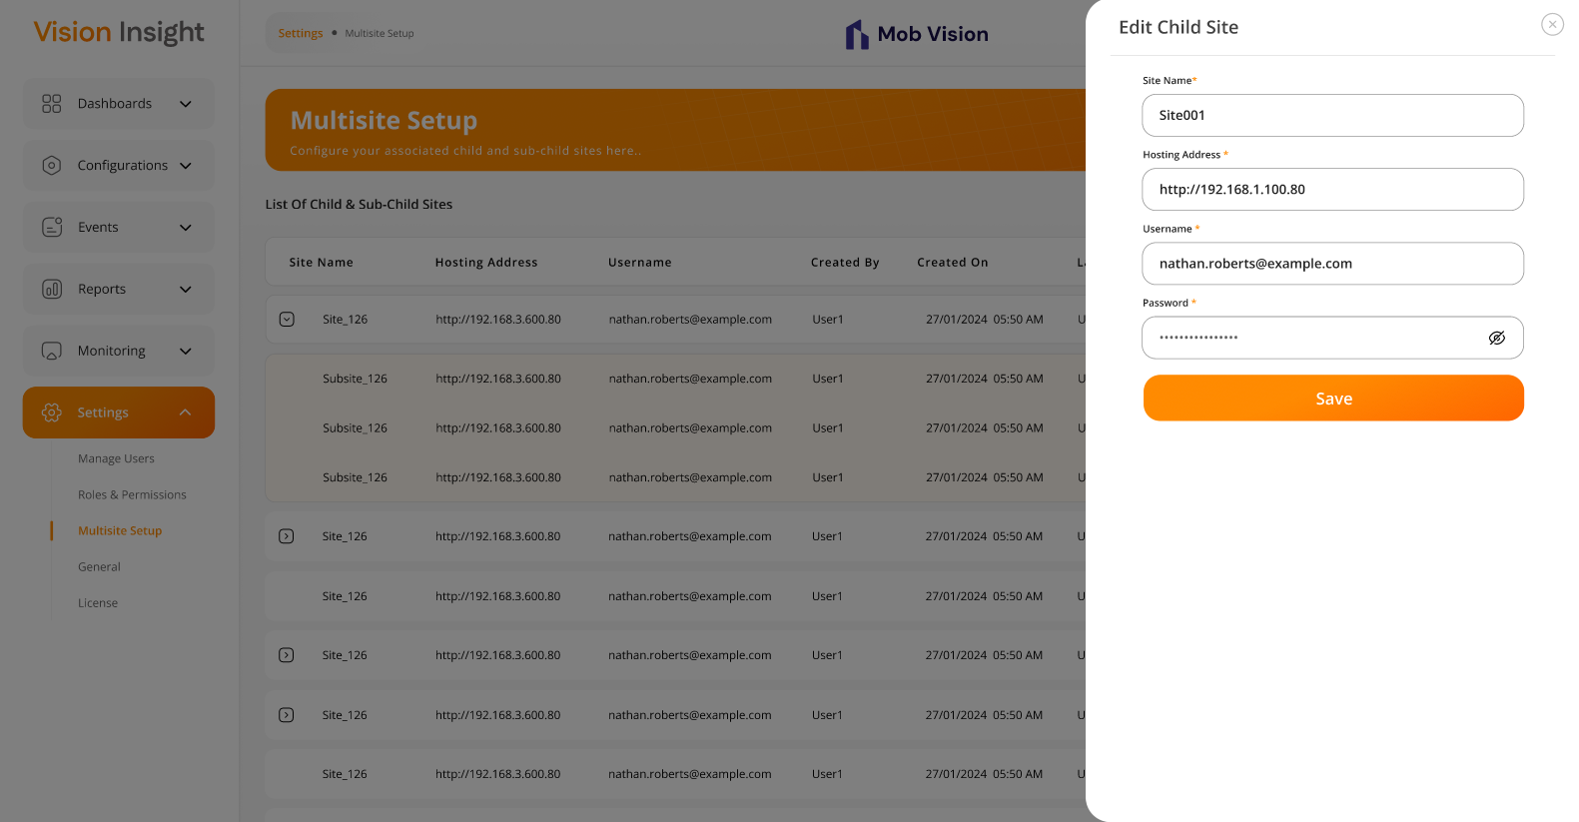
- The screen below represents the form for creating a new sub-child site, allowing users to enter relevant details and submit the information:
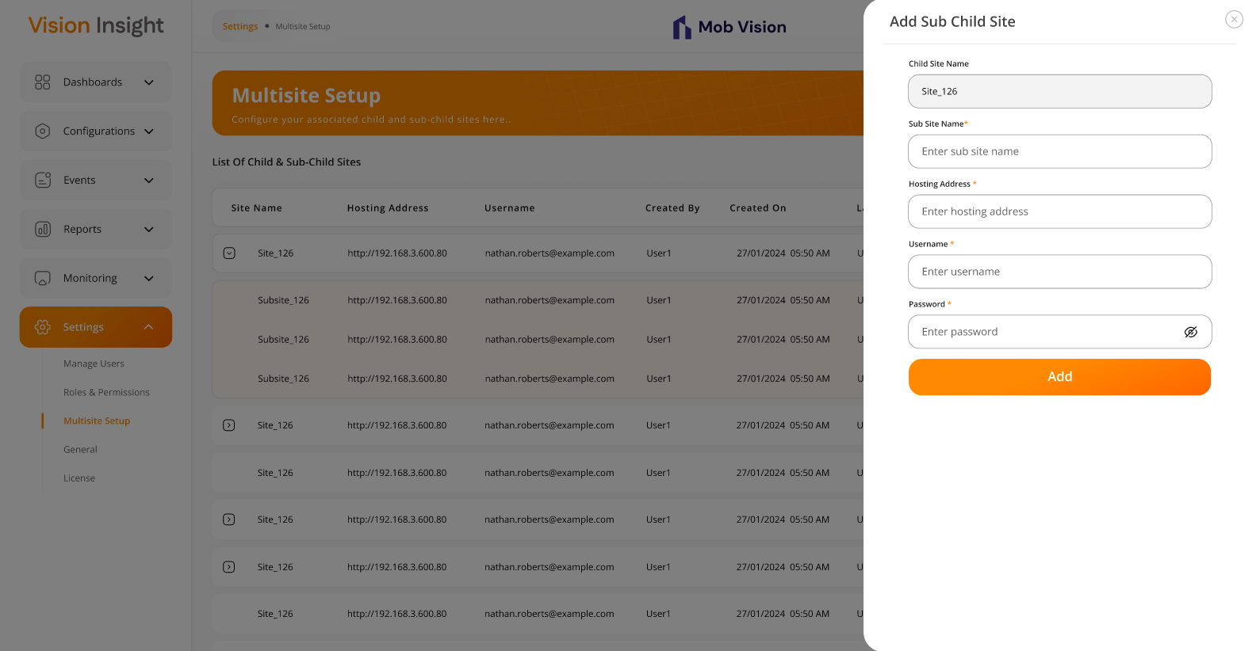

- The screen below displays the form for editing an existing sub-child site, allowing users to modify relevant details and update the information:
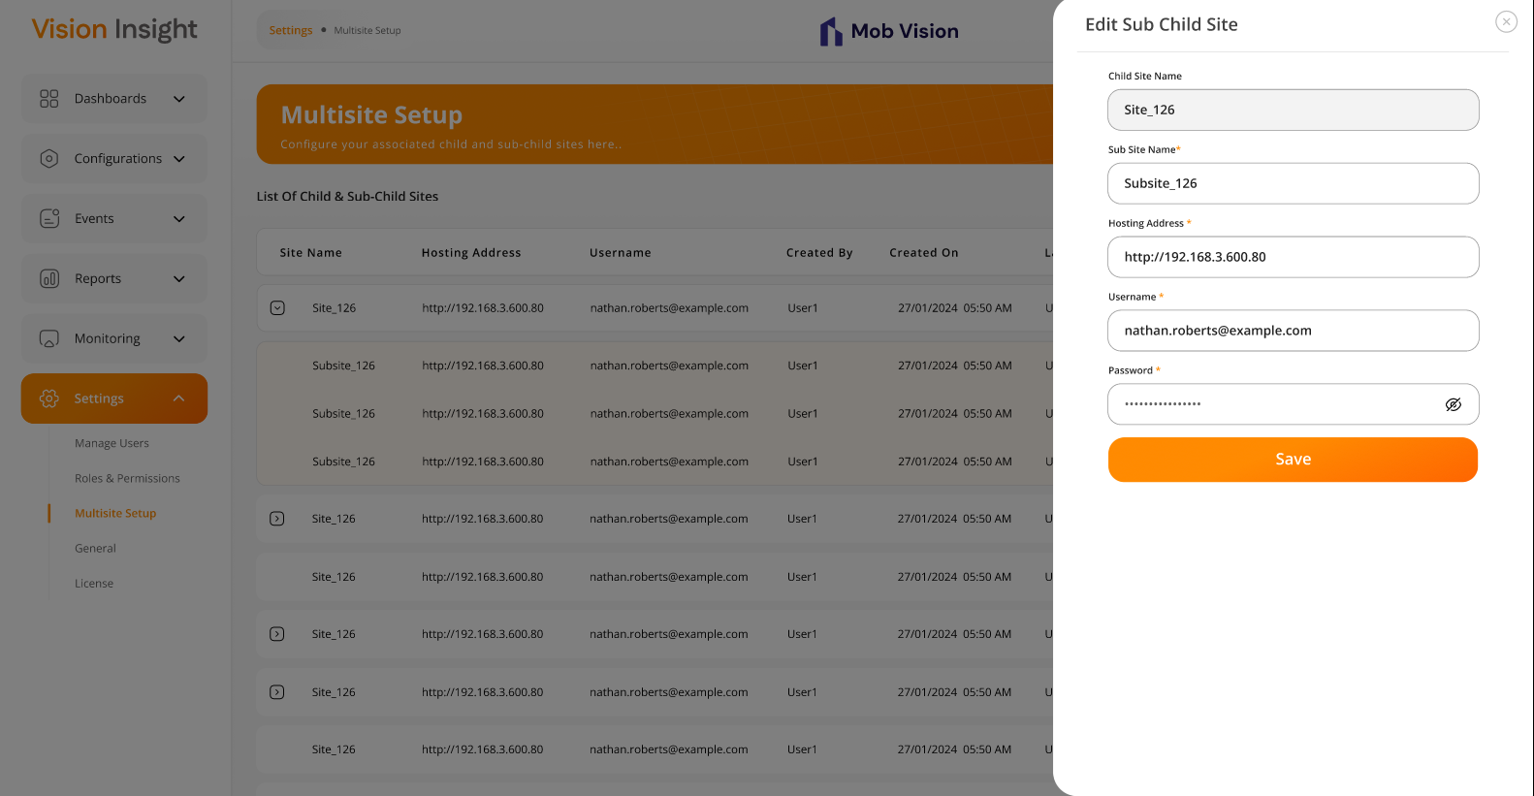
- The system will request confirmation when a logged-in user attempts to delete any child or sub-child site:
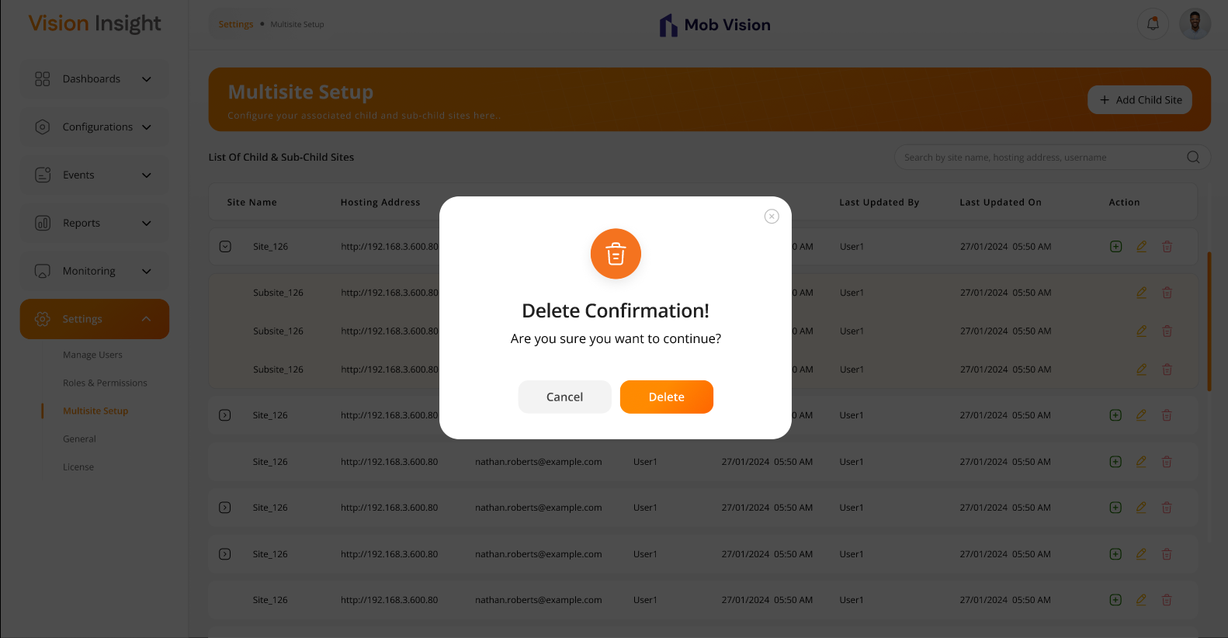

Business Rules:
- Only the parent site’s authorized / super admin users will have the ability to configure this information. This means that a child site’s user cannot configure their sub-child; only the parent site’s authorized user will have that ability.
- Once the above configurations are completed, the system will allow the parent site’s authorized / super admin users to view data from all the configured child & sub-child sites only.
- The parent site’s authorized / super admin users will be able to add, edit, and delete the following details for each child or sub-child sites:
  - Site Name
  - Hosting Address / URL
  - Username
  - Password
- When the user enters the required details while adding or updating a child or sub-child site, the system will validate the connection from the backend and display an appropriate message on the screen, allowing the user to determine whether the entered information is valid or invalid.
- The system will provide the following options for managing child and sub-child sites:
  - Add Child Site
  - Edit Child Site
  - Delete Child Site
  - Add Sub-Child Site
  - Edit Sub-Child Site
  - Delete Sub-Child Site
- This screen will display a list of all configured child and sub-child sites, with the following options for each:
  - Edit
  - Delete
- The system will group child and sub-child sites and display them accordingly in a structured list.
- Each child site will have an option to add a sub-child site by clicking the "+" icon.
- When adding or updating a sub-child site, the parent child site’s name will be displayed on the "Add Sub-Child Site" & "Edit Sub-Child Site" screens as non-editable.
- The authorized user can search for a specific record using Site Name and Hosting Address.
- This screen will not support pagination but will allow vertical scrolling, enabling users to view all records smoothly.
- If at least one sub-child site exists for a child site, the system will allow users to expand and view sub-child sites within the list.

Data Dictionary:

Settings > General Page

The system allows the Super Admin or authorized user to manage general settings such as SMTP setup, uploading the company logo, configuring operational time, and setting the Google Map API key from this page in the BI Dashboard Web Application. This screen will be accessible only to authorized users.

Prototype:
- The screen below represents the form for configuring SMTP details, company logo, and operational time, allowing users to enter and submit the relevant information:
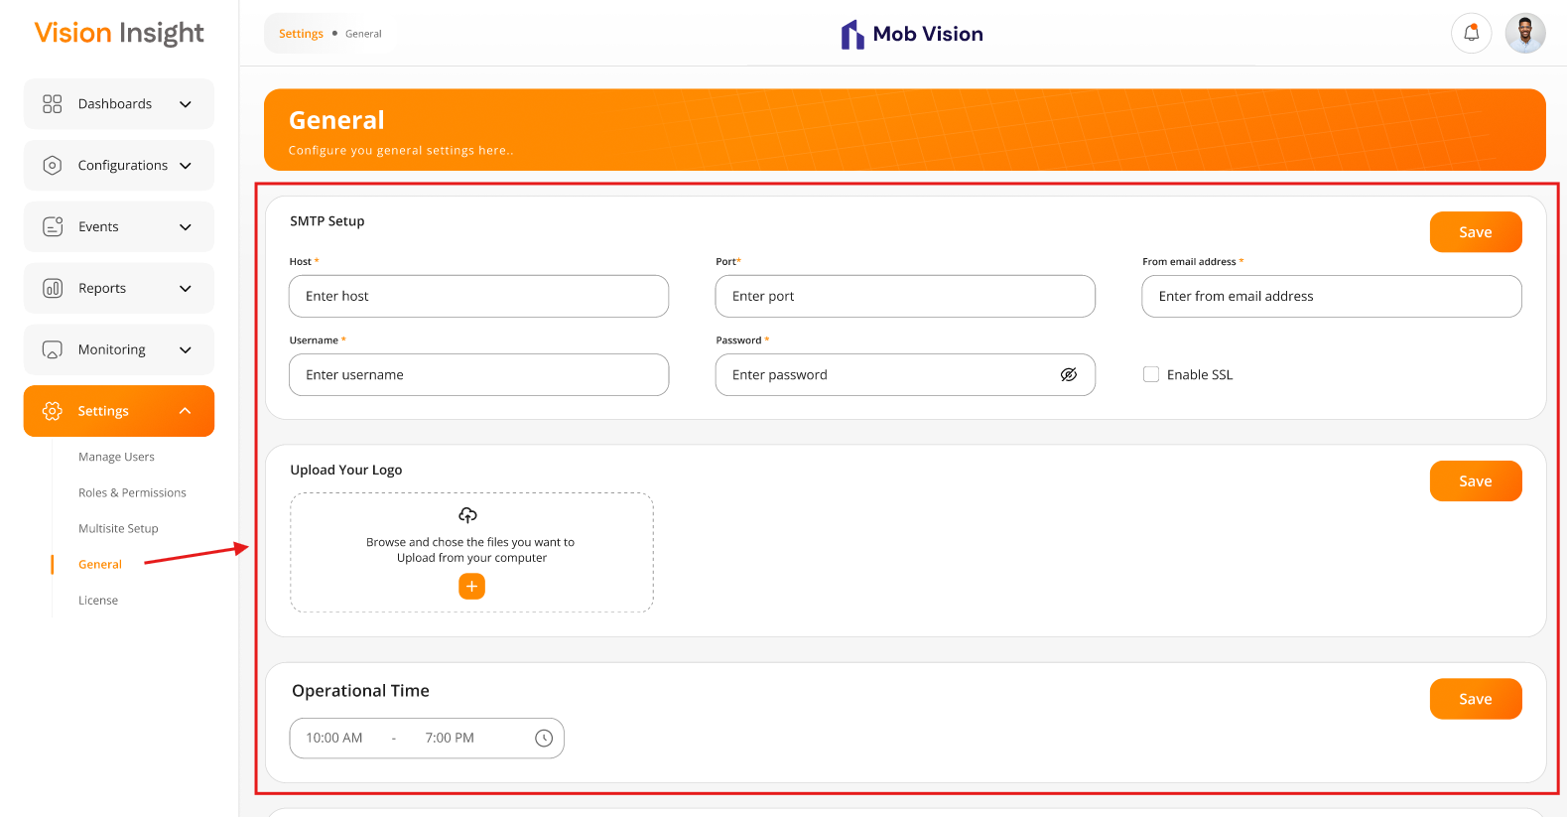
- The screen below represents the form for configuring Google Map Key, allowing users to enter and submit the relevant information:
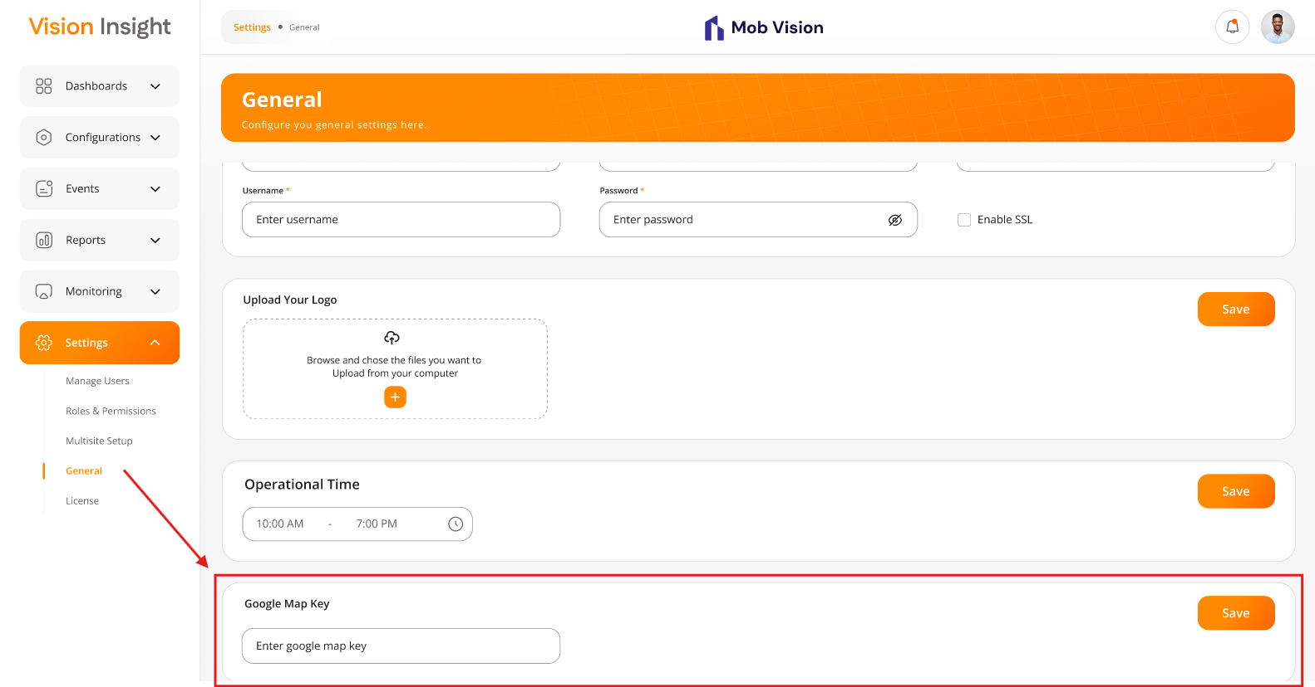

Business Rules:

- SMTP Setup:
  - Authorized users will be able to configure their SMTP credentials by entering the following fields from this section:
    - Host*
    - Port*
    - From email address*
    - Username*
    - Password*
    - Enable SSL (checkbox)
  - The system will send email notifications to users only when SMTP is configured only.
- Upload Your Logo:
  - Authorized users will be able to configure their company logo from this section.
  - Users will be able to select and upload their company logo.
  - The logo size will be fixed to maintain design consistency.
  - The uploaded logo will be displayed at the top center of the header section & it will be displayed when the logo is configured only.
- Operational Time:
  - Authorized users will be able to configure operational time by entering the following values:
    - Start Time*
    - End Time*
  - The system will calculate the day start and end based on the configured operational time for the specific site.
    - If no operational time is configured, the system will default to a 24-hour operational time.
- Google Map Key:
  - Authorized users will be able to configure the Google Map Key by entering it into this section.
  - The map feature will be enabled for the specific site only if the key is configured. Otherwise, the map plan will not be accessible for those users or sites.
  - The Google Map Key will be purchased & managed by the specific client only.
- Each of the above-mentioned sections will be managed independently. The user must click the “Save” button to update the values of each section separately.
- The system will display an appropriate “Success” or “Error” message when the user clicks the “Save” button.

Data Dictionary:

Settings > License

The system allows the Super Admin or authorized users to upload and manage license details from this page in the BI Dashboard Web Application.

This screen will be accessible only to authorized users.

Prototype:

- The screen below represents the form to upload a license file for the specific site only, allowing users to upload a publickey.pem & license.lic file and submit it:
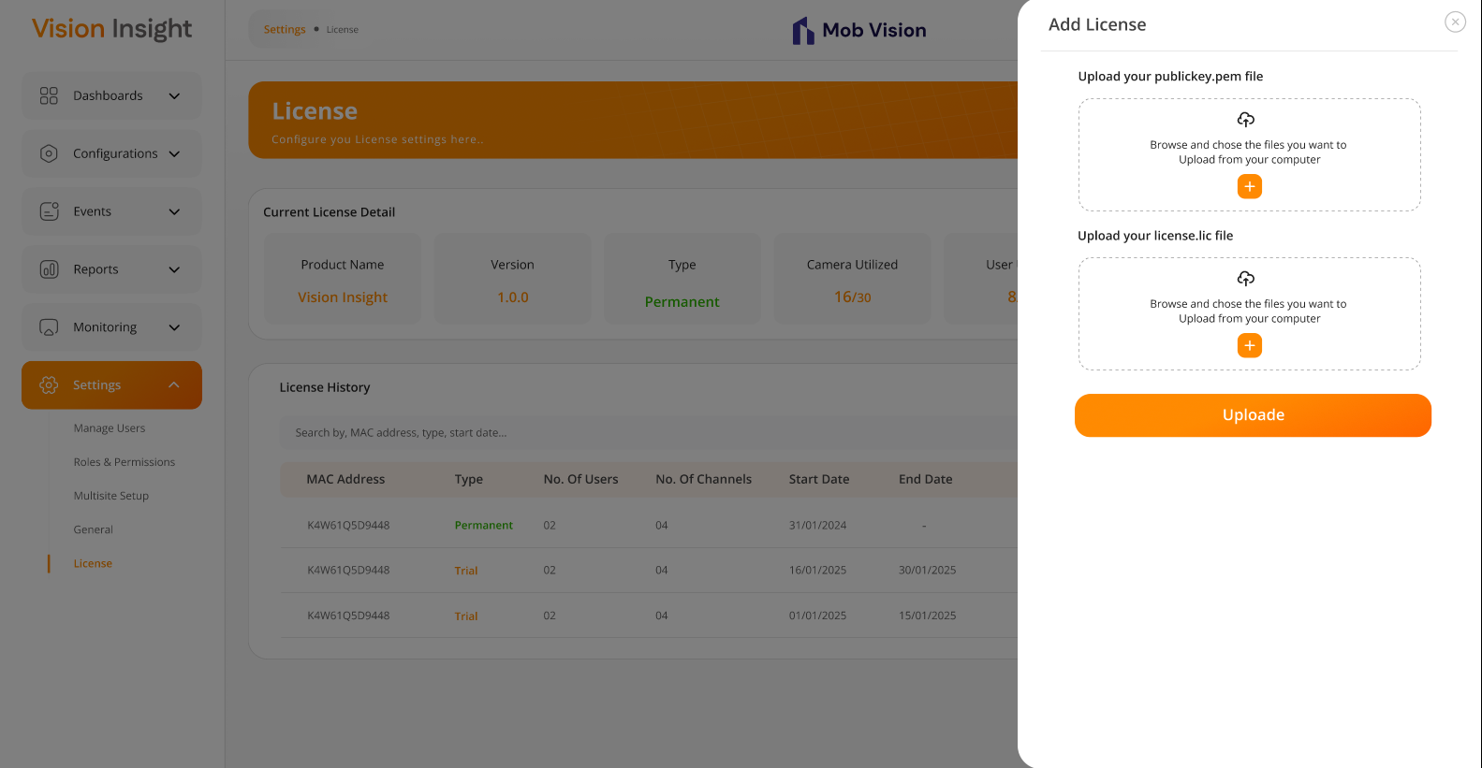
- The screen below represents the details of currently active license and their history, including an option to search the specific record from the history table:
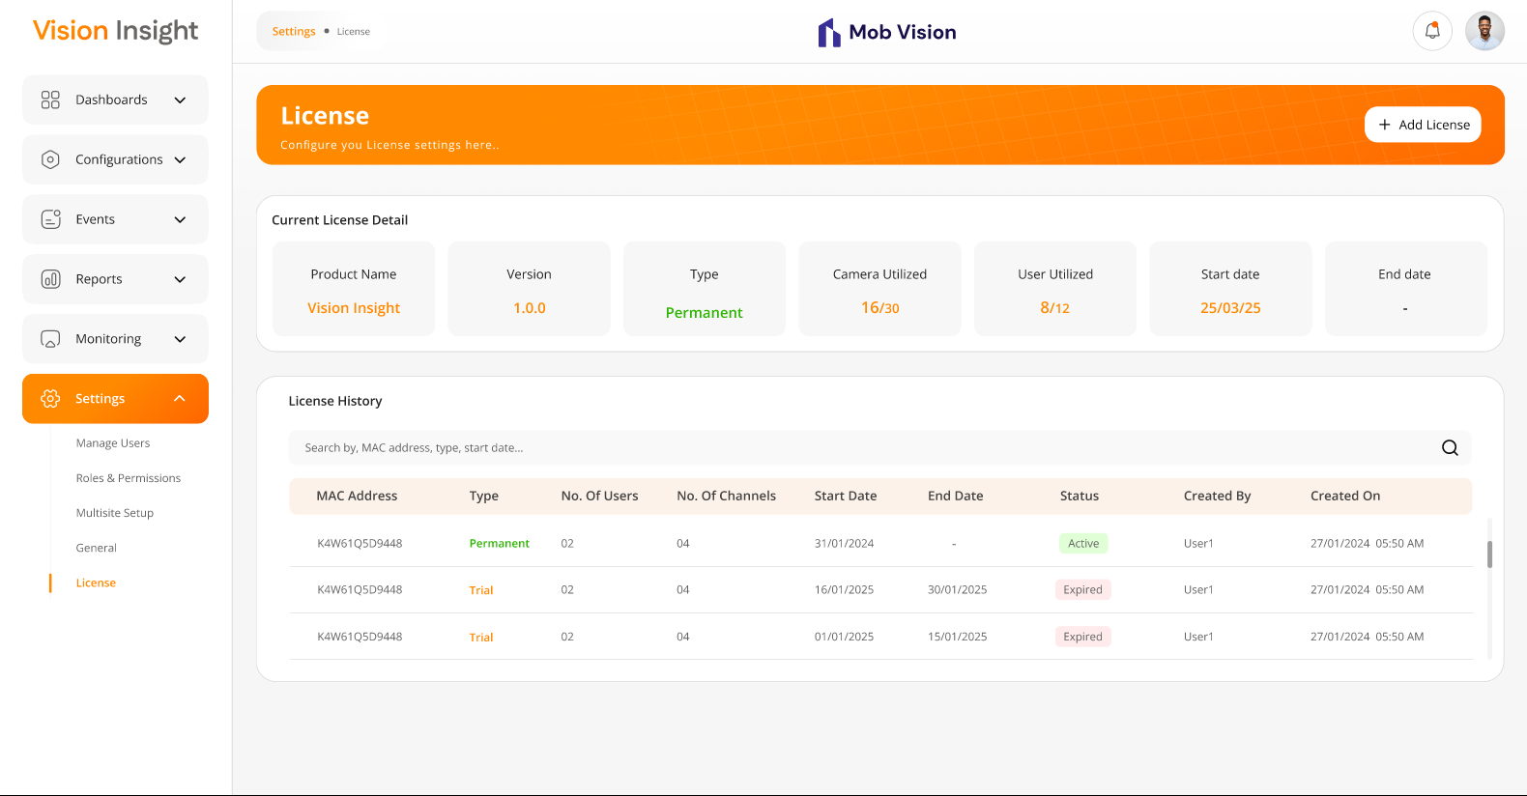

Business Rules:
- Authorized users will be able to upload the following files to authenticate the license:
  - publickey.pem – Contains the customer's public key, required for authentication during license configuration at the customer’s site.
  - license.lic – Contains the generated license details for the customer, used to validate and authenticate the license during configuration.
- The system will validate the associated MAC Address against the PC’s MAC Address when the authorized user attempts to upload the license from the “Add License” popup.
- If the MAC Address does not match, the system will display an “Unauthorized” error message, and the user will be instructed to contact their administrator for further assistance.
- If the MAC Address matches, the system will:
  - Successfully upload the license.
  - Display the following license details on the screen:
    - Product Name (e.g., Vision Insight)
    - Version (e.g., 1.0.0)
    - Type (e.g., Permanent / Trial)
    - Camera Utilized (e.g., 16/30)
    - User Utilized (e.g., 8/12)
    - Start Date (e.g., 25/03/2025)
    - End Date (e.g., 10/04/2025 or “–”)
  - Show an appropriate success message to the user.
- At any given time, only one license will be active in the system.
- The system will maintain a history of all uploaded licenses, which will be displayed under the “License History” section with the following columns:
  - MAC Address
  - Type
  - No. Of Users
  - No. Of Channels
  - Start Date
  - End Date
  - Status
  - Created By
  - Created On
- Users will be able to search licenses by:
  - MAC Address
  - Type
  - Start Date

Data Dictionary:

Login Page

There is a provision in the system for all users to login to the BI Dashboard Web Application.

This page will validate the user's credentials whenever a user attempts to login by entering their own login details.

Prototype:
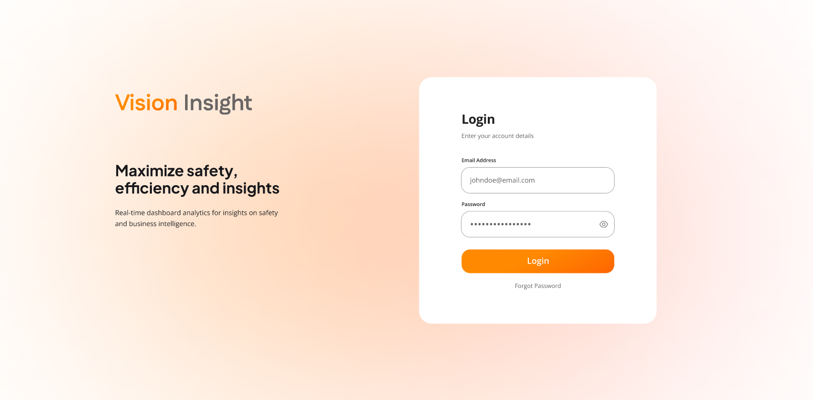

- The screen below represents the message which will be displayed when the user clicks on the “Forgot Password” link located just below the Login button, since the system does not allow users to reset their own password:
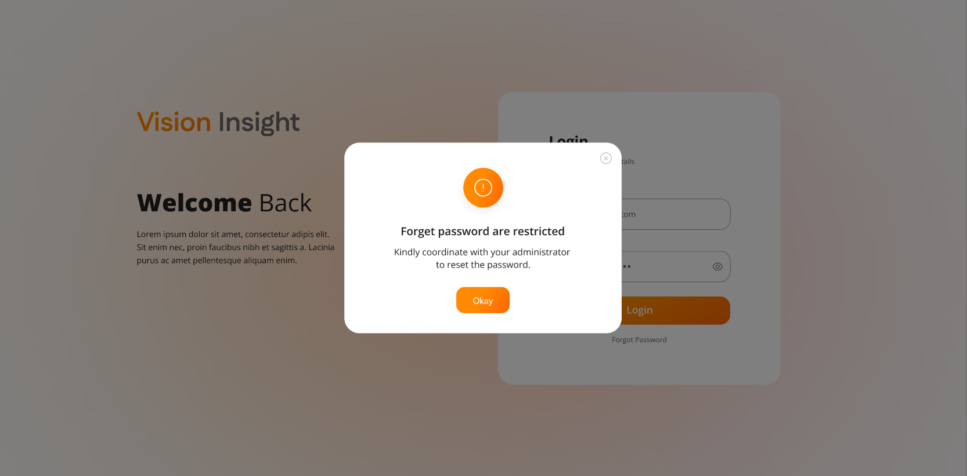

Business Rules:
- The login screen will include a logo and text fields for entering the username or email address and password, along with a Login (Submit) button as well as “Forgot Password” link.
- Upon clicking the "Forgot Password" link, the user will see the following message, as sub-users cannot reset their own passwords. Only the super admin or an authorized user can change the sub-user's password:
“Kindly coordinate with your administrator to reset the password”
- Upon clicking the “Login” button, the application will validate the entered username or email address and password.
- If the credentials are successfully validated:
  - The application will check the user's authorizations and redirect them to the Dashboard screen.
- If the entered credentials are invalid:
  - The system will display an appropriate error message on the login screen.
- If the user is marked as Inactive/Deleted in the system:
  - They will not be able to login using their existing credentials.
  - In such cases, the user must contact the super user & authorized users for further assistance.
- The system will validate below highlighted fields while logging into the system.

Data Dictionary:
- The system will utilize below highlighted fields from the userMaster table:

Menu Items for BI Dashboard Web Application

The system allows all users to log in to the BI Dashboard Web Application and access the following menus and options based on the specific assigned permissions:

The following options/menus will be displayed on the sidebar:
- Dashboards
  - The user will be able to configure any number of dashboards, each with a custom name.
- Configurations:
  - Manage Devices
  - Floor Plans & Zones
- Events
  - Event Logs
- Reports
  - My Reports
    - Site Performance Comparison Report
    - Zone Performance Comparison Report
- Monitoring
  - The user will be able to configure any number of monitoring, each with a custom name.
- Settings:
  - Manage Users
  - Roles & Permissions
  - Multisite Setup
  - General
  - License

The following options/menus will be displayed when the user clicks on their profile image in the top right-hand corner:
- Profile
- Preferences
- Change Password
- Logout

Prototype:
- The screen below illustrates above mentioned menu items & options for Bi Dashboard Web Application.

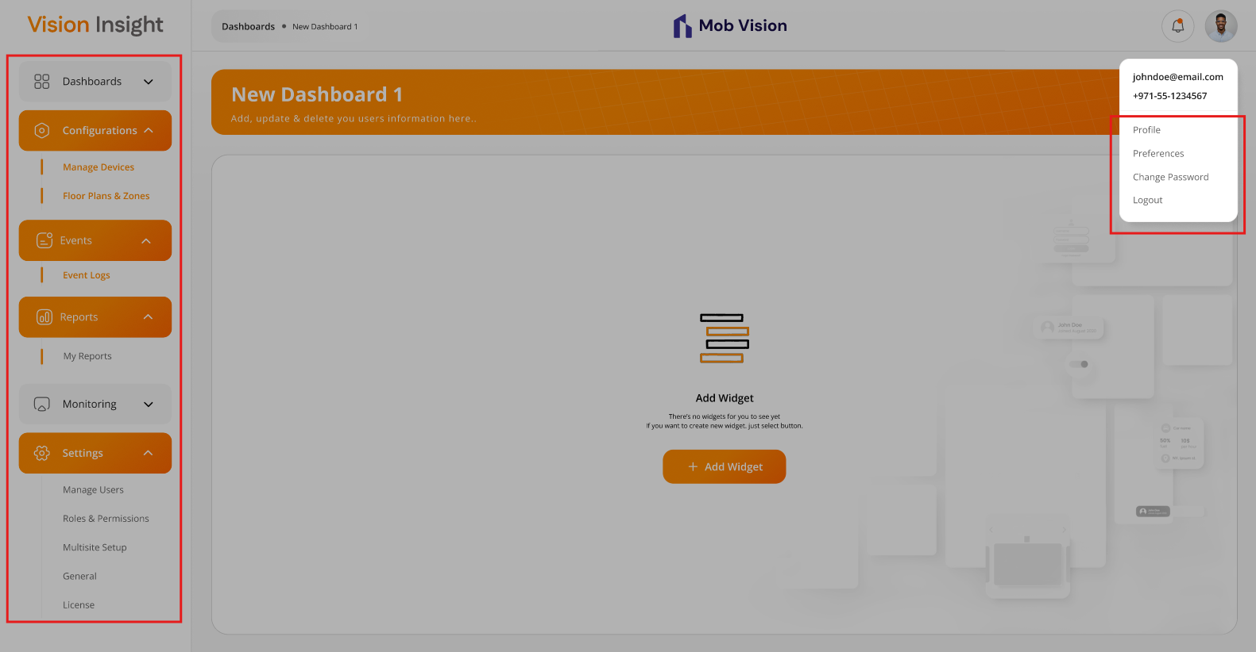

Business Rules:
- The logged-in user will be able to access the above highlighted menus or options based on the specific assigned permissions only.
- All users will be able to access the following options:
  - Profile
  - Preferences:
  - Change Password
  - Logout
- The system will automatically hide any menus or specific actions on screens that the logged-in user is not authorized to access based on their assigned permissions.

Data Dictionary:
- It is not required to manage any data dictionary for menu items, as it will be handled directly in the frontend code only.

Header Section > Profile Page

The system provides a feature for all users to log in to the BI Dashboard Web Application and access their Profile page.

This page displays details specific to the logged-in user only. The screen can be accessed by clicking on the Profile link located at the top-right corner of the top bar.

Prototype:
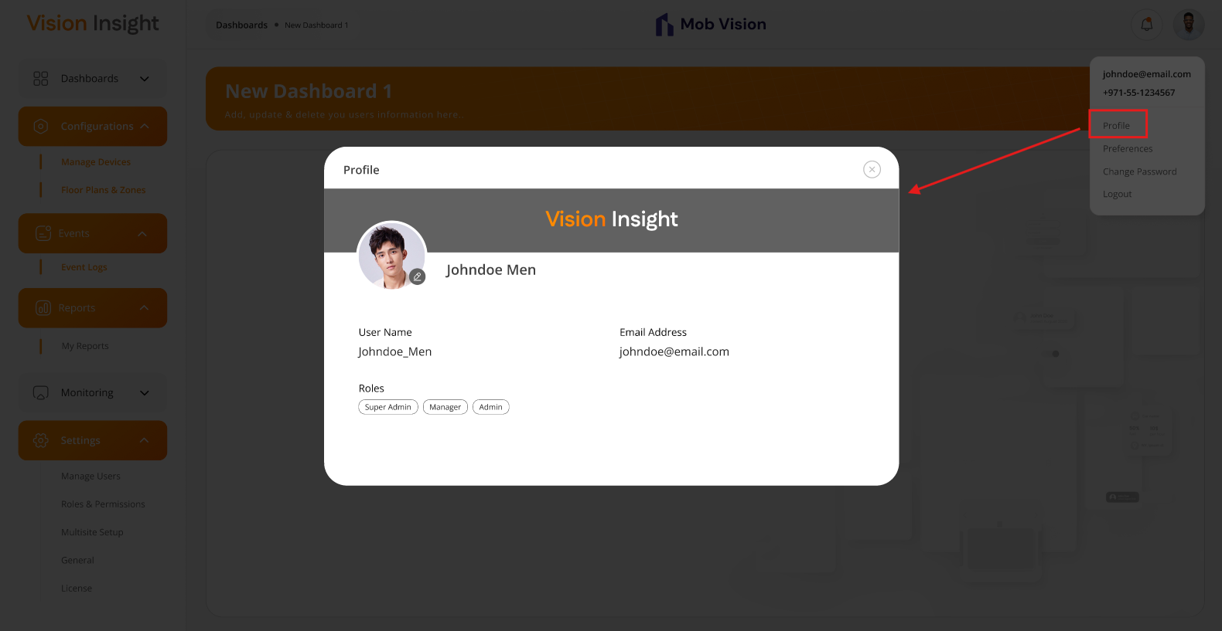

Business Rules:
- The system will display information related to the logged-in user on this page. Which are enlisted below:
  - Profile Image
  - Full Name (First & Last Name)
  - Username
  - Email Address
  - Roles (which is assigned to logged-in user from the Manage Users page)
- This screen will allow logged-in users to only view their details except updating their profile image only.
- The user can update their profile picture by clicking on the current profile image and selecting a new one & the updated profile picture will be reflected across the entire system after re-logging in.
Data Dictionary:
- This page will display registered information for the specific logged-in user from the userMaster table only.

Header Section > Change Password Page

The system will not allow any users to change their own password from the BI Dashboard Web Application.

To reset or change their password, users must contact a Super User or authorized user.

Only a Super User or authorized user can update or reset passwords from the Manage Users page for any user.

This page will be accessible when the user clicks on their profile image located at the top right-hand corner of the screen.

Prototype:

- The screen below illustrates the message that will appear once users click on the “Change Password” option:
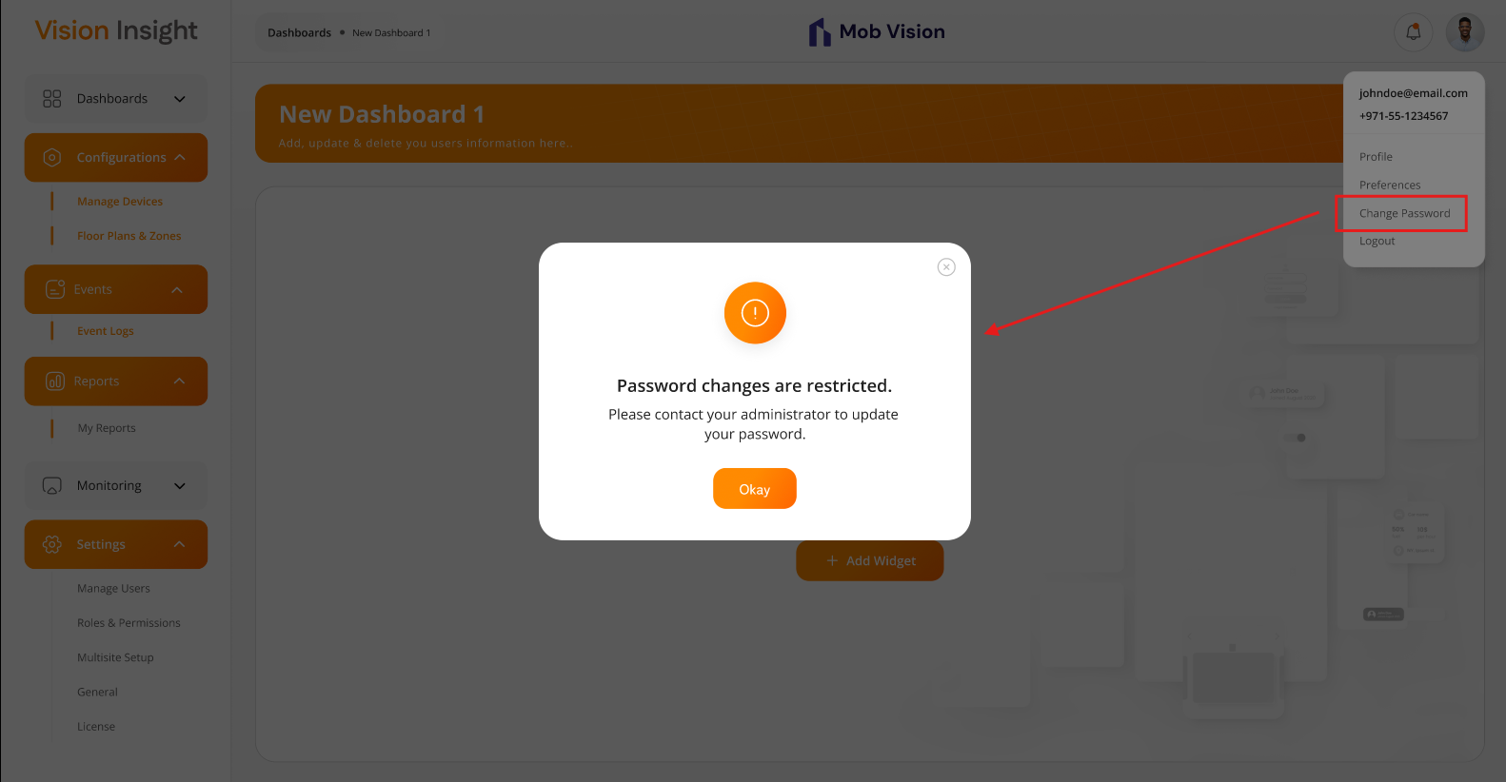
Business Rules:
- All users will have access to this option.
- Upon clicking this option, the system will display the following message:
“Kindly coordinate with your administrator to change your password”
- If the Super Admin user forgets their password, they will need to contact the technical development team to reset or change their password.

Header Section > Preferences Page

The system allows the authorized user to manage preferences such as Color Theme, Time Zone, and Language from this page in the BI Dashboard Web Application.

This page will be accessible when the user clicks on their profile image located at the top right-hand corner of the screen. All preference options on this page will be available to all users.

Prototype:

- The screen below illustrates the options available for users to select their own preferences, like Theme, Time Zone, and Language:
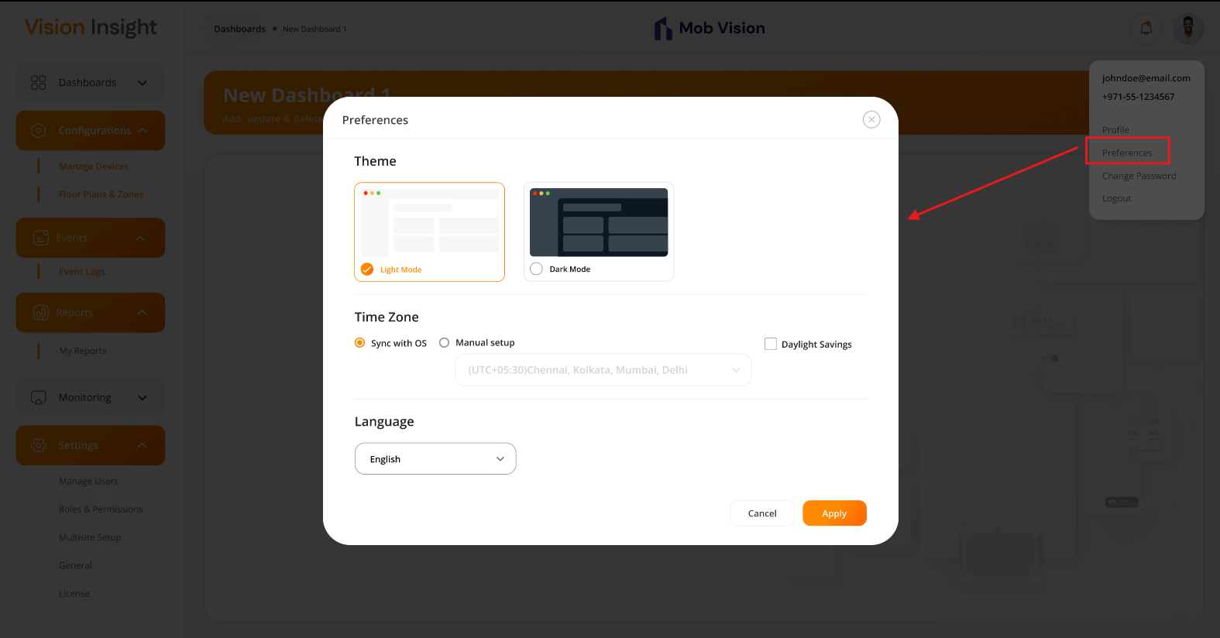

Business Rules:
- Color Theme:
  - All users will be able to select this option.
  - Users can choose from the following color theme options:
    - Light
    - Dark
  - The UI will be appeared based on the selected theme only.
  - By default, light theme will be selected.
- Time Zone:
  - The system will provide following two options for time zone configuration:
    - Synce with OS
    - Manual Setup
  - When user selects the “Synce with OS” option,
    - The system will fetch the information from the OS & configure the time zone accordingly.
  - When user selects the “Manual Setup” option,
    - The system will display the predefined list of time zones.
    - The user will be able to select a single time zone from the dropdown list.
  - Authorized users will be able access this option.
  - Based on the selected time zone, the system will display the date and time accordingly to the logged-in user in entire system.
  - The system will also allow users to enable “Daylight Savings”. If selected, the system will automatically adjust the time for users located in the respective time zones where Daylight Savings is applicable.
- Language:
  - The system will display the predefined list of languages.
  - In this scope, the system will support & provide only single option. That is “English”.
- The system will display an appropriate “Success” or “Error” message when the user clicks the “Apply” button.

Data Dictionary:

Header Section > Notifications

The system allows the authorized users to view all the notification received within the BI Dashboard Web Application.

This page will be accessible when the user clicks the bell icon, located at the top-right corner of the screen. Only authorized users will be able to view notifications under this section.

Prototype:

- The screen below illustrates the notification section which includes counts of the total unread notifications, option to mark all notifications as read, acknowledge the event notification & click on any notification and mark it as read. This will be appeared when user clicks on the Bell Icon of the header section:
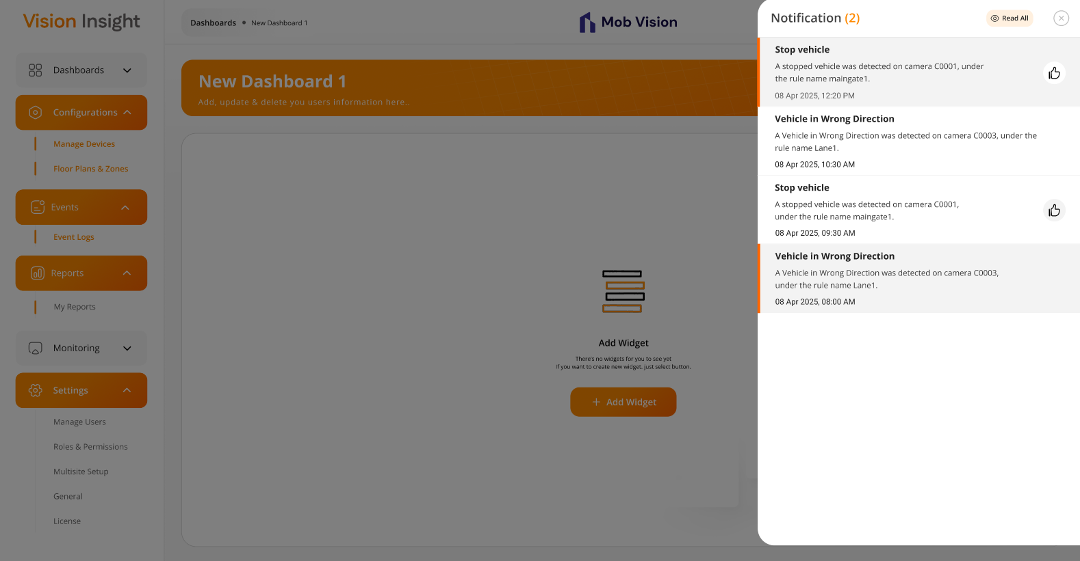

Business Rules:
- Authorized users will be able to view the bell icon in the header section. Upon clicking the icon, they can access all system notifications.
- Each notification will include the title, description, and date & time of the notification.
- The system will display the following types of notifications only:
  - Event Notification (may include an option to acknowledge it)
  - Alert Notification (displayed in case of emergencies or where immediate action is required)
- The system will show a visual indication in RED DOT on the bell icon when unread notifications are present.
- The system will display the count of unread notifications next to the bell icon.
- Authorized users will have the option to mark all unread notifications as read by clicking the “Read All” button. This action will be reflected for all authorized users, as the system does not generate or maintain user-specific notifications.

Data Dictionary:

Configurations > Manage Devices Page

The system provides a feature for Super Admin and authorized users to manage devices (such as Cameras and AI Boxes) through the BI Dashboard Web Application.

This page will be accessible exclusively to Super Admin and authorized users, with actions such as adding, editing, and deleting devices displayed based on the permissions assigned to the logged-in user.

Prototype:

- The screen below illustrates the list of all created devices under List view, including options for Search, Reload, Remove, Add, and Edit:
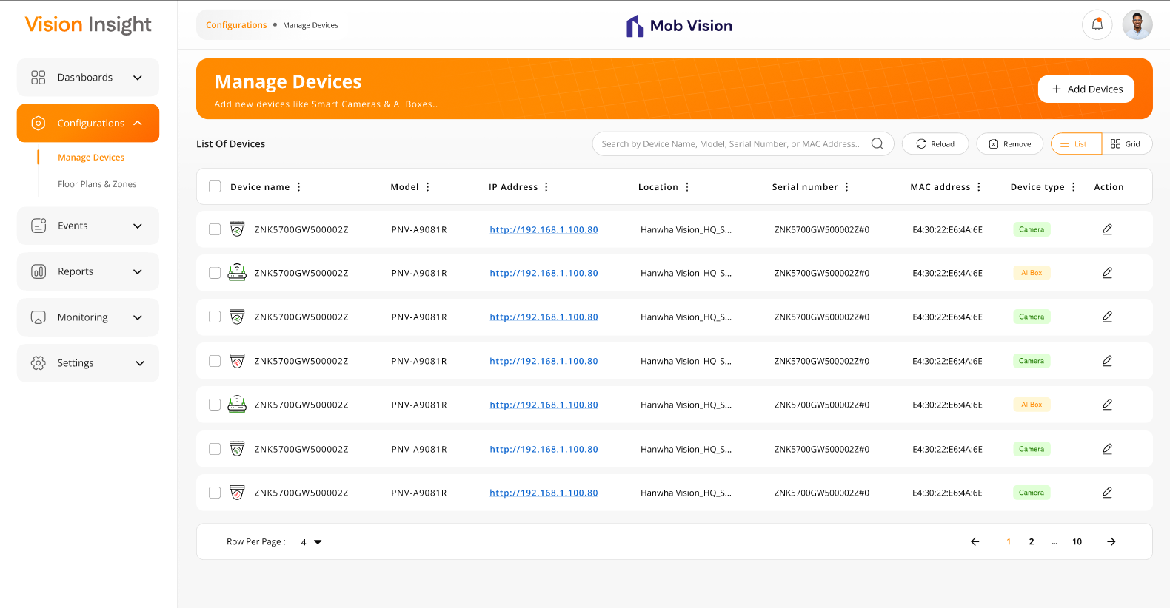

- The screen below illustrates the list of all created devices under Grid view, including options for Search, Reload, Remove, Add, and Edit:
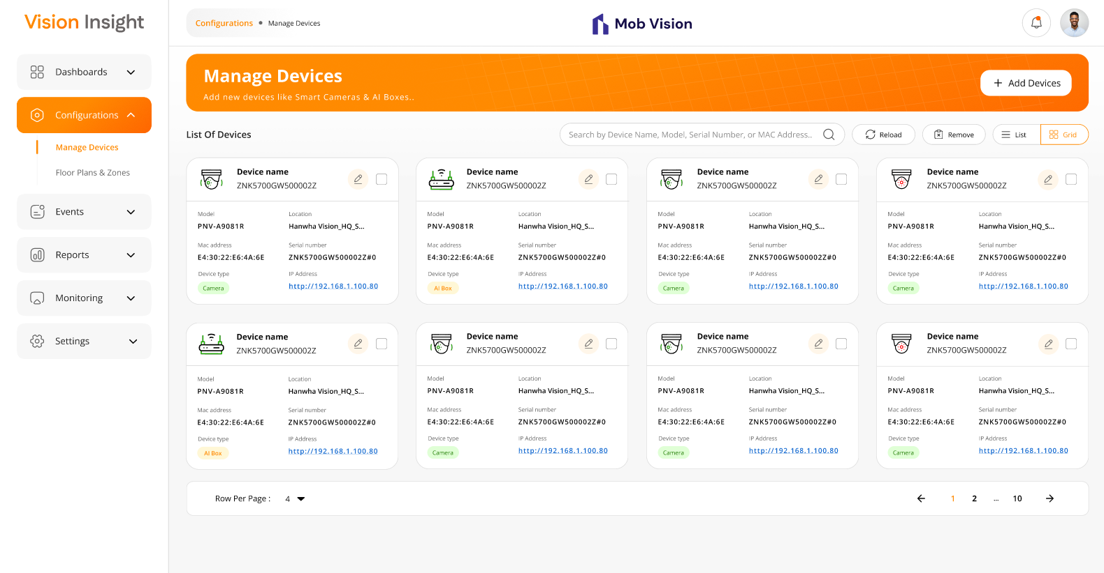

- The screen below represents the form for creating a new camera device, allowing users to enter relevant details and submit the information:
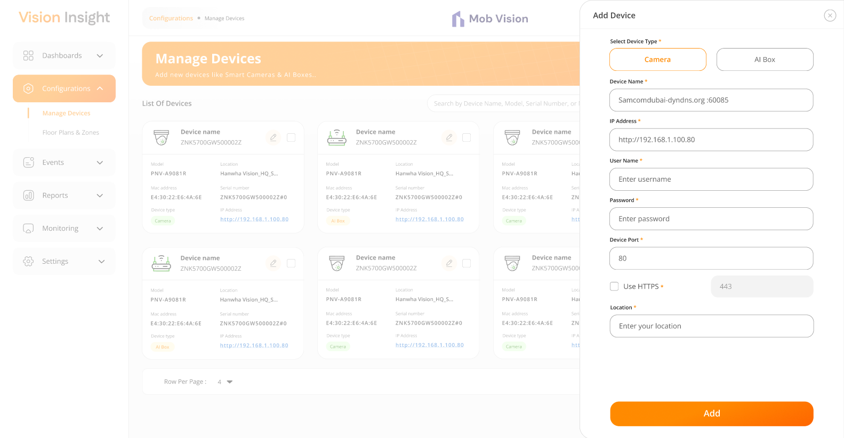

- The screen below represents the form for creating a new AI Box device, allowing users to enter relevant details and submit the information:
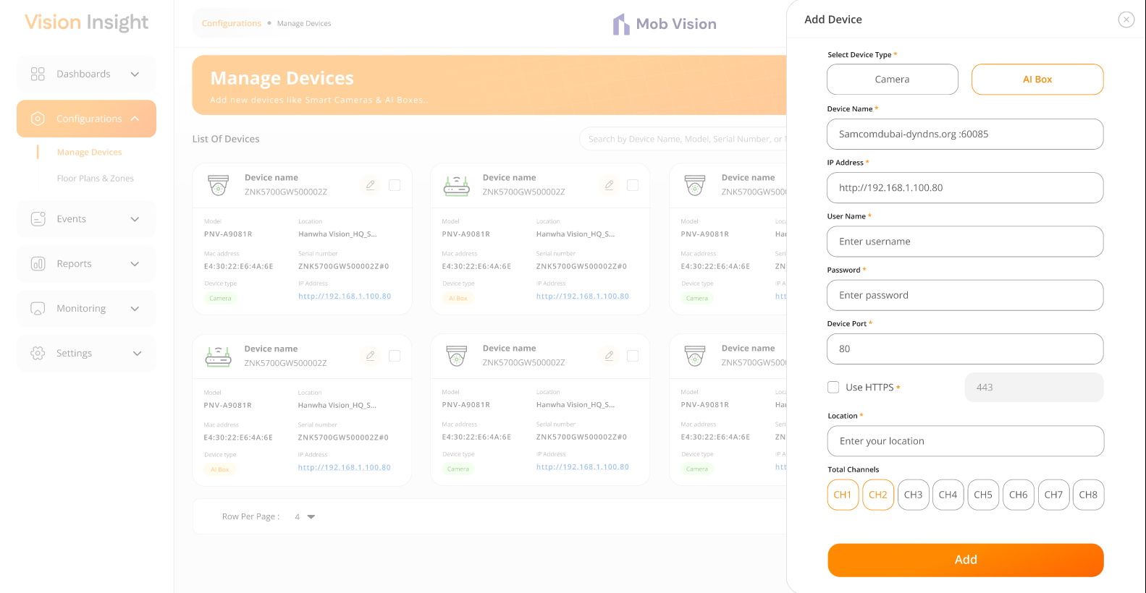

- The screen below displays the form for editing an existing camera device, allowing users to modify relevant details and update the information:
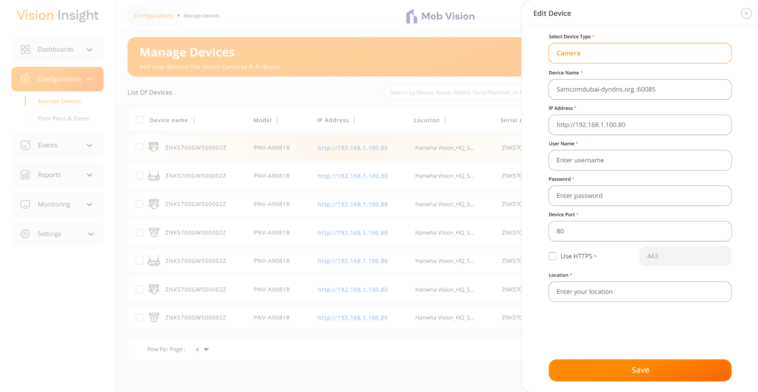
- The screen below displays the form for editing an existing AI Box device, allowing users to modify relevant details and update the information:
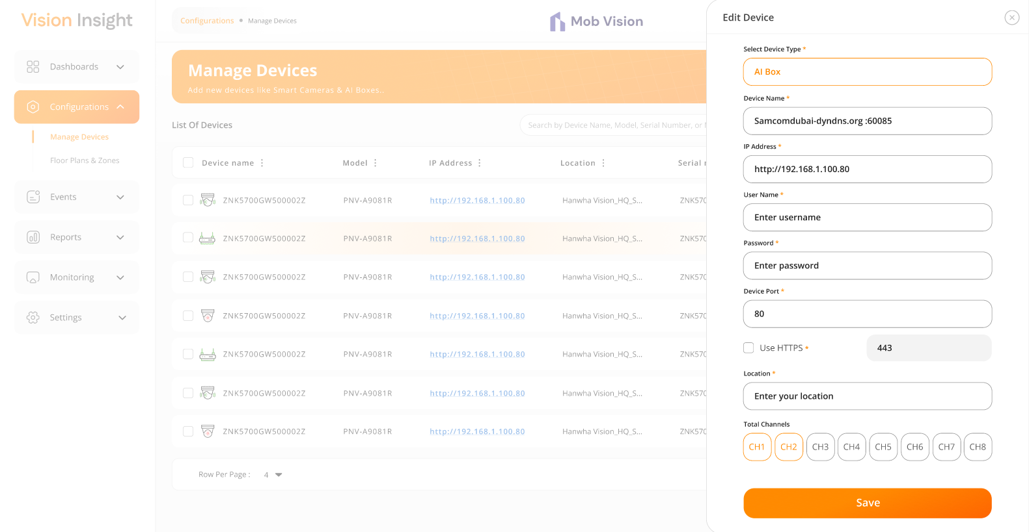

- The system will request confirmation along with an appropriate message when a logged-in user attempts to delete any authorized user:
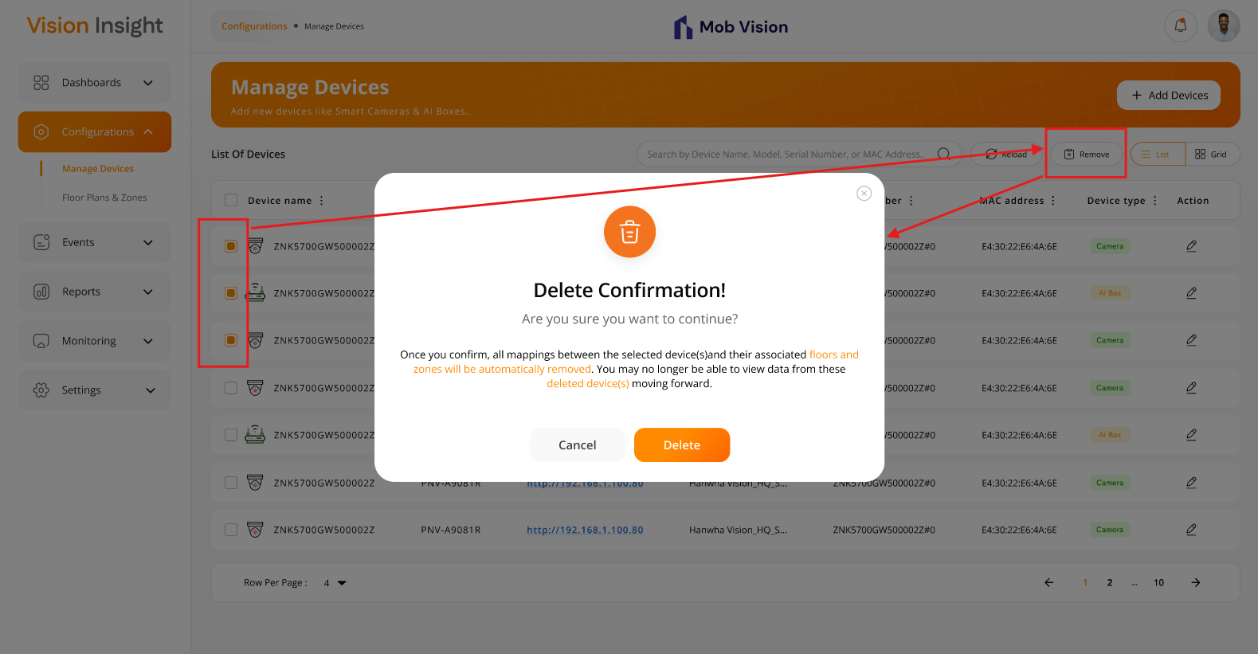

- The screen below represents the loader on the page when the authorized user clicks on the “Reload” button:
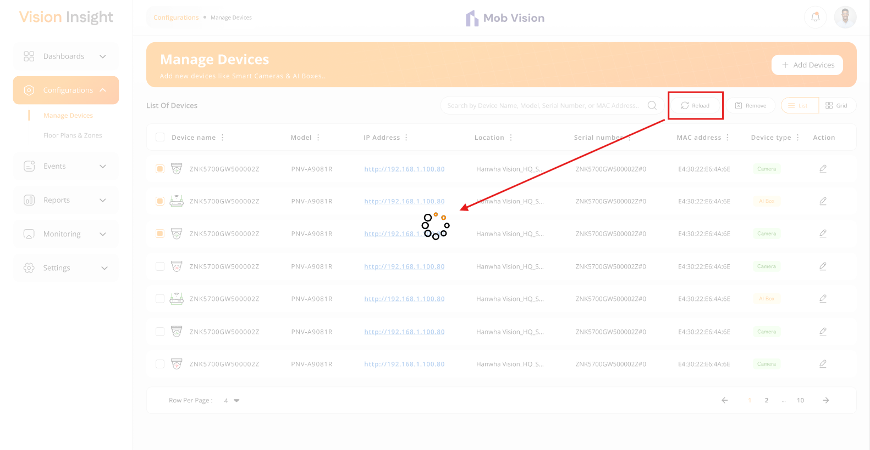

Business Rules:
- Authorized users will have the ability to add, update, and delete devices within the system.
- The system will allow users to select one or more devices from the list and provide the ability to remove the selected device(s) from the records.
- When a user attempts to delete one or more devices, the system will display a confirmation popup with an appropriate message. Upon confirmation, the system will automatically un-map the selected device(s) from their associated floors and zones, and users will no longer be able to view data from these deleted device(s) moving forward.
- When a logged-in user attempts to delete device(s), the system will prompt for confirmation. Once confirmed, the system will soft delete the selected device(s), meaning the records will remain in the database but will no longer be visible in the web application.
- The system will prevent duplicate entries for devices by validating the Device Name and IP Address.
- The “Add Device” and “Edit Device” screens will include the following fields:
  - Select Device Type* - (Camera / AI Box)
  - Device Name*
  - IP Address*
  - Username*
  - Password*
  - Device Port*
  - Location*
  - Use HTTP (Ability to specify HTTP port; default value will be 443)
  - Total Channels (This will be displayed only if the device type is AI Box)
- The asterisk (*) indicates a mandatory field only.
- The system will provide authorized users the ability to view the list of added devices using two options: “Card View” and “List View”.
- Both views will support pagination and allow users to configure the number of rows per page.
- The list will include the following fields along with pagination:
  - Checked / Unchecked (selection checkbox)
  - Device Online / Offline status (The device icon for Camera / AI Box will be displayed based on its status)
  - Device Name
  - Model
  - Location
  - Serial Number
  - MAC Address
  - Device Type
  - Action (Edit & View)
- The system will allow users to search for specific device(s) using Device Name, Model, Serial Number, or MAC Address only.
- The system will allow authorized users to click on the value in the "IP Address" column, and upon clicking, it will open the corresponding URL in a new browser window.
- The system will allow users to “Reload” the device list.
- The system will make API calls to retrieve the current online/offline status of devices when the user clicks on the "Reload" button. The fetched status will be stored in the database and will be reflected in the web application accordingly.
- Under “List View” only, the system will offer filter options on specific columns using the MUI library, which is integrated throughout the web application. These filters will reset when the user reloads the page or navigates to another page.
- The system will retrieve device status data from a background job at a predefined time interval (default: 15 minutes). This interval can be modified from the source code and may require restarting the application from the hosted environment. The retrieved status will be stored in the database for all configured devices and will be reflected in the web application.

Data Dictionary:

Configurations > Floor Plans & Zones Page

The system provides a feature for authorized users to manage Floor Plans and Zones through the BI Dashboard Web Application.

This page will be accessible exclusively to authorized users, with actions such as adding, editing, and deleting floor plans and their associated zones, adding camera on the specific zone, etc.

Prototype:
- The screen below illustrates first landing page with appropriate message & action to add new floor plan when there is no any floor plan yet configured in the system:
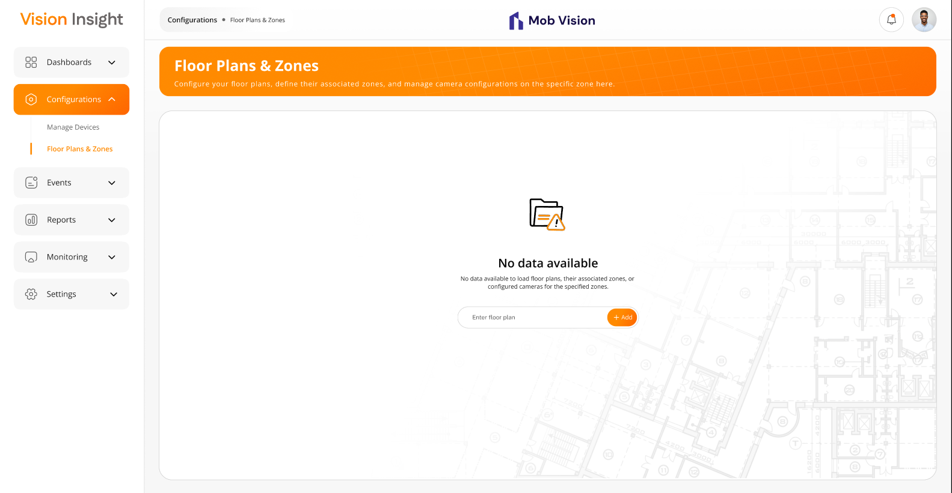
- The screen below illustrates the list of added floor plans, including options to Search, Add, Update & Delete the floor plan from:
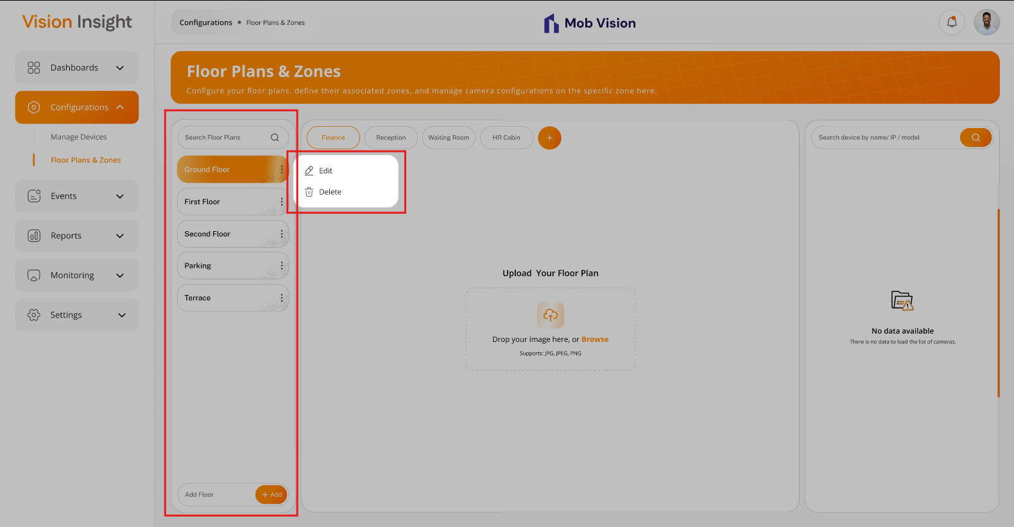

- The screen below represents the form for creating a new zone, allowing users to enter relevant details and submit the information. Additionally, the list of all the created zones:
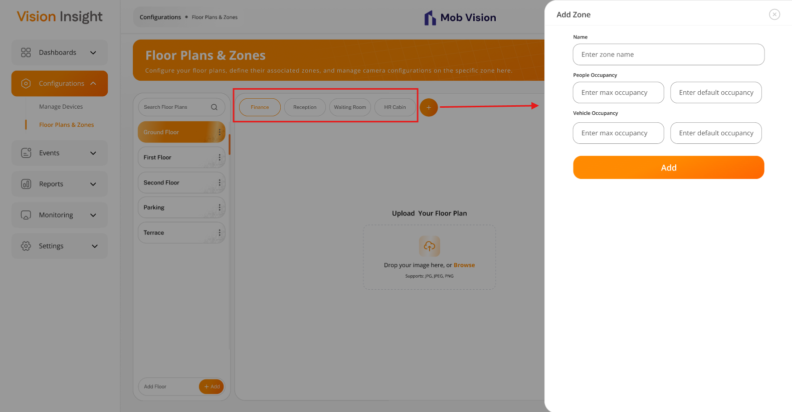
- The screen below displays the form for editing an existing zone, allowing users to modify relevant details and update the information:
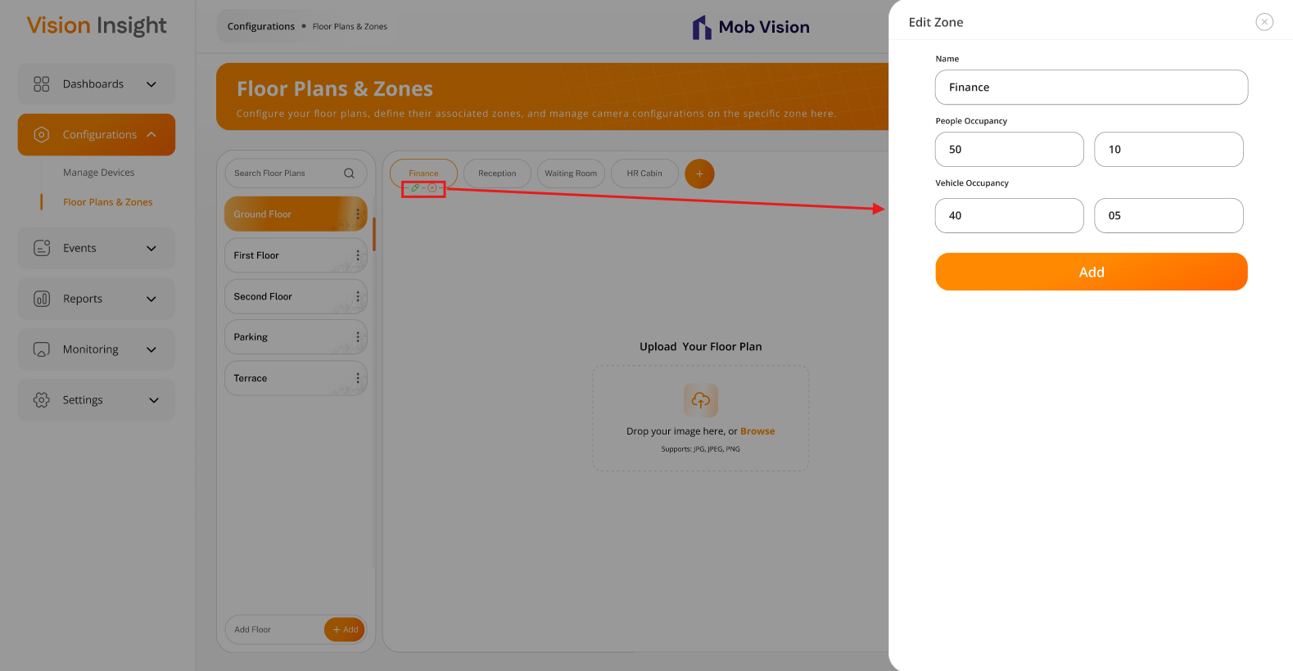

- The screen below displays the option to select & upload floor plan image:
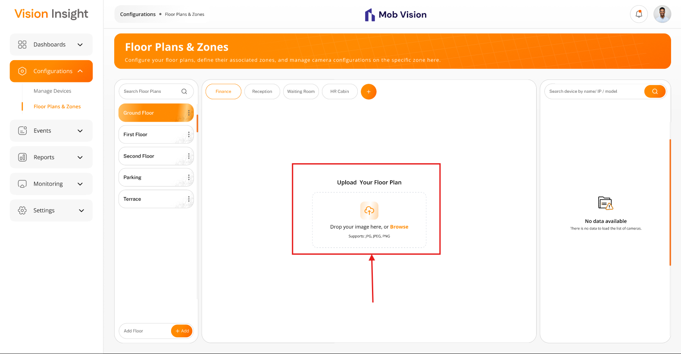
- The screen below displays the uploaded floor plan image along with the options to replace floor plan image, save entire changes, zoom-in & zoom-out floor plan image, & list of all online cameras which are yet pending to configure on the zone:
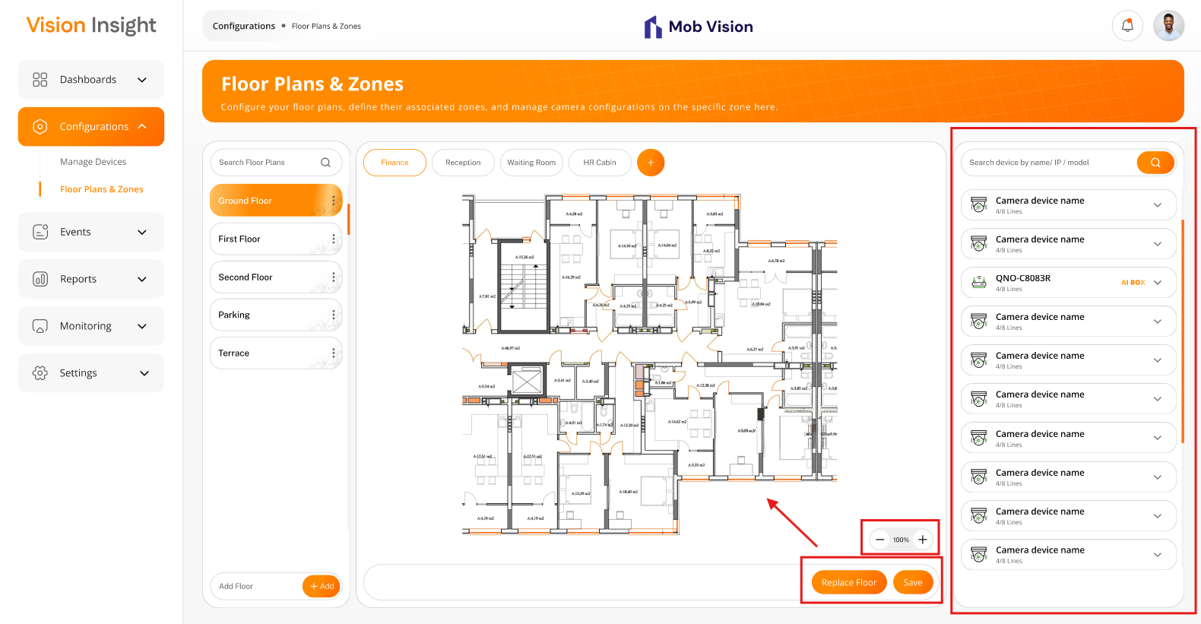

- The screen below displays the camera-related options including search the camera, expand, select & drag-and-drop the camera on the floor plan image under selected zone, adjust the sphere & focal view, adjust the color of sphere & focal view, rotate the camera, selection of line(s) while configuring the camera, and delete the camera from the specific area:
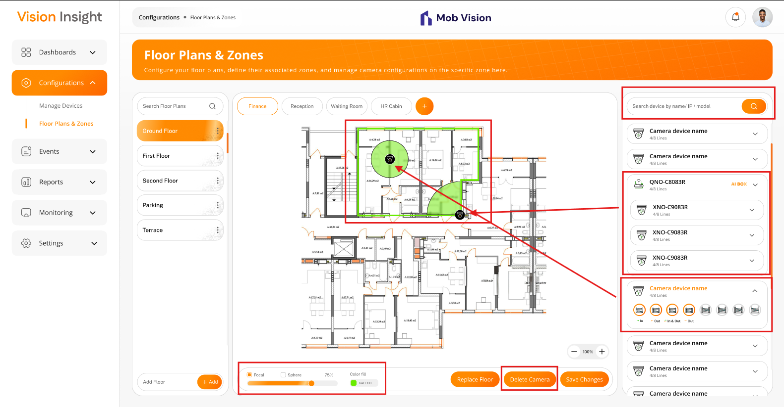
- The system will request confirmation with an appropriate message when a logged-in user attempts to delete any authorized zone:
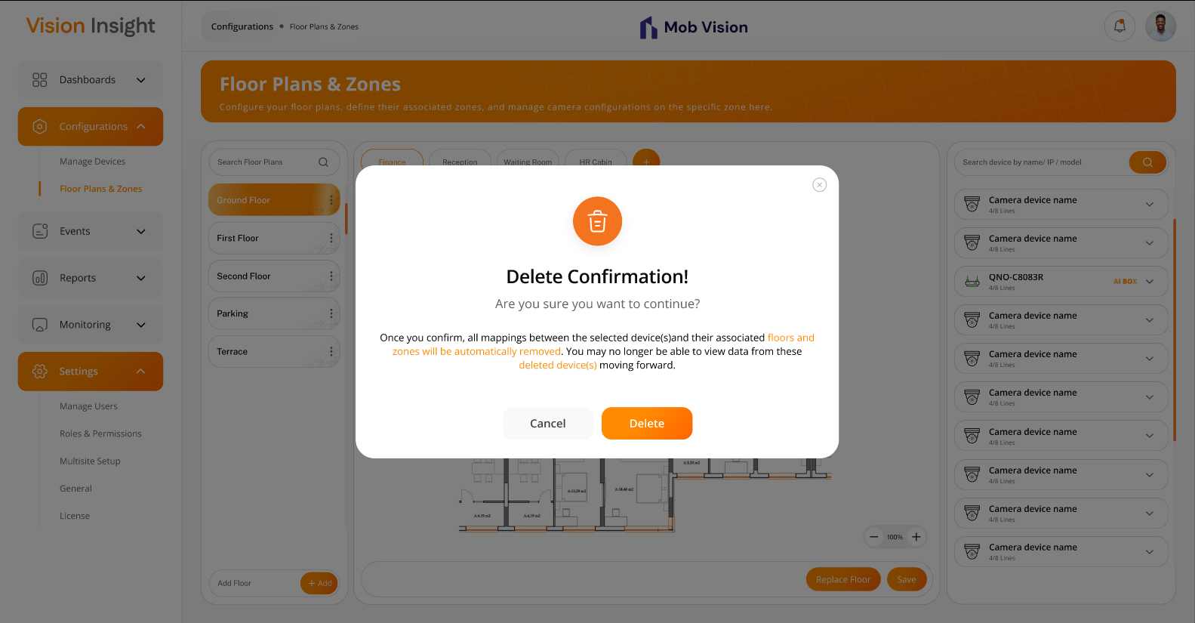

Business Rules:
- Authorized users will have the ability to add, update, and delete specific floor plans within the system.
- The system will display a confirmation popup with an appropriate message when a user attempts to delete a floor plan from the list:
  - Once the user confirms the prompt, the system will automatically delete all associated zones, unmapped their devices, and the user may no longer be able to view data from these deleted floor plans, zones, and mapped devices moving forward.
- Authorized users will also have the ability to add, update, and delete specific zones within the system.
- The system will display a confirmation popup with an appropriate message when a user attempts to delete a zone from the list:
  - Once confirmed, the system will automatically unmapped all configured devices, and the user may no longer be able to view data from these deleted zones and mapped devices.
- When a authorized users attempts to delete floor plans or zones along with their configured devices, the system will prompt for confirmation:
  - Once confirmed, the system will perform a soft delete, meaning the records will remain in the database but will no longer be visible in the web application.
- The system will prevent duplicate entries for floor plans and zones by validating their names.
- The “Add Floor Plan” and “Edit Floor Plan” features will include the following fields:
  - Floor Plan Name*
- The “Add Zone” and “Edit Zone” features will include the following fields:
  - Name*
  - People Occupancy*
    - Max Occupancy
    - Default Occupancy
  - Vehicle Occupancy*
    - Max Occupancy
    - Default Occupancy
- NOTE: Either "People Occupancy" or "Vehicle Occupancy" is a mandatory field - at least one must be provided.
- The asterisk (*) indicates a mandatory field only.
- NOTE: The system will automatically create a default Floor Plan and Zone when a user adds a single device for the first time or if the device is not yet assigned to any zone. By default, such devices will be assigned to this default Floor Plan and Zone.
- The system will provide authorized users the ability to view the list of added floor plans & their zones.
- The system will allow users to search for specific floor plan using Floor Plan Name only.
- The system will allow users to upload floor plan image with a maximum size of 10 MB, supporting only the following formats: .pdf, .jpg, .png, .jpeg, and .svg.
- The system should allow users to upload only single-page PDF files. If a file contains multiple pages, the system must reject it and display an appropriate error message.
- Authorized users will be able to Zoom-In and Zoom-Out on the uploaded floor plan image.
- Authorized users will have the option to replace the existing floor plan image by clicking on the “Replace Floor Plan” button.
- The system will display a list of online Camera / AI Box devices that are not yet configured in any zone.
- The camera / AI Box list will support data filtration for the following columns:
  - Camera Name
  - IP Address
  - Model Name
- Users will be allowed to configure an unlimited number of cameras within a specific zone (no limitation).
- Each configured camera will be exclusively associated with one specific zone.
- During real implementation, if the system fails to retrieve the model’s name of a camera connected to an AI Box, it should default to generic names like "Camera-1", "Camera-2", etc.
- Users will be able to drag a camera device from the device list and drop it onto a specific zone on the floor plan image.
- After dragging, users can move and position the camera within the zone as needed.
- Users can select a specific camera lane and map it to different zones within the same floor. However, when camera lanes are divided across multiple zones, the data counts will not be automatically synchronized across all zones, as discussed with Bala.
- Once a camera is placed, users will be able to select it and perform the following actions.
  - Choose between “Focal” or “Sphere” view and adjust its size up to 100%.
  - Select a color for the Focal or Sphere area.
  - Delete the selected camera from the zone.
  - Rotate the camera
  - Save all changes to the database by clicking the “Save Changes” button.]

Floor Plans and Zones Permissions:
- The system will maintain permissions at the Floor Plan and Zone levels only.
- It will be the responsibility of the admin user (who configures the application, users, and user permissions) to assign appropriate permissions for specific floor plans and zones to each user role, especially in cases where a single camera is configured in multiple zones.
- As per Bala’s request, the system will not handle this scenario automatically.
- The system will display information strictly based on the assigned permissions at the Zone and Floor plan levels.

Data Dictionary:

Events > Event Logs Page

The system provides a feature for Super Admin and authorized users to view the details of all detected events through the BI Dashboard Web Application.

This page will be accessible only to Super Admin and authorized users, with actions such as acknowledging events and viewing pre- and post-5-second videos, based on the permissions assigned to the logged-in user.

Prototype:

- The screen below illustrates the list of all detected events, including options for searching using filters, acknowledging specific events, and an icon to view the pre- and post-5-second video clips:
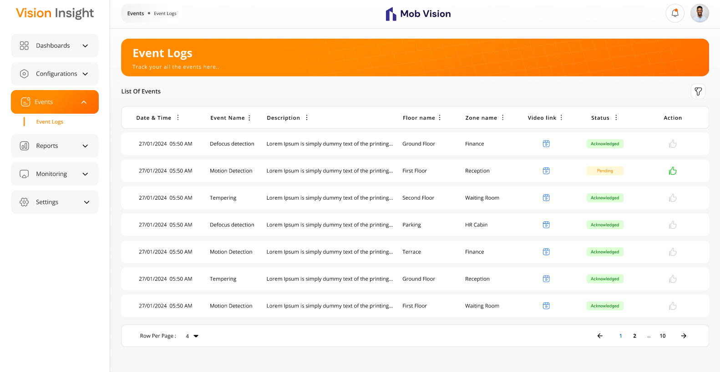
- The screen below illustrates the filter options:
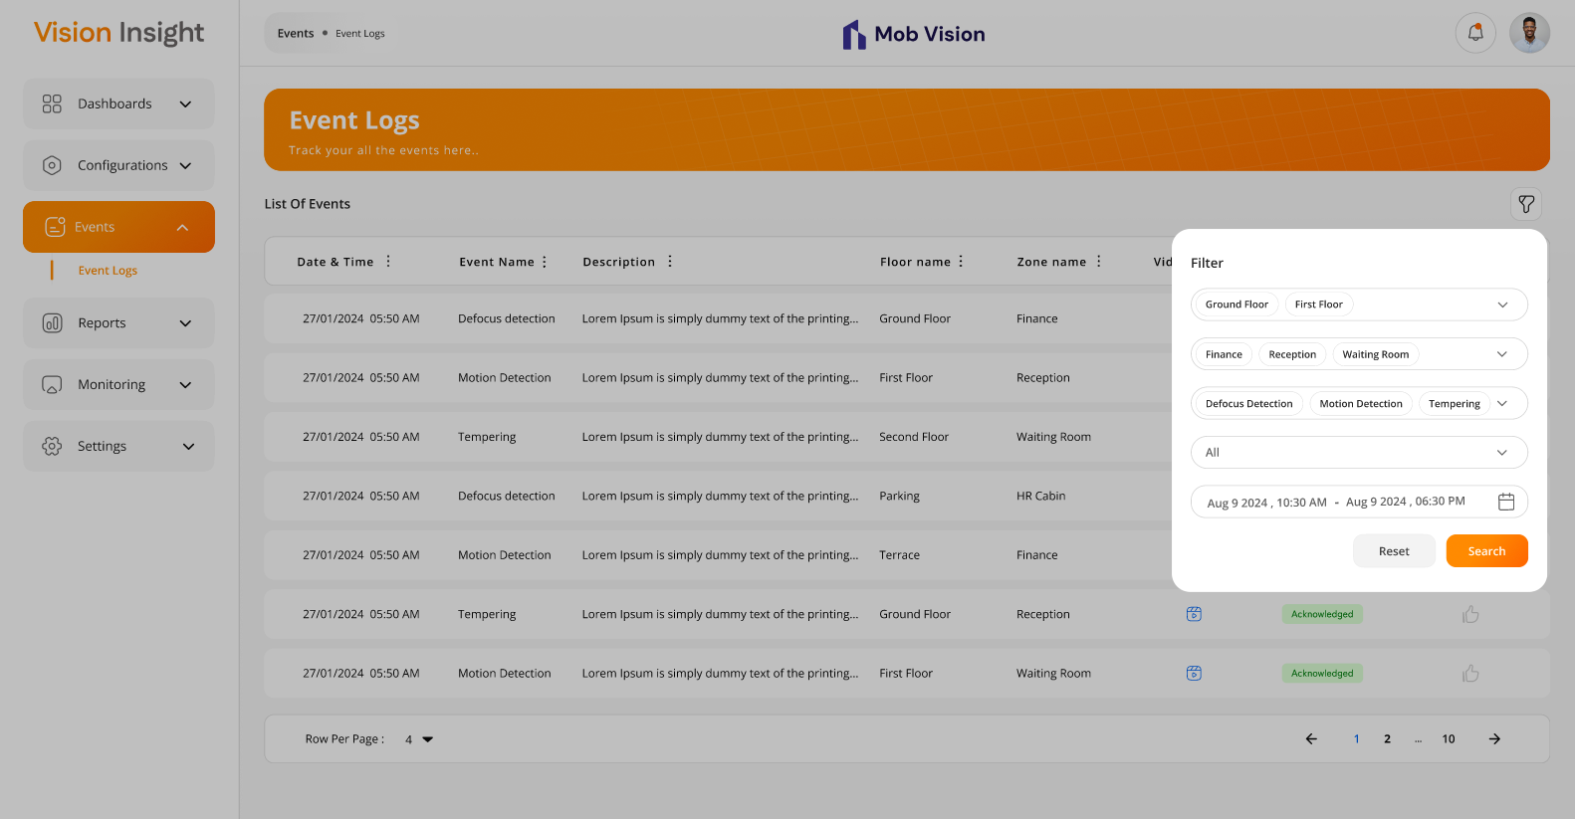

- The screen below illustrates the view for the pre- and post-5-second video clips:
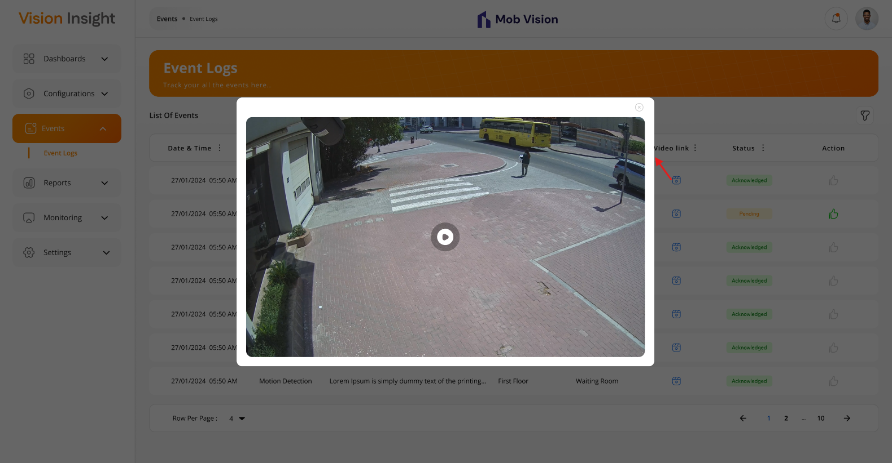

Business Rules:
- Authorized users will be able to view all the detected events on this page.
- Events will be displayed in descending order by default based on the created time in the database.
- The list will be displayed with the following columns:
  - Date & Time
  - Event Name
  - Description
  - Floor Name
  - Zone Name
  - Video Link
  - Status (Acknowledged / Pending)
  - Action (to acknowledge the event, if it is still pending to acknowledge)
- The system will offer filter options (like Sort By ASC, Sort by DESC, Filter, Hide Column, Manage Columns) on specific columns using the MUI library, which is integrated into the entire web application. These filters will reset when the user reloads the page or navigates to another page.
- Pagination will be applied to the list so that users can navigate to any page and check specific events.
- Authorized users will be able to filter the data by the following:
  - Event Name
  - From Date – To Date (Date Range)
  - Floor Name (Dropdown List)
  - Zone Name (Dropdown List)
  - Status (Acknowledged / Pending) (Dropdown List)
- The system will allow authorized users to acknowledge events that are still pending acknowledgment.
- The system will display an appropriate message to the user when an event is acknowledged.
- Authorized users will be able to view pre- and post-5-second videos by clicking on the video icon.
- The camera must store all event videos exclusively on the FTP server, with no local or alternative storage as BI Dashboard Web Application will always stream the video from the configured FTP server only.
- The system will open a popup when users click on the above option to view the video.

Data Dictionary:

Reports > My Reports Page

The system provides a feature for Super Admin and authorized users to manage reports by selecting from predefined report templates while adding them to the list through the BI Dashboard Web Application.

This page will be accessible only to Super Admin and authorized users, with actions such as add, edit, delete, and export reports as PDF, based on the permissions assigned to the logged-in user.

Prototype:
- The screen below illustrates first landing page with appropriate message & action to add new report when there is no any report yet configured in the system:
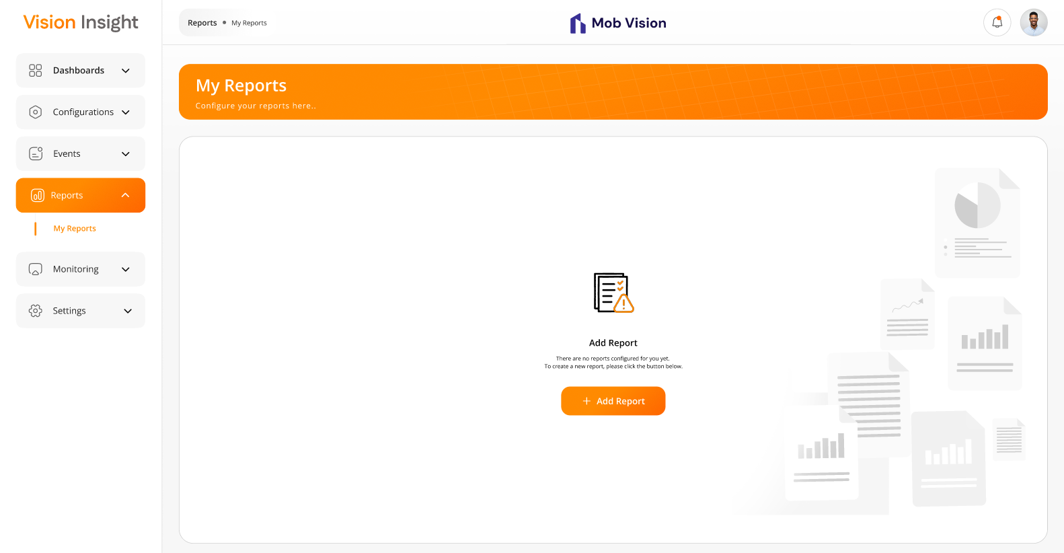
- The screen below represents the report creation form, allowing users to enter relevant details and submit the information to create a new report:
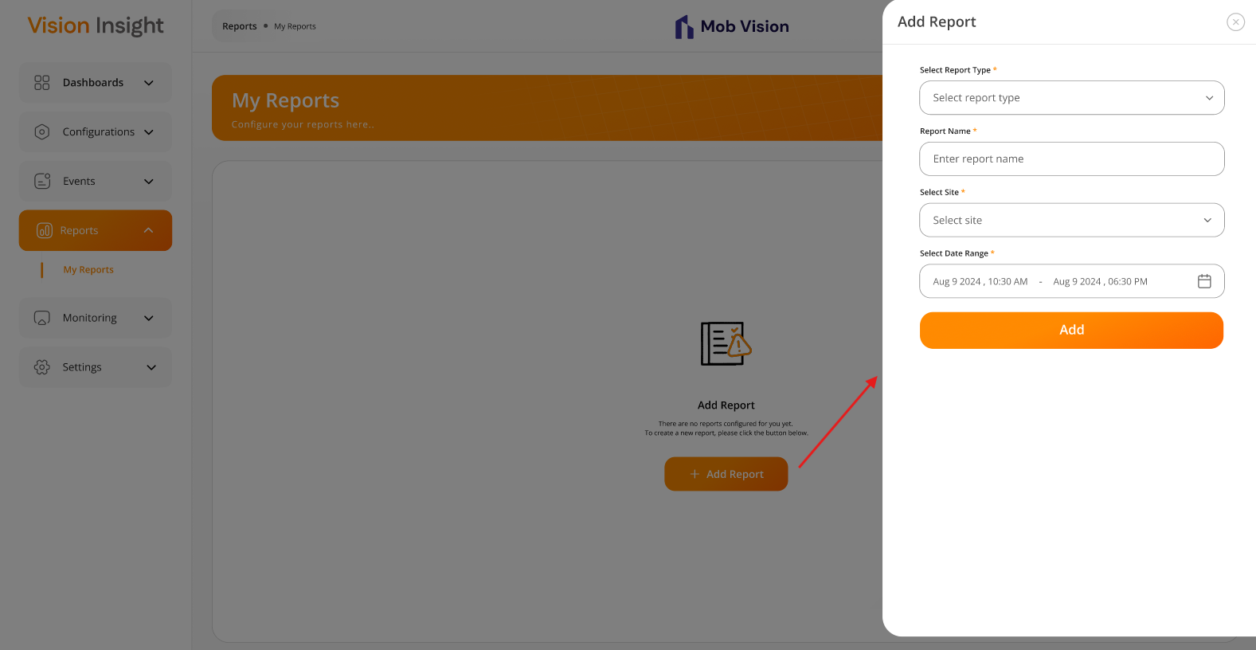
- The screen below displays the "Site Performance Comparison Report" page, featuring options to Edit, Delete, and Export as PDF. Users can scroll through the page to view the entire report, including predefined charts:
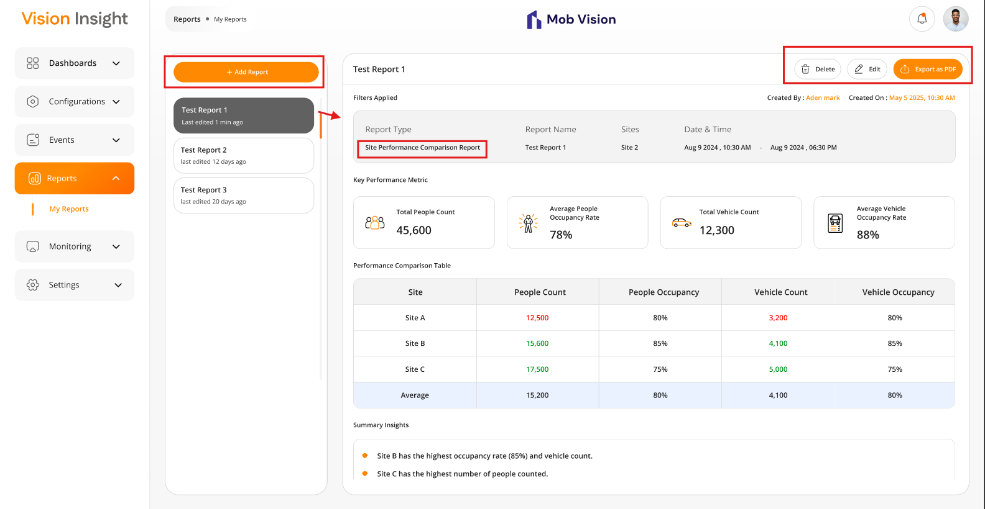
- The screen below displays the "Zone Performance Comparison Report" page, featuring options to Edit, Delete, and Export as PDF. Users can scroll through the page to view the entire report, including predefined charts:
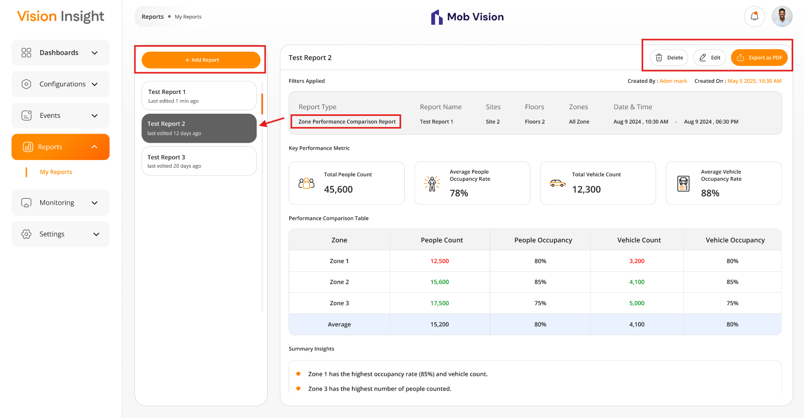

- The screen below displays the form for editing an existing report, allowing users to modify relevant details and update the information:
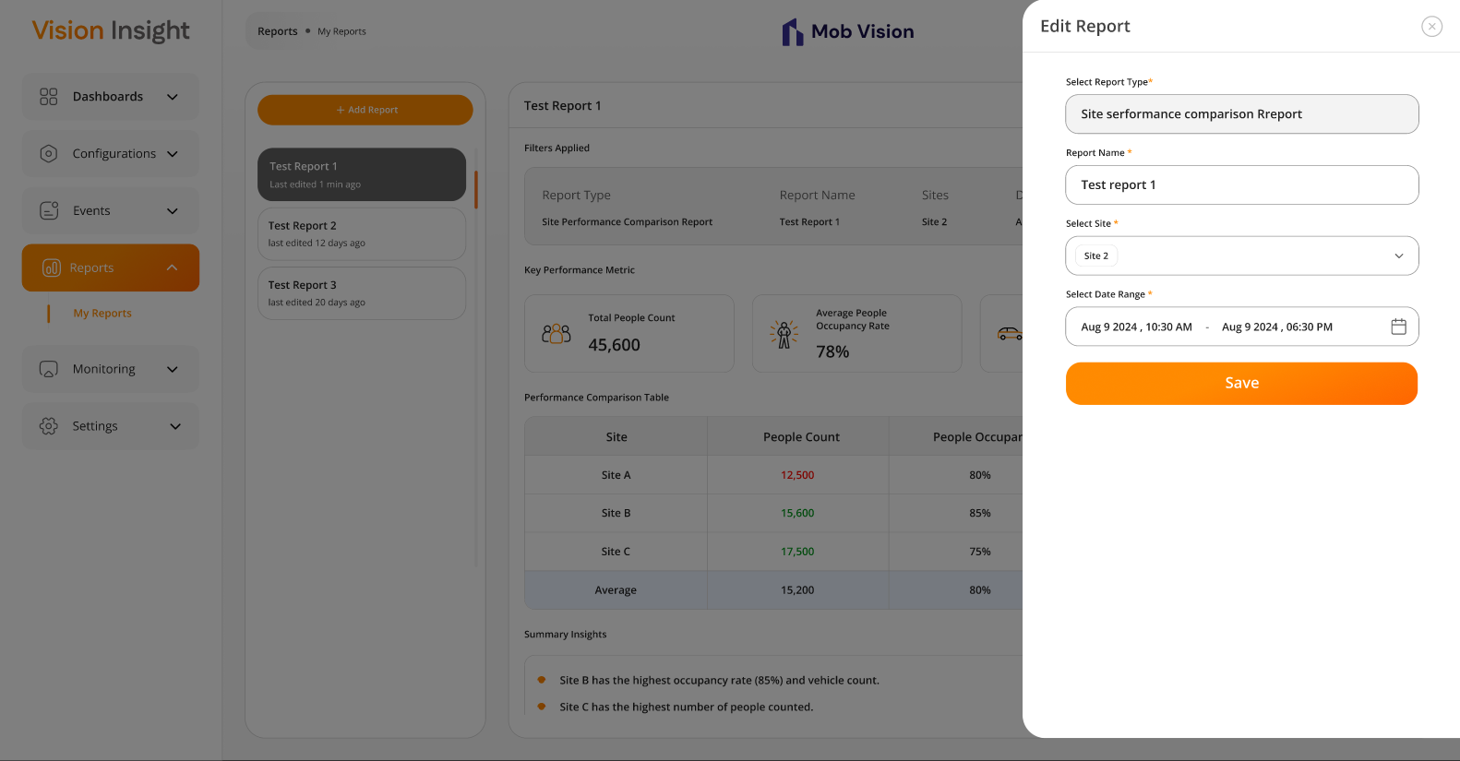

Business Rules:
- Authorized users will be able to add, edit, and delete specific configured reports from the list.
- The system will display a blank screen with the following message when no reports are configured yet:
“There are no reports configured for you yet. To create a new report, please click the button below”
- Users will have the option to add a new report by clicking on the “Add Report” button on the above screen.
- The authorized user can configure a new “Site Performance Comparison Report” by providing the following required information:
  - Select Report Type* (e.g., Site Performance Comparison)
  - Report Name* (custom input by user)
  - Select Site* (sites to be compared)
  - Select Date Range*
- The authorized user can configure a new “Zone Performance Comparison Report” by providing the following required information:
  - Select Report Type* (e.g., Zone Performance Comparison Report)
  - Report Name* (custom input by user)
  - Select Site* (sites to be compared, single selection)
  - Select Floor*
  - Select Zone*
  - Select Date Range*
- The asterisk (*) indicates a mandatory field only.
- Authorized users will be able to view all configured reports in the list.
- Each report will allow users to Edit, Delete, and Export as PDF.
- When an authorized user attempts to delete a report, the system will prompt for confirmation:
  - Upon confirmation, the system will perform a soft delete (the record remains in the database but is hidden in the application).
- When an authorized user selects “Export as PDF”, the system will download the report in PDF format.
- The “Site Performance Comparison Report” will contain the following information:
  - Title (user-defined report name)
  - Created By & Created On
  - Filters Applied:
    - Report Type
    - Report Name
    - Sites
    - Date & Time
  - Key Performance Matric
    - Total People Count
    - Average People Occupancy Rate
    - Total Vehicle Count
    - Average Vehicle Occupancy Rate
  - Performance Comparison Table
    - Site (name of the sites)
    - People Count
    - People Occupancy
    - Vehicle Count
    - Vehicle Occupancy
    - Average of “People Count, People Occupancy, Vehicle Count, Vehicle Occupancy”
  - Summary Insights
    - Bullet-point summary to provide clear comparison highlights.
  - Visualizations
    - It will display following Charts:
      - People & Vehicle Counts by Site
      - Occupancy Rate Comparison
      - Traffic Composition (Peoples vs Vehicles)
- The “Zone Performance Comparison Report” will contain the following information:
  - Title (user-defined report name)
  - Created By & Created On
  - Filters Applied
    - Report Type
    - Report Name
    - Sites
    - Floors
    - Zones
    - Date & Time
  - Key Performance Matric
    - Total People Count
    - Average People Occupancy Rate
    - Total Vehicle Count
    - Average Vehicle Occupancy Rate
  - Performance Comparison Table
    - Zone (name of the zones)
    - People Count
    - People Occupancy
    - Vehicle Count
    - Vehicle Occupancy
    - Average of “People Count, People Occupancy, Vehicle Count, Vehicle Occupancy”
  - Summary Insights
    - Bullet-point summary to provide clear comparison highlights.
  - Visualizations
    - It will display following Charts:
      - People & Vehicle Counts by Site
      - Occupancy Rate Comparison
      - Traffic Composition (Peoples vs Vehicles)
- Authorized users can add any number of reports using the same report type.
- The system will prevent duplicate entries using the same report name.

Data Dictionary:

Monitoring > Monitoring Page

The system provides a feature for users to manage and configure one or multiple monitoring setups through the BI Dashboard Web Application.

This page will be accessible only to Super Admin and authorized users, with actions such as add, update, and delete for:
- Monitoring
- Groups
- URL Previews (Poles)

Authorized users can configure any number of monitoring entries based on their operational needs and the permissions assigned to their user account.

Prototype:
- The screen below illustrates first landing page with appropriate message & action to add new group for the specific monitoring when there is no any group yet configured in the specific monitoring:
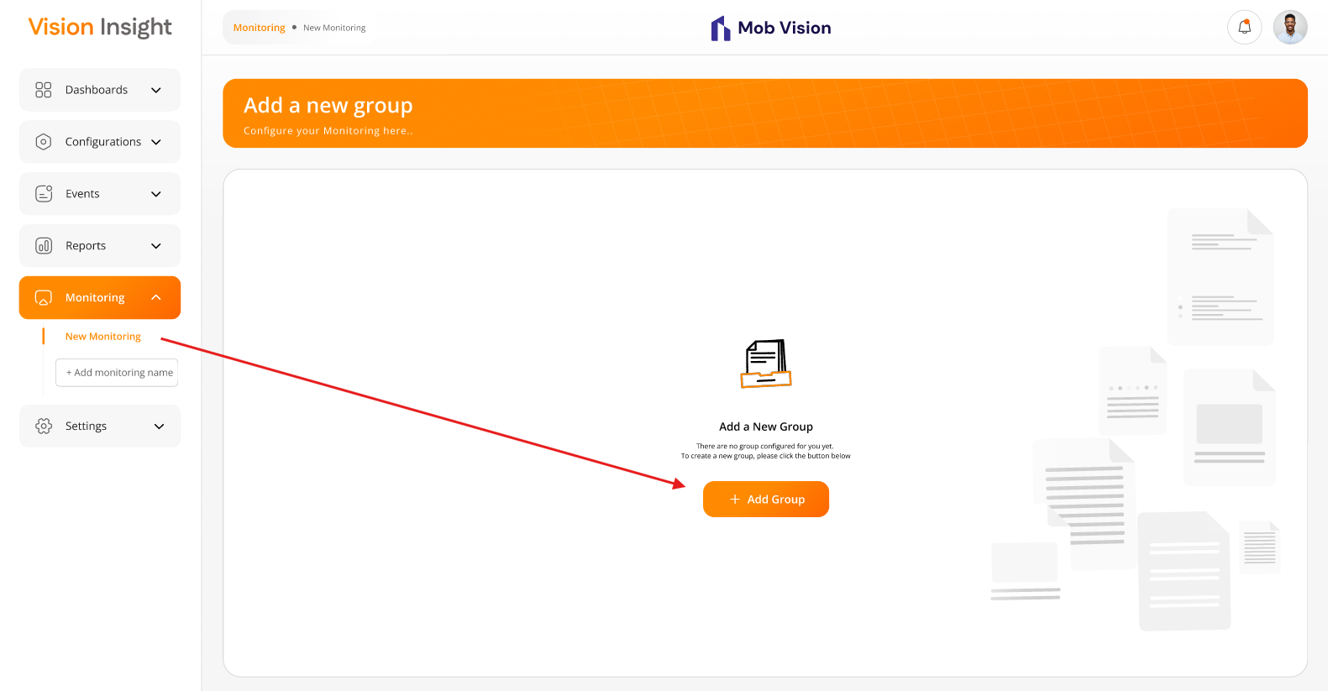

- The screen below illustrates the list of created groups along with their URL previews (Poles), including options to Add, Edit, and Delete them:
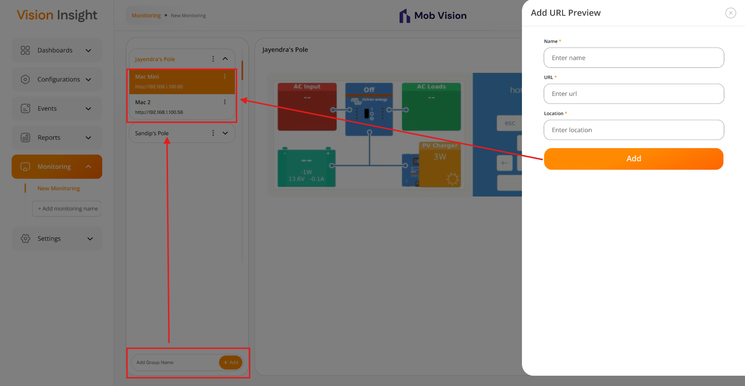
- The added URL preview will be displayed only within the highlighted area shown below:
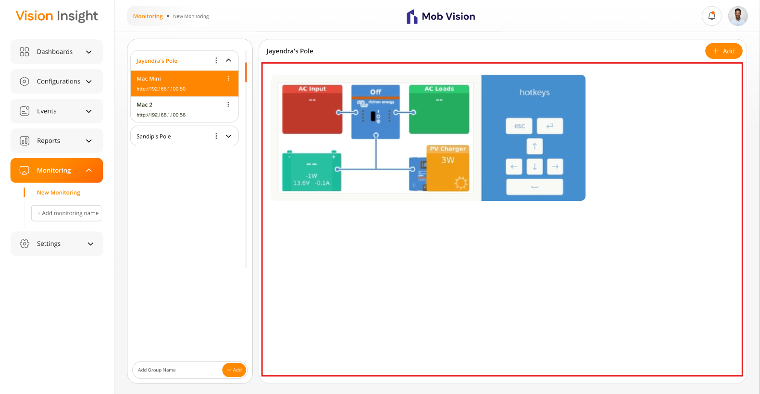

Business Rules:
- The system will display a blank screen with the following message when no groups are configured yet:
“There are no group configured for you yet. To create a new group, please click the button below”
- Users will have the option to add a new group by clicking on the “Add Group” button on the above screen.
- Authorized users will be able to add, edit, and delete any number of monitoring from the main side menu of the application by providing the name of the monitoring.
- Inside the above-added monitoring, users will be able to add, edit, and delete any number of groups by providing the name of the group only.
- Under each group, users will be able to add, edit, and delete any number of URL Preview (Pole) by providing the following fields:
  - Name of the URL preview*
  - URL* (the URL of the web page, which will get embedded into an iframe)
  - Location*
- The asterisk (*) indicates a mandatory field only.
- The system will prevent duplicate entries for the “URL Preview” using the same Name & URL combination.
- The provided URL while adding or updating “URL Preview (Pole)” will be directly embedded into an iframe, and whatever user interface is available at the added URL will be displayed on the screen directly.
- The added/provided URL will always be accessible from the BI Dashboard Web Application. If it is not accessible, the system will not handle such scenarios.
- The system will prevent duplicate entries using the same Monitoring and Group name.

Data Dictionary:

Dashboards > Dashboard Creation

The system provides a feature for authorized users to manage and configure one or multiple dashboards through the BI Dashboard Web Application.

This page will be accessible only to authorized users, with actions such as add, update, and delete dashboards, based on the permissions assigned on the widget to the logged-in user.

Authorized users can configure any number of dashboards based on their requirements and the permissions assigned to them on the widgets.

Prototype:
- The screen below illustrates first landing page with appropriate message & action to add new widget for the specific dashboard when there is no any widget yet configured in the specific dashbaord:
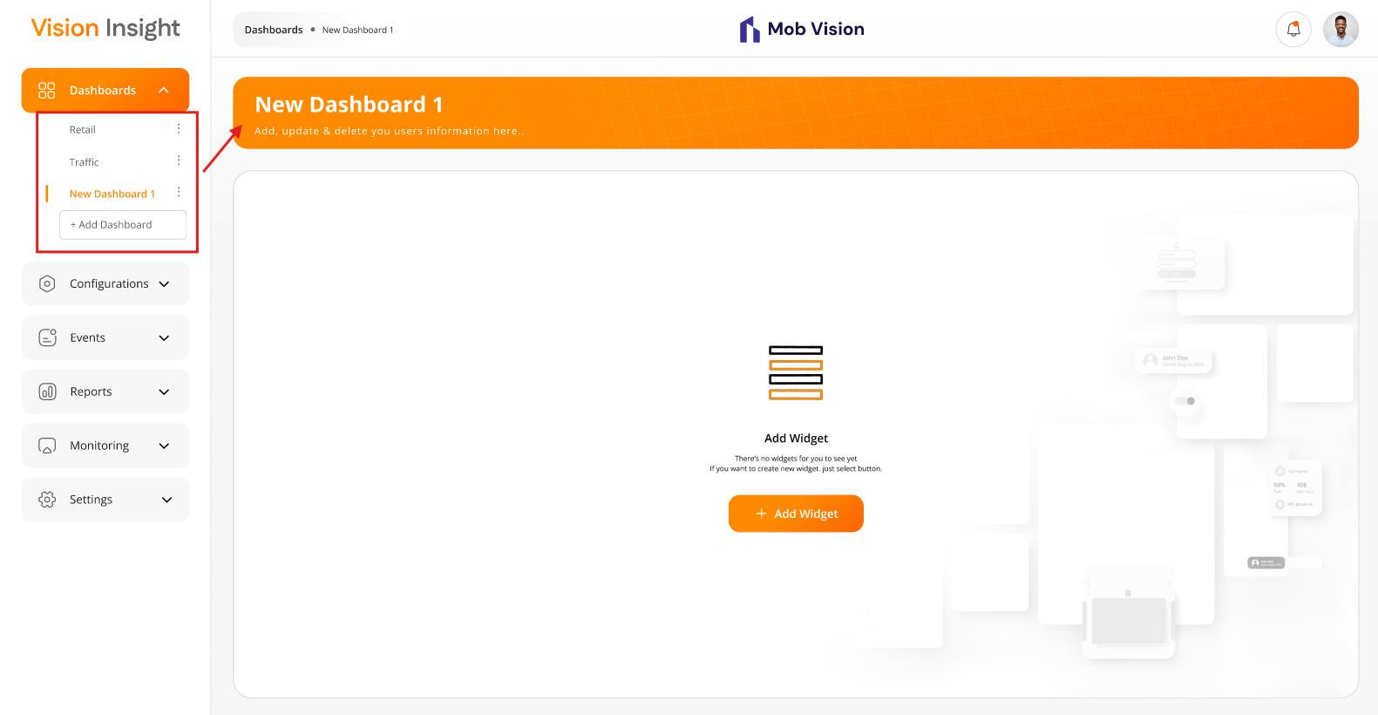

Business Rules:
- Authorized users will be able to add, update, and delete any number of dashboards by providing name of the dashboard.
- The system will prevent duplicate entries for the added dashboards using the same Name.
- The system will allow users to enter characters only in the dashboard name field. It is a mandatory field while adding or updating the dashboard name.

Data Dictionary:

Dashboards > Dashboard Page > Add Widget Screen

The system provides a feature for authorized users to manage and add one or multiple widgets under the specific dashboard through the BI Dashboard Web Application.

Authorized users can select & add any number of widgets from the “Add Widget” screen based on their requirements and the permissions assigned to them.

Prototype:
- The screen below illustrates the flow of adding new widget(s) to a specific dashboard. Users can select any category and choose any number of widgets to add:
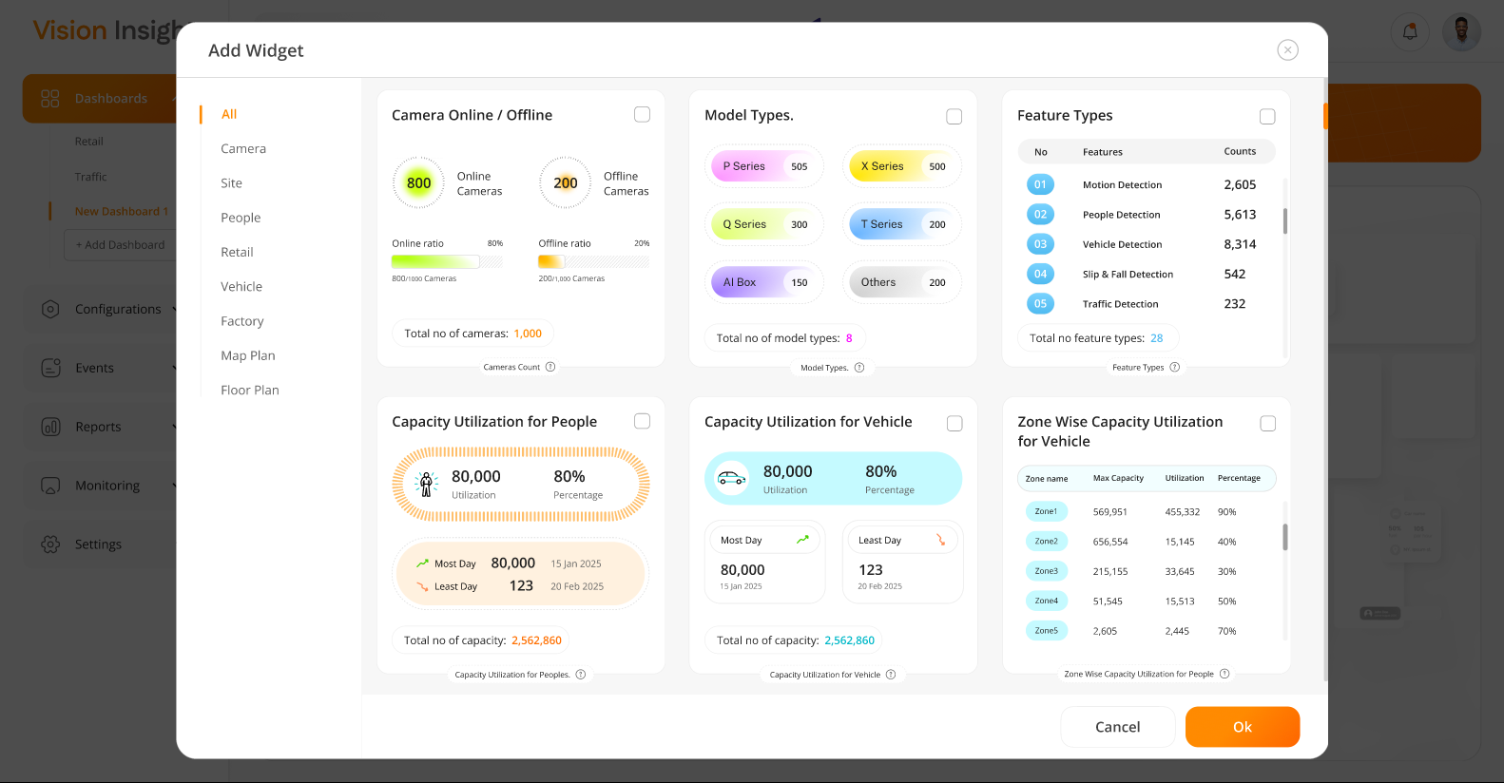
- The screen below illustrates the second option to add a new widget(s) to a specific dashboard:
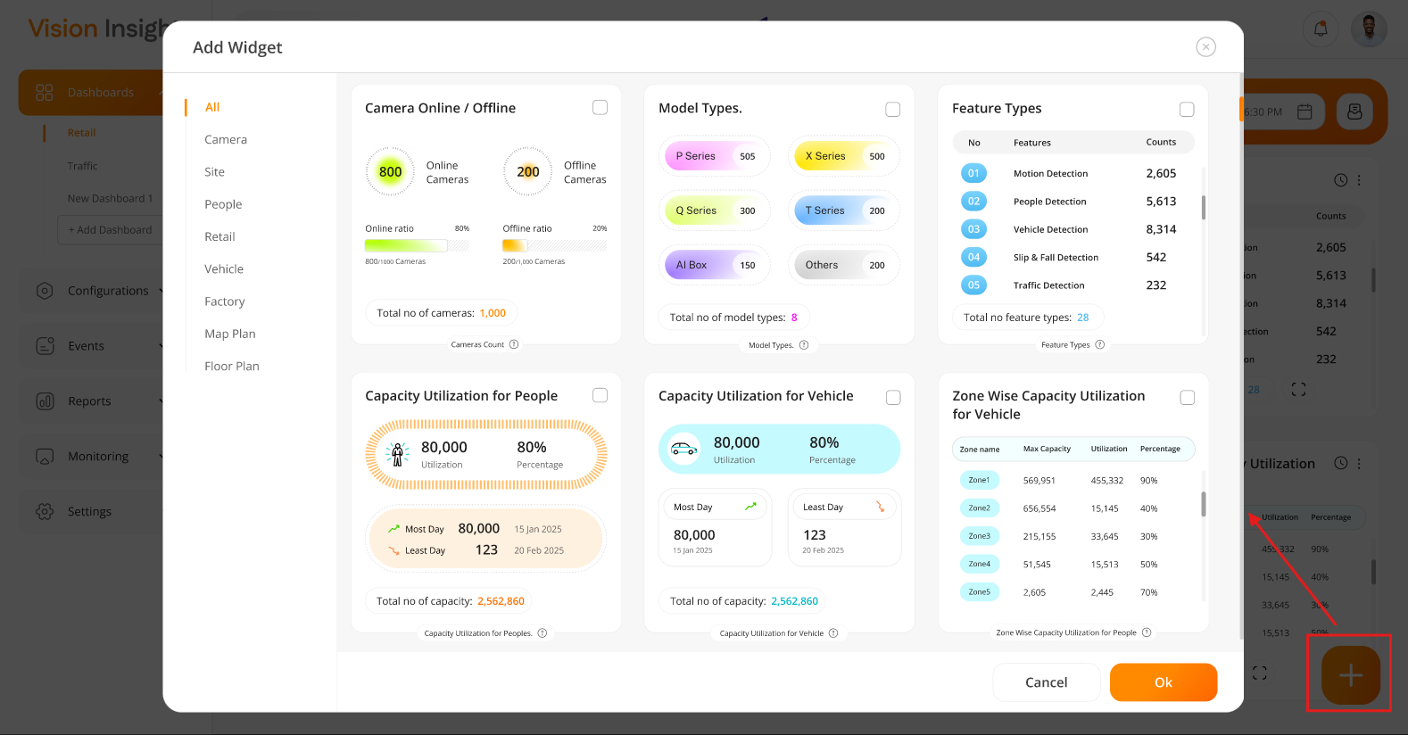

Business Rules:
- Authorized users will be able to add any number of widgets from the “Add Widget” popup.
- The system will prevent duplicate entries for the added widget under any specific dashboard. It means, users will be able to select & add any widgets at a single time under the specific dashboard only, because the added widget will not appear under the “Add Widget” screen again for that dashboard.
- The system will allow users to add the same widget(s) under other dashboards.
- The system will provide this option at two places.
  - From the blank screen when there are no widgets configured yet.
  - From the “+” button at the bottom-right corner, when any widget is already configured on the specific dashboard.
- When there are no widgets configured/added on the dashboard, the system will display a blank screen with the following message:
“There are no widgets for you to see yet. If you want to create new widget, just select button”
- When user clicks on “Add Widget” button, the system will open a popup, and users will be able to see the list of different categories as a left side menu.
- Under this left side menu, users will be able to click on any category, and each category will display their associated widgets on the right-hand side.
- By default, “All” category will be selected under the left side category menu, and it will display all widgets available in the system, regardless of their category.
- The following categories & their associated widgets will be displayed:
  - All
    - All widgets will be displayed under this category, regardless of their actual category.
  - Camera
    - Camera Online/ Offline
    - Model Types
    - Feature Types
  - Site
    - Capacity Utilization for People
    - Capacity Utilization for Vehicle
    - Zone Wise Capacity Utilization for Vehicle
    - Zone Wise Capacity Utilization for People
  - People
    - Slip & Fall Detection
    - People In & Out
    - Average People Counting
    - People Count by Gender
    - Cumulative People Count
    - New Vs Total Visitors
    - Safety Measures
    - Zone Wise People Counting
  - Retail
    - Shopping Cart Counting
    - Queue Events for Shopping Cart
    - Queue Events for People
    - Shopping Cart Heatmap
    - Block Exit Detection
  - Vehicle
    - Vehicle Count by Type
    - Vehicle in Wrong Direction
    - Vehicle U Turn Detection
    - Pedestrian Detection
    - Vehicle In & Out
    - Average Vehicle Counting
    - Vehicle Queue Analysis
    - Stopped Vehicle Count Time
    - Vehicle Turning Movement Counts
    - Vehicle Detection Heatmap
    - Speed Violation by Vehicle
    - Traffic Jam by Day
  - Factory
    - Counting for Forklift
    - Queue Events for Forklift
    - Detected Forklifts
    - Forklift Heatmap
    - Block Exit Detection
    - Forklift Speed Detection
  - Map Plan
    - Map Plan
  - Floor Plan
    - Floor Plan
- The system will allow authorized users to select/unselect any number of widgets from this popup and under any category.
- All the selected widgets will be displayed on the specific dashboard from where the user tried to add new widgets.
- The system will provide a “Delete” option under each widget configured on the specific dashboard.
- Once user clicks on the “Delete” option, the system will display a confirmation popup, and once confirmed, that widget will be permanently deleted from the specific dashboard.

Data Dictionary:

- The system will utilize below highlighted column in the dashboardPreference table:

Dashboards > Dashboard Page > Filters & Export Option

The system provides a feature for authorized users to manage or apply the Floors, Zones, and Date & Time Range filters under the specific dashboard through the BI Dashboard Web Application.

The system will retrieve and display data in all the configured widgets based on the applied filters only.

The system will also provide an option to export your report in the .pdf and .csv format.

Prototype:
- The screen below illustrates the options for Floors, Zones, Date & Time range filters, along with the ability to export your report. These options become available on each newly created dashboard and will be visible once the user adds at least one widget to the specific dashboard:
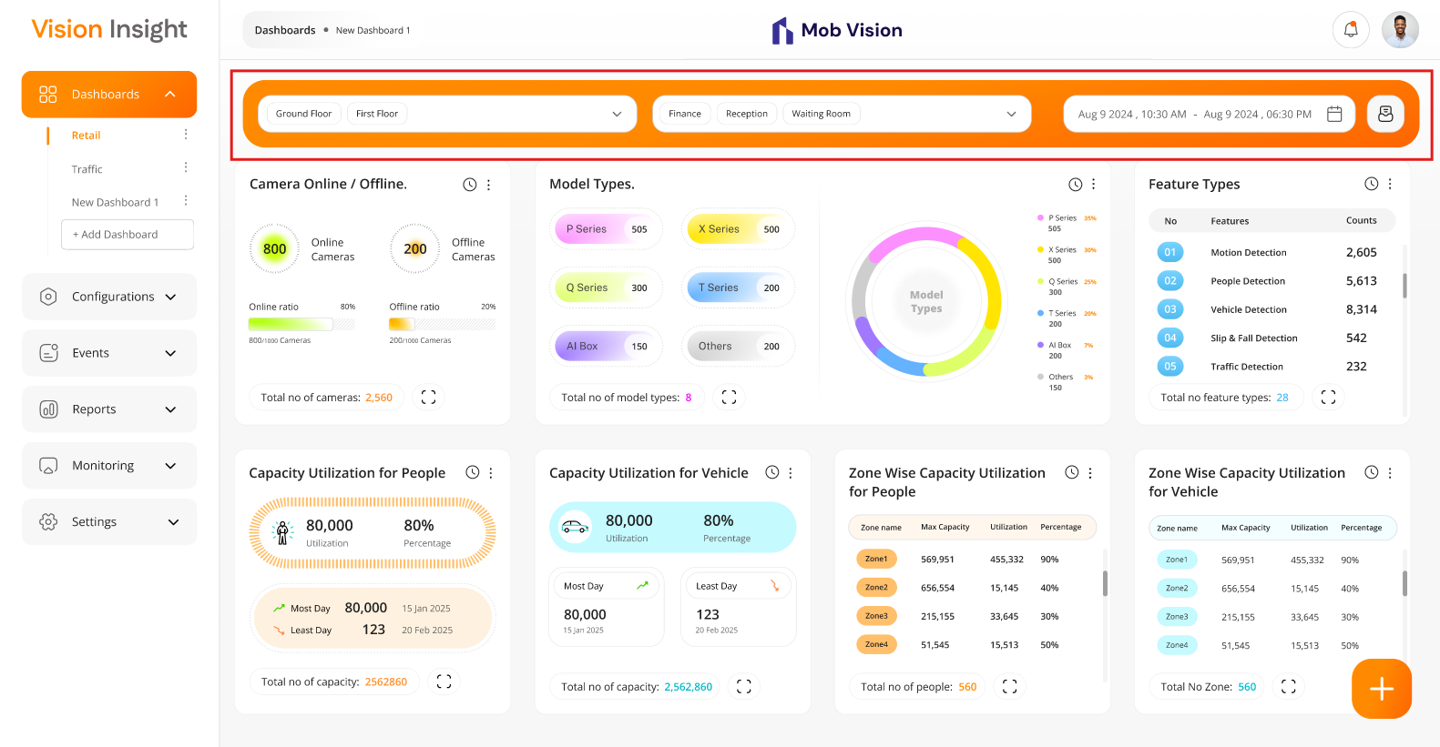
- The screen below illustrates the export report option, allowing users to select a specific widget configured on the dashboard or choose “All” to export a report for all configured widgets. Reports can be exported in PDF or CSV format:
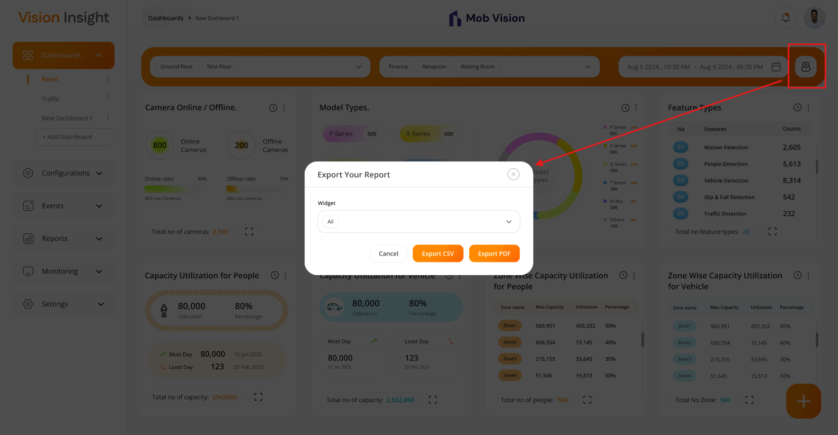

Business Rules:
- The system will provide following filter options on each dashboard once the users will add any single widget on the dashboard:
  - Floors
    - Multi select dropdown list, The users can select one or more floors from this dropdown list.
    - By default, default floor will be selected.
  - Zones
    - Multi select dropdown list, The users can select one or more floors from this dropdown list.
  - Date & Time Range
    - Allow users to select any range from date & time picker, along with following options:
      - Today, Yesterday, Two day ago, 7 Days, 1 Month, 3 Months, 6 Months, 1 Year.
- Authorized users will be able to apply any of the above filters & the system will render the data accordingly for all the configured / added widgets on that dashboard.
- The system will select following filters by default when user has not applied any filters, reloaded the page or redirected to the page:
  - Default Floor will be selected
  - Default Zone will be selected
  - Today’s date & time will be selected
- The system will not store applied filters in the database. It will store those applied filters in the local storage of the browser page.
- The data for the local storage will be removed once the user reload the page manually or close the browser window

Export Your Report Option:
- The system will allow authorized users to access this option.
- Once user clicks on the export icon located at top right-hand side of the specific dashboard, the system will open popup screen.
- The above-mentioned popup screen will provide following options:
  - Selection of Widgets (which are added on the specific dashboard only, non-mandatory field)
  - Export CSV
  - Export PDF
- The users will be able to select specific widget, and the system will export the report as CSV / PDF for the selected widgets only.
- If users have not selected any widget from the dropdown list, the system will export report as CSV / PDF for all the widgets which are added on the specific dashboard.
- The CSV will include following information in the exported report:
  - Exported By
  - Exported On (Date & Time)
  - Selected Date Range & Time
  - Data of all the selected widgets with whatever filters they have applied on the specific widget & showcased on the specific dashboard
- The PDF will include following information in the exported report:
  - Logo of the Vision Insight / company logo
  - Exported By
  - Exported On (Date & Time)
  - Selected Date Range & Time
  - Images of all the selected widgets with whatever filters they have applied on the specific widget & showcased on the specific dashboard.

Data Dictionary:

- The system utilizes the floorPlanMaster and zoneMaster tables to display the list of floors and zones in the filters mentioned above. These represent the user-defined floor plans and zones created manually within the system.

Dashboards > Dashboard Page > Widgets

The system provides a feature for authorized users to manage up to 39 widgets on the specific dashboard through the BI Dashboard Web Application.

The system will retrieve and display data in all the configured widgets based on the applied filters only.

The system will allow users to configure only those widgets which are assigned to them & it will only be displayed based on the given permission from the “Roles & Permissions” screen.

Prototype:
- The system will provide following 39 widgets:

  - Camera Online/ Offline Widget:
- This report will display counts & their ratio for total camera online & offline.
- It will be generated from the configured camera in the system only.
- It will provide only two charts with 2*1 option. By default, the system will display 1*1 only.
- Pleased find the attached screenshot below for your reference:
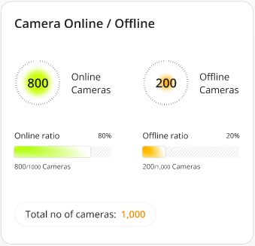
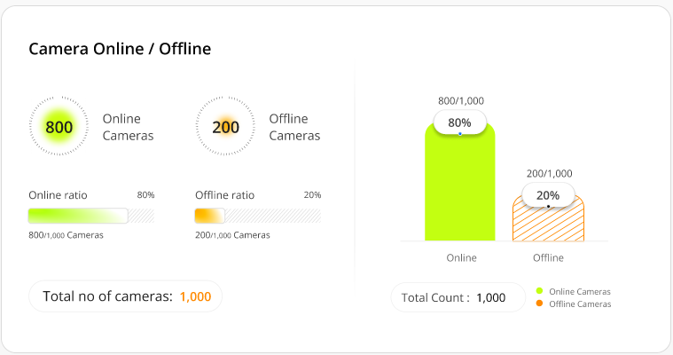

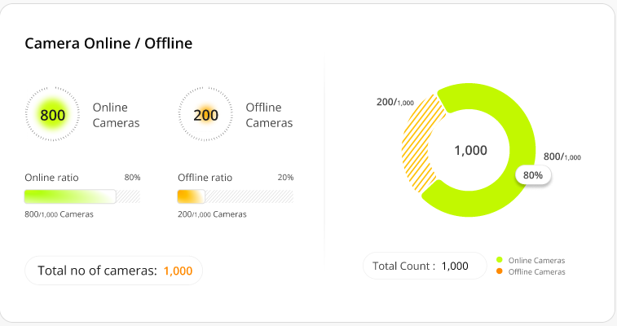
  - Model Types:
- This report will display counts configured cameras in the specific camera series.
- It will be generated from the configured camera in the system only.
- It will provide only two charts with 2*1 option. By default, the system will display 1*1 only.
- Pleased find the attached screenshot below for your reference:
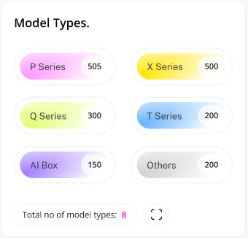
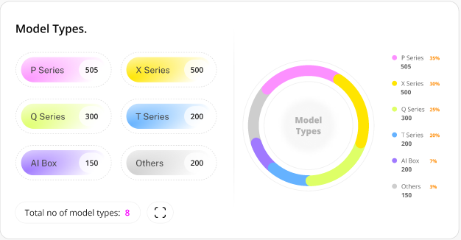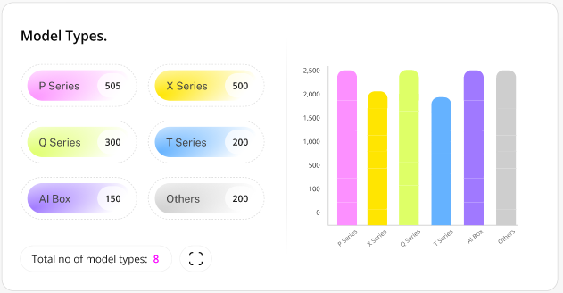

  - Feature Types:
- This report will display counts configured cameras with specific camera features.
- It will be generated from the configured camera in the system only.
- It will provide only two charts with 2*1 option. By default, the system will display 1*1 only.
- Pleased find the attached screenshot below for your reference:
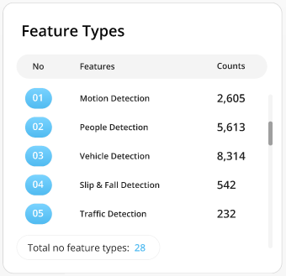
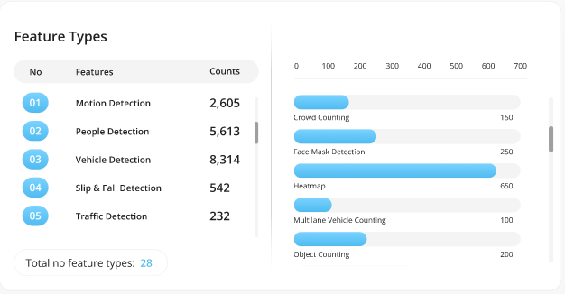
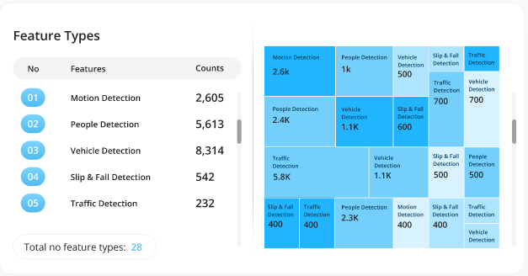
  - Capacity Utilization for People:
- This report will display the total capacity, percentage of total utilization, as well as the most and least utilized day along with the corresponding people counts.
- It will be generated from the configured camera in the system only.
- It will provide only 3 charts with 2*1 option. By default, the system will display 1*1 only.
- Pleased find the attached screenshot below for your reference:
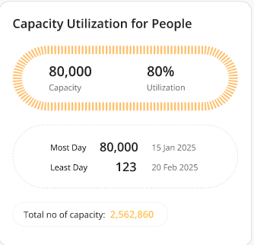
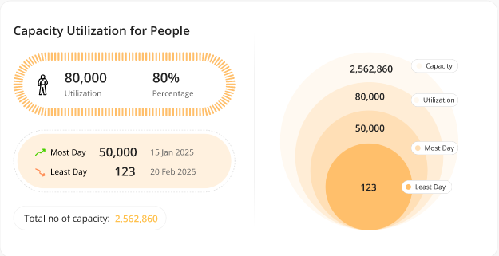
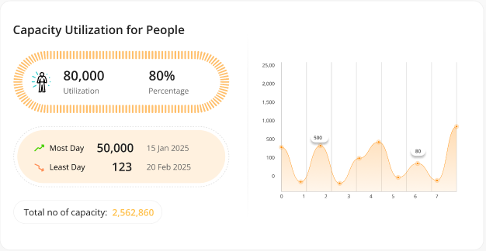
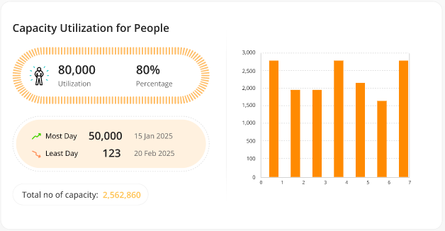
  - Capacity Utilization for Vehicle:
- This report will display the total capacity, percentage of total utilization, as well as the most and least utilized day along with the corresponding vehicle counts.
- It will be generated from the configured camera in the system only.
- It will provide only 3 charts with 2*1 option. By default, the system will display 1*1 only.
- Pleased find the attached screenshot below for your reference:
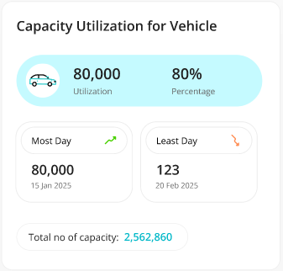
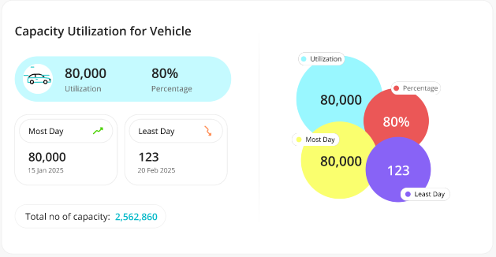
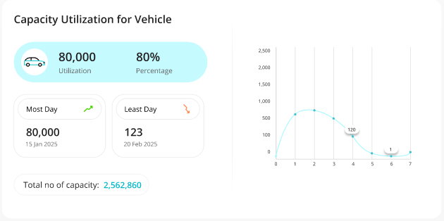
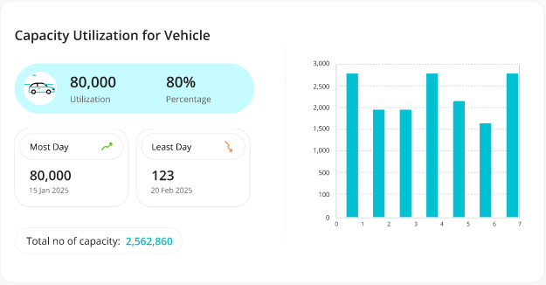
  - Zone Wise Capacity Utilization for People:
- This report will display the zone wise max capacity, utilization counts & their percentages for the peoples.
- It will be generated from the configured camera in the system only.
- It will provide only 3 charts with 2*1 option. By default, the system will display 1*1 only.
- Pleased find the attached screenshot below for your reference:
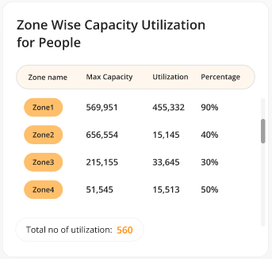
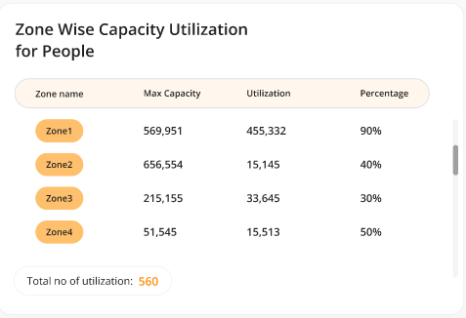
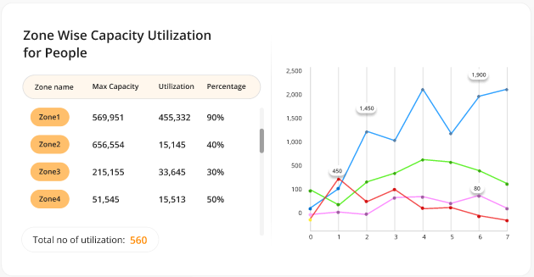
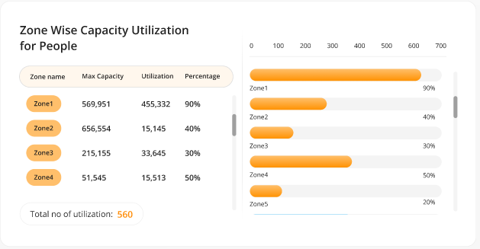
  - Zone Wise Capacity Utilization for Vehicle:
- This report will display the zone wise max capacity, utilization counts & their percentages for the vehicles.
- It will be generated from the configured camera in the system only.
- It will provide only 3 charts with 2*1 option. By default, the system will display 1*1 only.
- Pleased find the attached screenshot below for your reference:
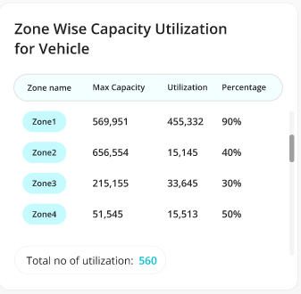
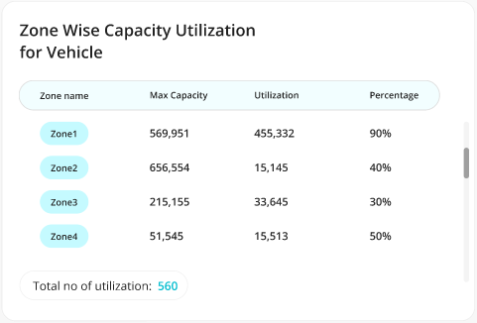
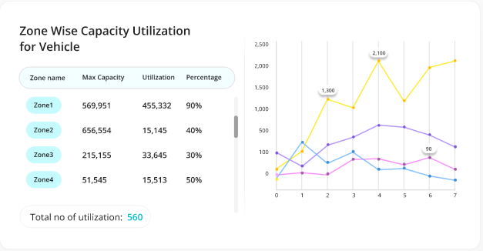
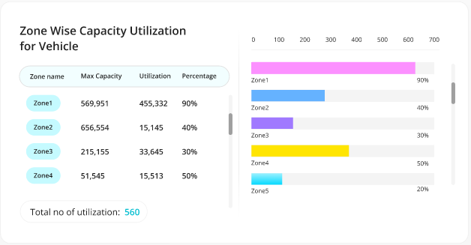
  - People In & Out:
- This report will display counts of total people IN & OUT.
- The setup page will provide the ability to select the specific camera & system will reflect the data accordingly on the dashboard.
- It will be generated from the configured camera in the system only.
- It will provide only 3 charts with 2*1 option. By default, the system will display 1*1 only.
- Pleased find the attached screenshot below for your reference:
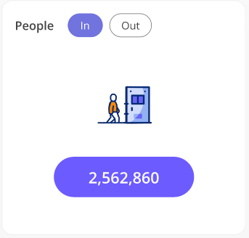
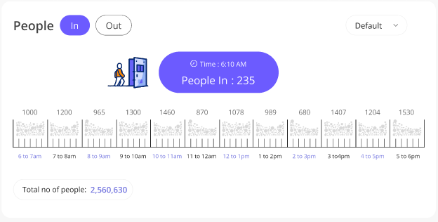
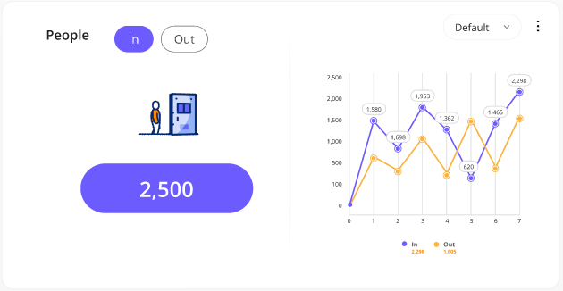
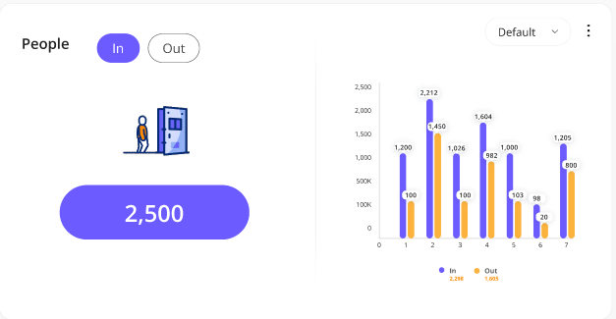
  - Average People Counting:
- This report will display counts of total average people incoming & outgoing with their Most & Least day and counts.
- It will be generated from the configured camera in the system only.
- It will provide only two charts with 2*1 option & 1 chart with 3*1 option. By default, the system will display 1*1 only.
- Pleased find the attached screenshot below for your reference:
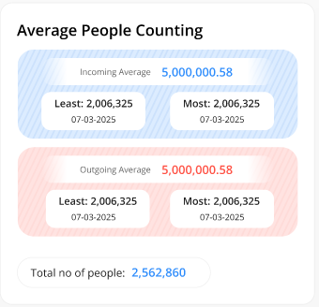
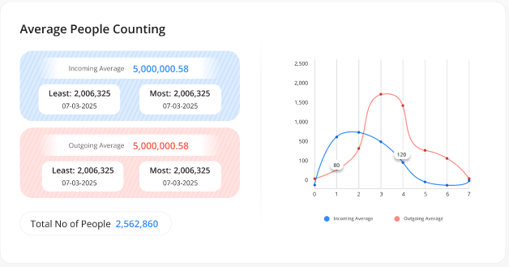
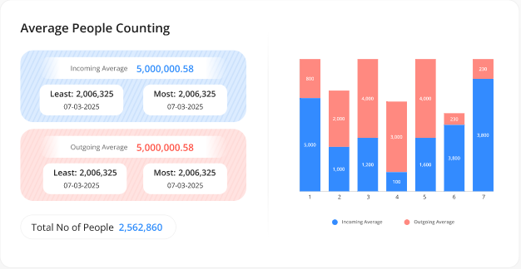
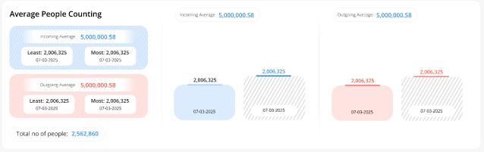
  - Safety Measures:
- This report will display counts of the detected peoples who is following or not following safety measures. These will include Mask, Helmet & Jacket Vest only.
- It will be generated from the configured camera in the system only.
- It will provide only 3 charts with 2*1 option. By default, the system will display 1*1 only.
- Pleased find the attached screenshot below for your reference:
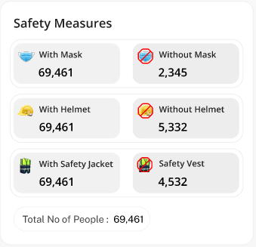
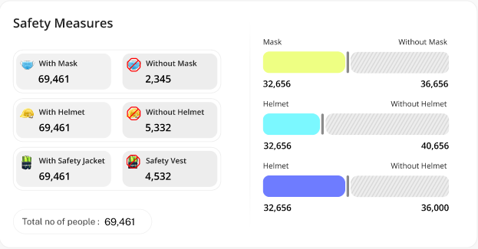
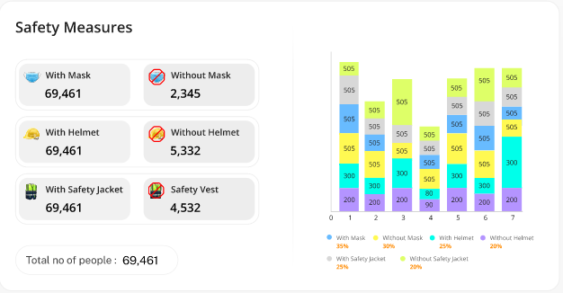
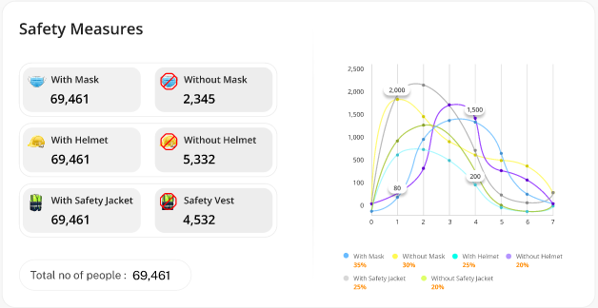
  - Slip & Fall Detection:
- This report will display counts of the detected peoples who is fall on the surface.
- It will be generated from the configured camera in the system only.
- It will provide only 2 charts with 2*1 option. By default, the system will display 1*1 only.
- Pleased find the attached screenshot below for your reference:
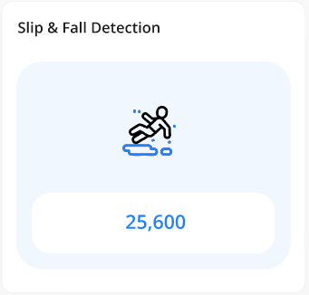
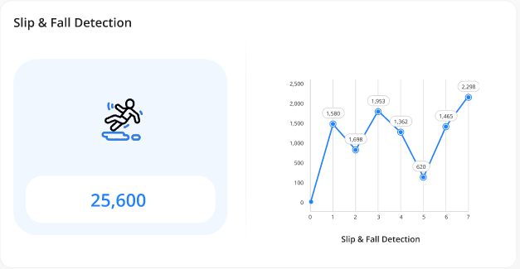
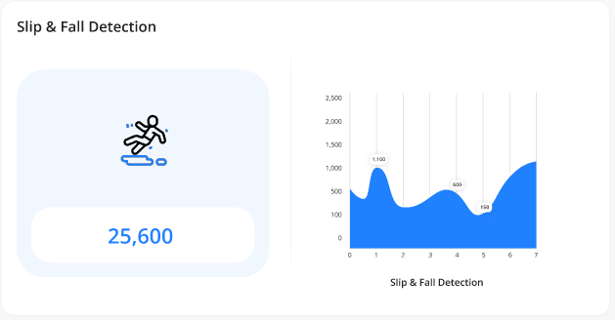
  - Zone Wise People Counting:
- This report will display the zone wise counts of the detected IN & OUT peoples.
- It will be generated from the configured camera in the system only.
- It will provide only 2 charts with 2*1 option. By default, the system will display 1*1 only.
- Pleased find the attached screenshot below for your reference:
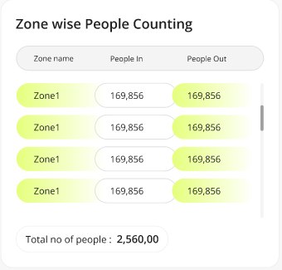
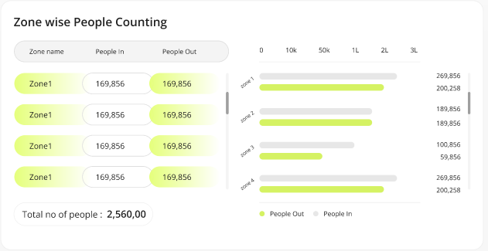
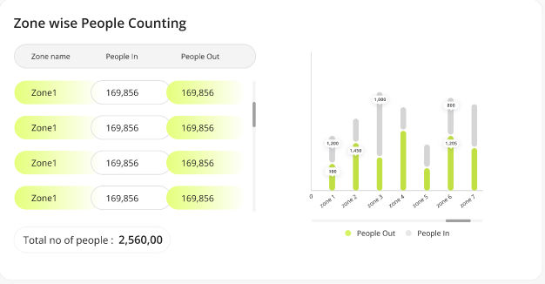
  - People Count by Gender:
- This report will display the gender wise people counts along with their Most & Least day Date & counts.
- It will be generated from the configured camera in the system only.
- It will provide only 2 charts with 2*1 option & 1 charts with 3*1 option. By default, the system will display 1*1 only.
- Pleased find the attached screenshot below for your reference:
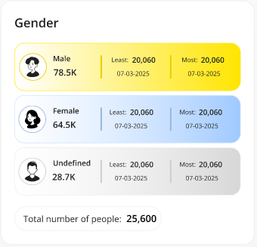
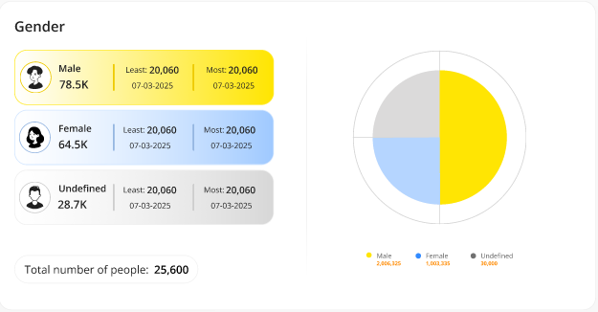
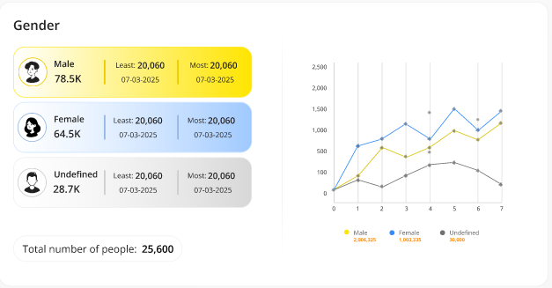

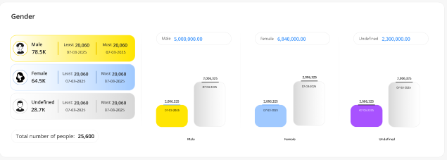
  - New Vs Total Visitors:
- This report will display the counts of the people for New Vs Total Visitors.
- It will be generated from the configured camera in the system only.
- It will provide only 3 charts with 2*1 option. By default, the system will display 1*1 only.
- Pleased find the attached screenshot below for your reference:
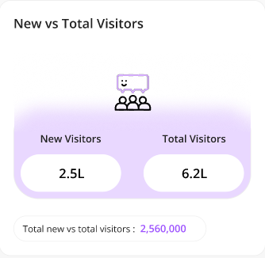
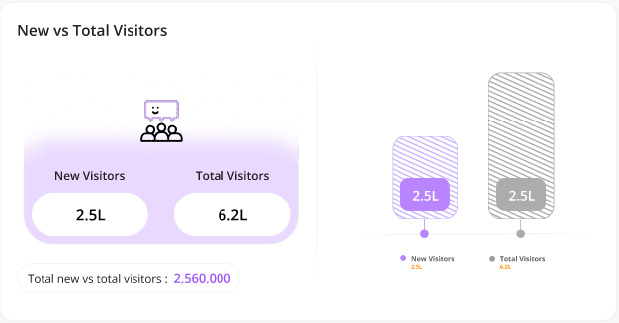
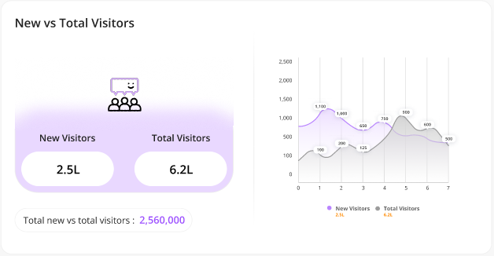
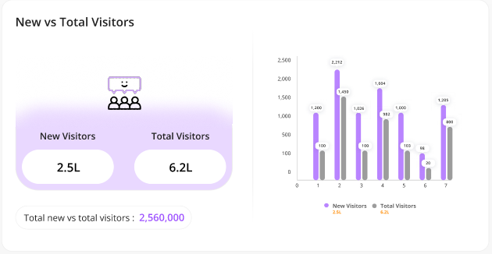
  - Cumulative People Count:
- This report will display the total number of cumulative people counts.
- It will be generated from the configured camera in the system only.
- It will provide only 2 charts with 2*1 option. By default, the system will display 1*1 only.
- Pleased find the attached screenshot below for your reference:
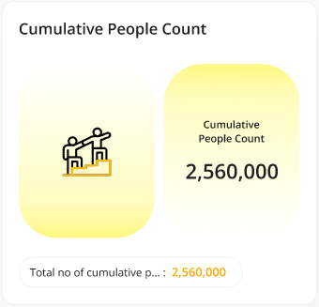
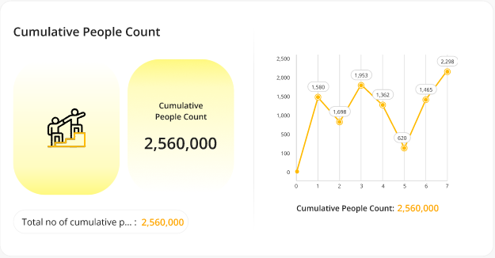
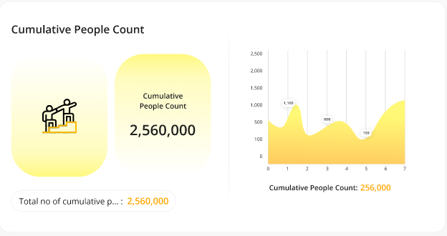
  - Vehicle Count by Type:
- This report will display the total number of detected vehicles counts by its type.
- It will be generated from the configured camera in the system only.
- It will provide only 3 charts with 2*1 option. By default, the system will display 1*1 only.
- Pleased find the attached screenshot below for your reference:
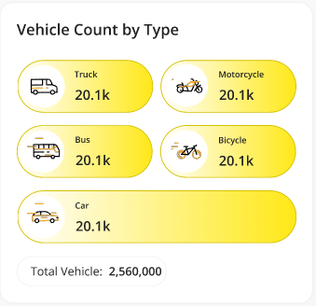
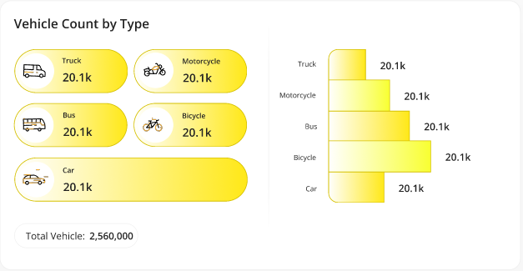
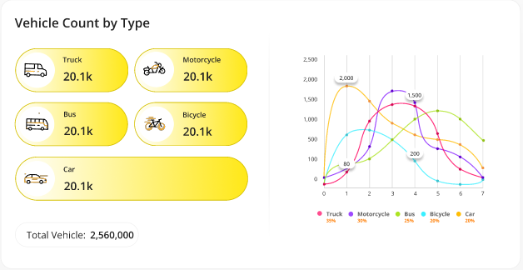
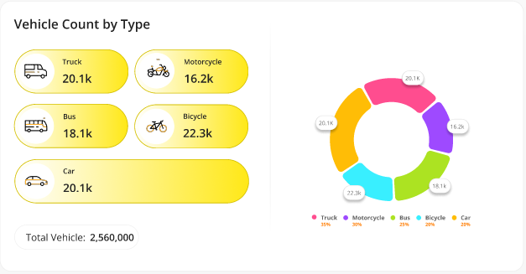
  - Vehicle in Wrong Direction:
- This report will display the counts of total number of detected vehicles in wrong direction.
- It will be generated from the configured camera in the system only.
- It will provide only 2 charts with 2*1 option. By default, the system will display 1*1 only.
- Pleased find the attached screenshot below for your reference:
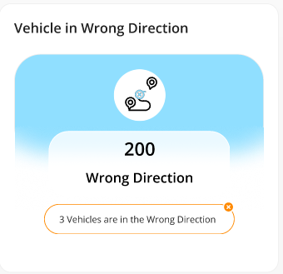
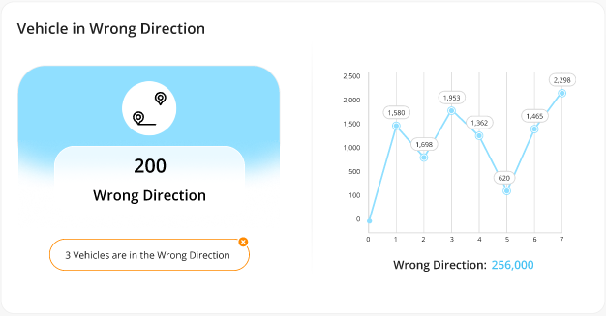
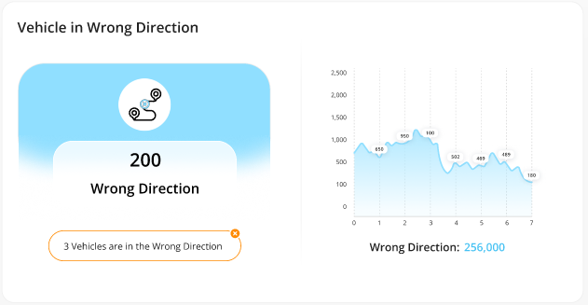
  - Vehicle U Turn Detection:
- This report will display the counts of total number of detected vehicles who has taken u turns.
- It will be generated from the configured camera in the system only.
- It will provide only 2 charts with 2*1 option. By default, the system will display 1*1 only.
- Pleased find the attached screenshot below for your reference:
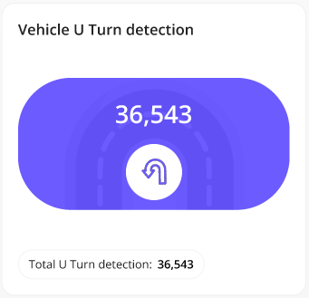
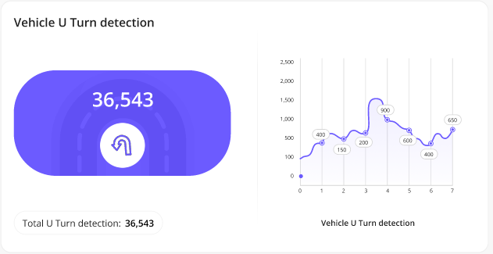
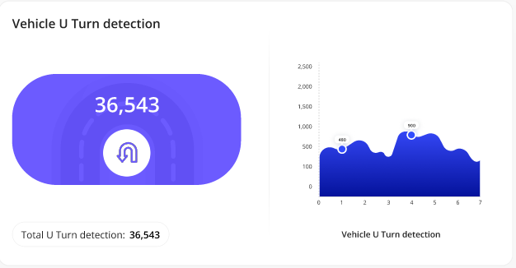
  - Pedestrian Detection:
- This report will display the counts of total number of detected pedestrians.
- It will be generated from the configured camera in the system only.
- It will provide only 2 charts with 2*1 option. By default, the system will display 1*1 only.
- Pleased find the attached screenshot below for your reference:
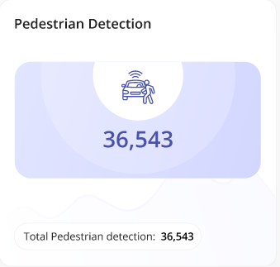
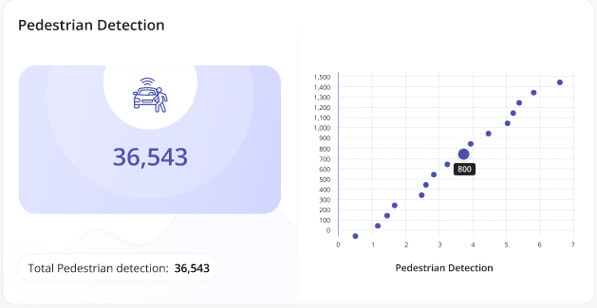
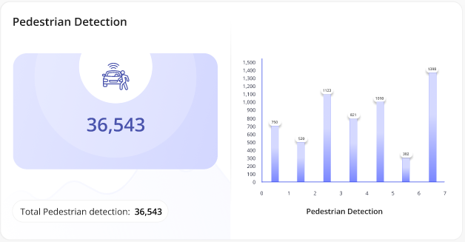
  - Vehicle In & Out:
- This report will display the IN & OUT counts for the total number of detected vehicles.
- It will be generated from the configured camera in the system only.
- It will provide only 3 charts with 2*1 option. By default, the system will display 1*1 only.
- Pleased find the attached screenshot below for your reference:
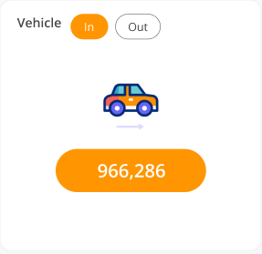
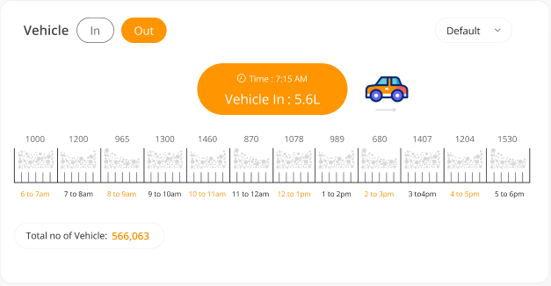
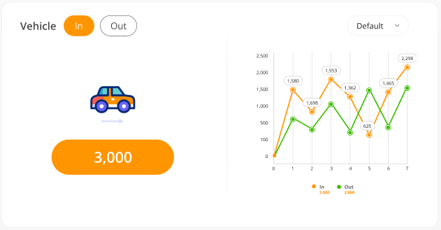
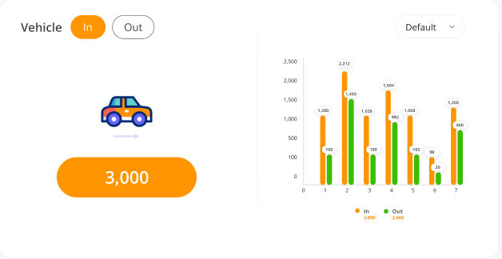
  - Average Vehicle Counting:
- This report will display the average of total incoming & outgoing vehicles with their most & least day & counts.
- It will be generated from the configured camera in the system only.
- It will provide only 3 charts with 2*1 option. By default, the system will display 1*1 only.
- Pleased find the attached screenshot below for your reference:
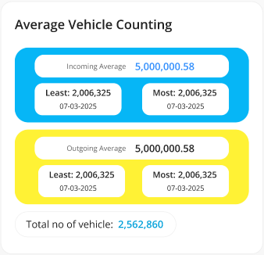
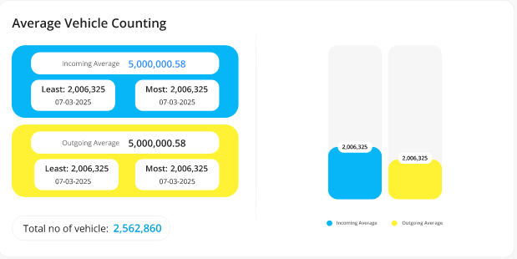
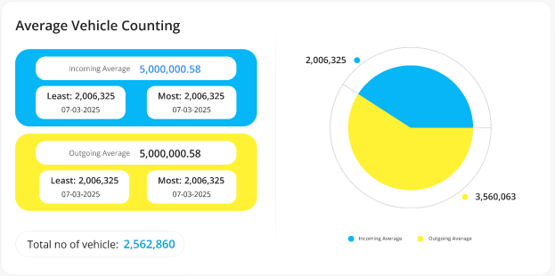
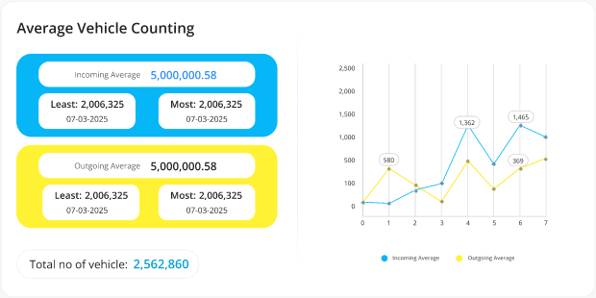
  - Vehicle Queue Analysis:
- This report will display the counts of total vehicles which are in the queue within selected time duration.
- It will be generated from the configured camera in the system only.
- It will provide only 3 charts with 2*1 option. By default, the system will display 1*1 only.
- Pleased find the attached screenshot below for your reference:
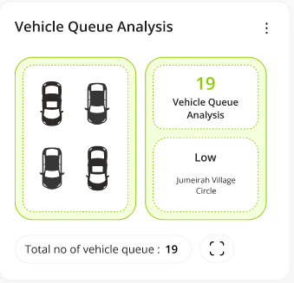
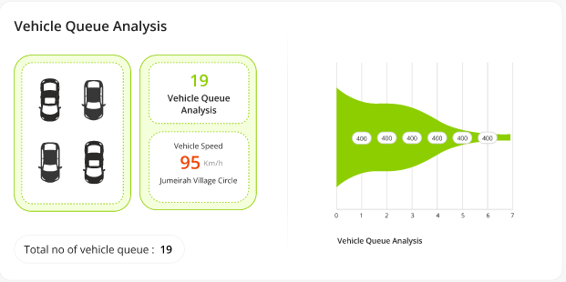
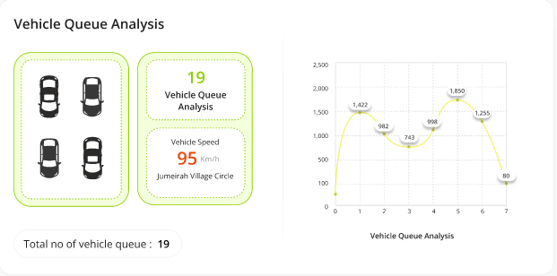
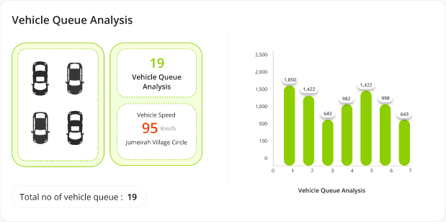
  - Stopped Vehicle Count Type:
- This report will display the counts of total vehicles stopped by its type.
- It will be generated from the configured camera in the system only.
- It will provide only 3 charts with 2*1 option. By default, the system will display 1*1 only.
- Pleased find the attached screenshot below for your reference:
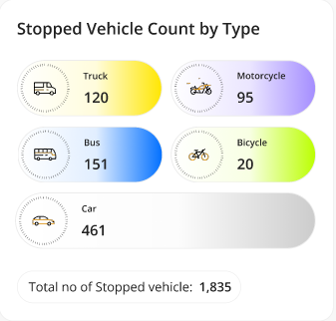
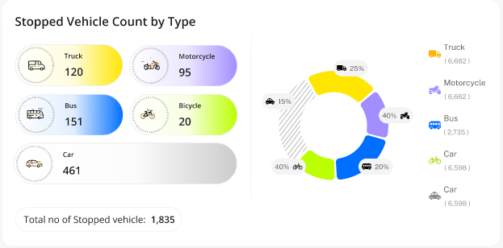
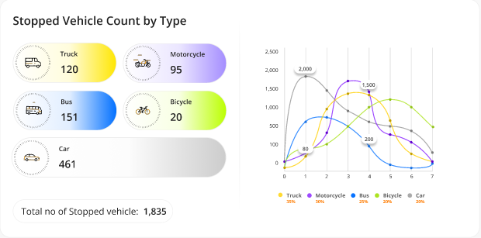
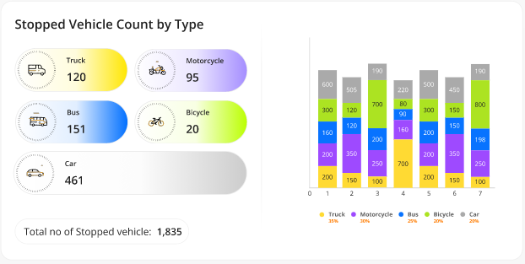
  - Vehicle Turning Movement Counts:
- This report will display the counts vehicles turning movements.
- It will be generated from the configured camera in the system only.
- It will provide only 3 charts with 2*1 option. By default, the system will display 1*1 only.
- Pleased find the attached screenshot below for your reference:
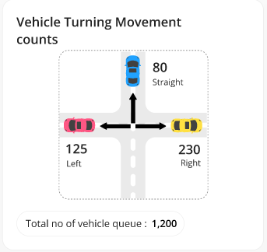
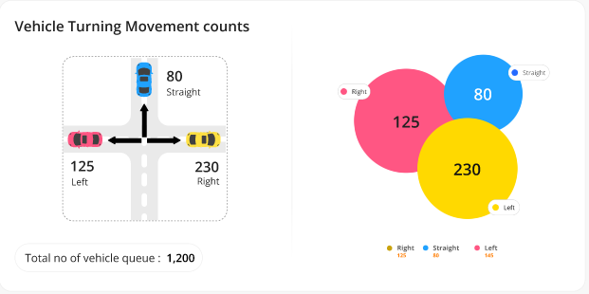
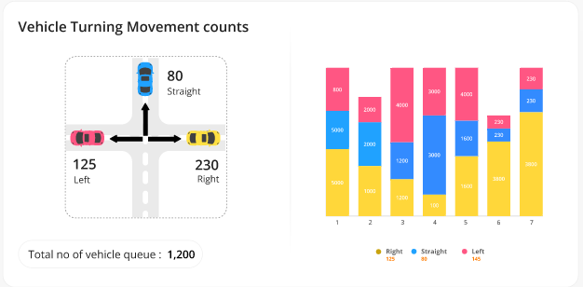
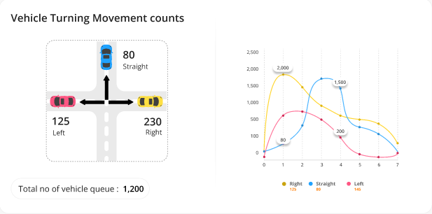
  - Shopping Cart Counting:
- This report will display the counts of total shopping carts detected.
- It will be generated from the configured camera in the system only.
- It will provide only 3 charts with 2*1 option. By default, the system will display 1*1 only.
- Pleased find the attached screenshot below for your reference:
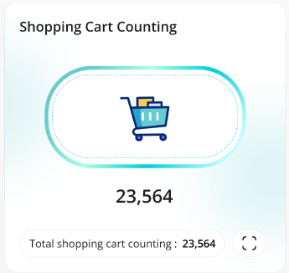
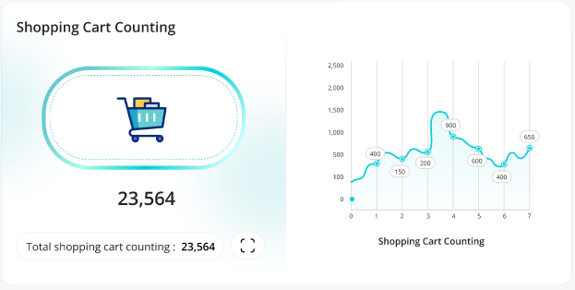

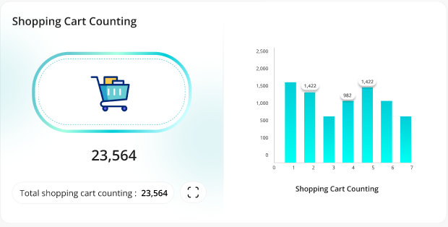
  - Queue Events for Shopping Cart:
- This report will display the counts of total shopping carts detected in the queue.
- It will be generated from the configured camera in the system only.
- It will provide only 3 charts with 2*1 option. By default, the system will display 1*1 only.
- Pleased find the attached screenshot below for your reference:

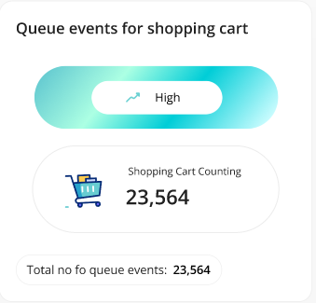

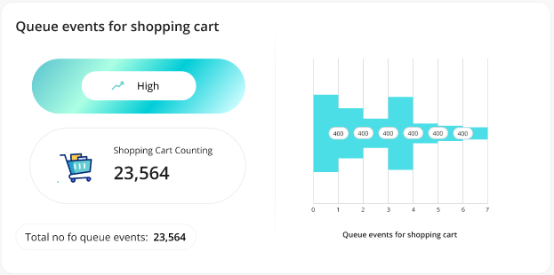
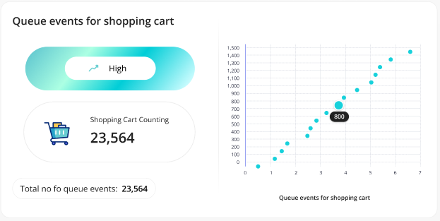

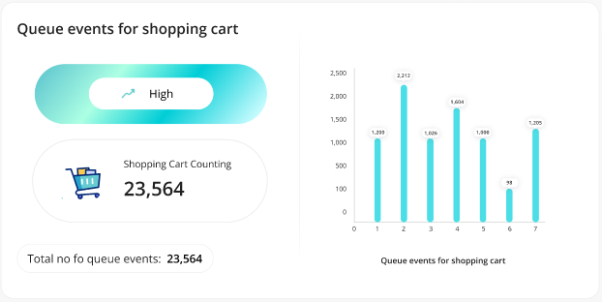
  - Queue Events for People:
- This report will display the counts of total peoples detected in the queue.
- It will be generated from the configured camera in the system only.
- It will provide only 3 charts with 2*1 option. By default, the system will display 1*1 only.
- Pleased find the attached screenshot below for your reference:
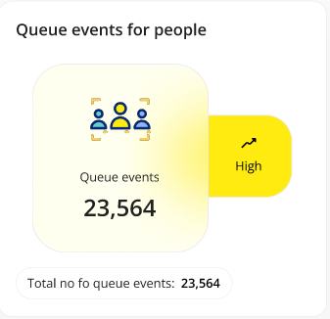

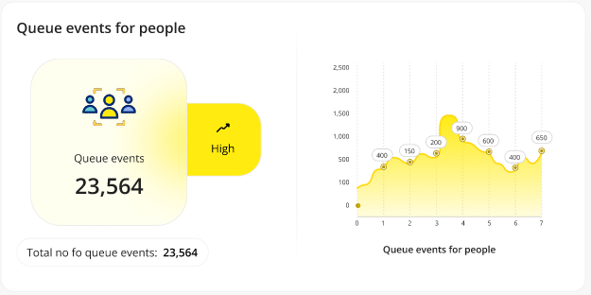
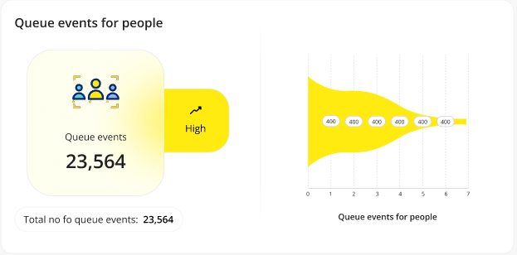
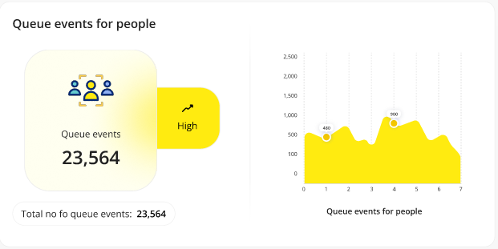
  - Block Exit Detection:
- This report will display the counts of total exit block detected.
- It will be generated from the configured camera in the system only.
- It will provide only 3 charts with 2*1 option. By default, the system will display 1*1 only.
- Pleased find the attached screenshot below for your reference:
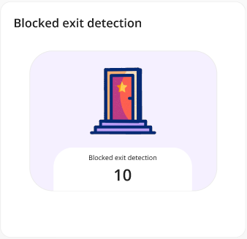

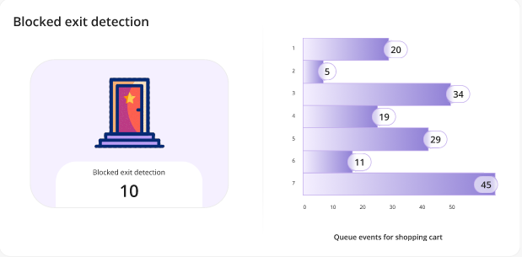
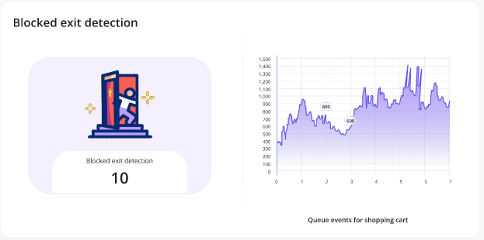

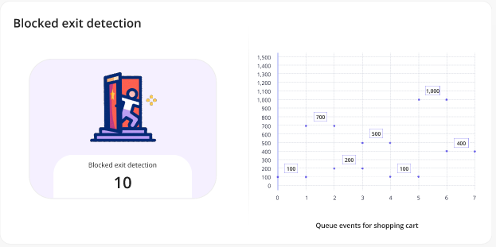
  - Speed Violation by Vehicle:
- This report will display the counts of total detected speed violations.
- It will be generated from the configured camera in the system only.
- It will provide only 2 charts with 2*1 option. By default, the system will display 1*1 only.
- Pleased find the attached screenshot below for your reference:
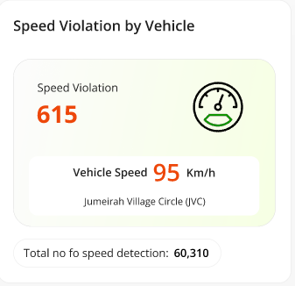

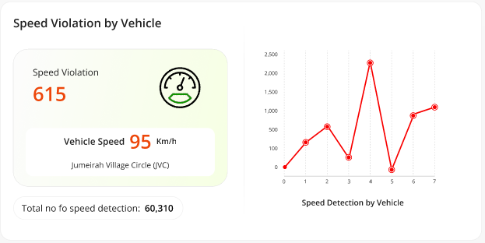
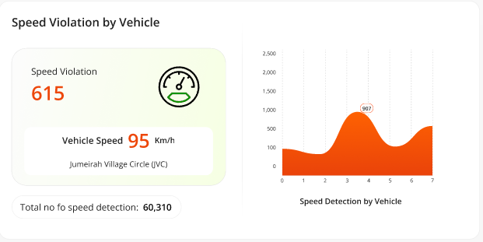
  - Traffic Jam by Day:
- This report will display the counts of total detected traffic jams.
- It will be generated from the configured camera in the system only.
- It will provide only 3 charts with 2*1 option. By default, the system will display 1*1 only.
- Pleased find the attached screenshot below for your reference:
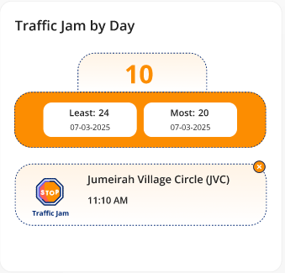
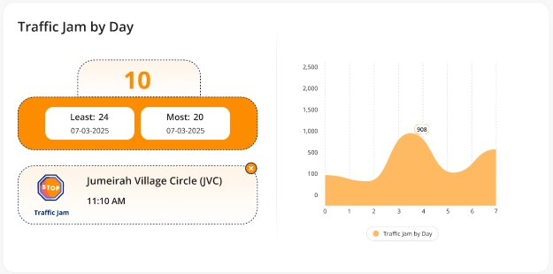

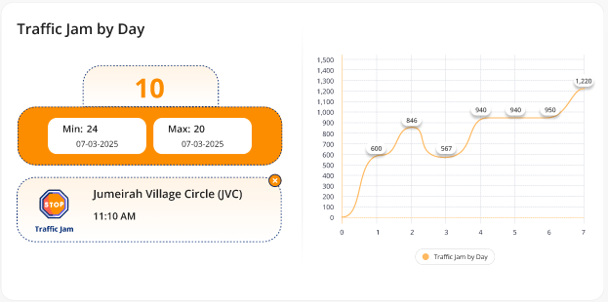
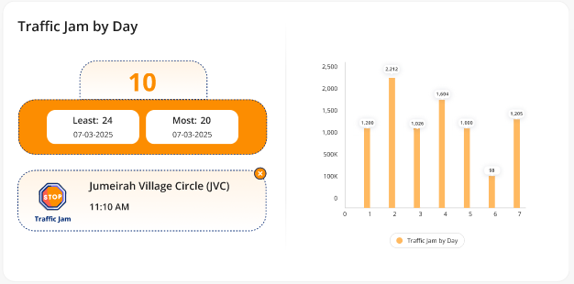
  - Counting for Forklift:
- This report will display the counts of total detected forklifts.
- It will be generated from the configured camera in the system only.
- It will provide only 3 charts with 2*1 option. By default, the system will display 1*1 only.
- Pleased find the attached screenshot below for your reference:
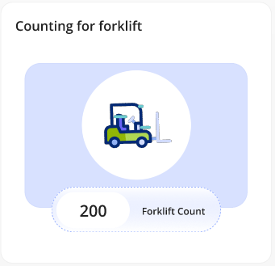
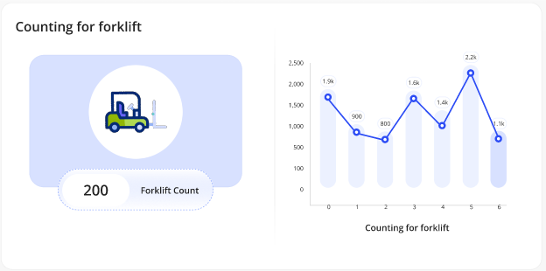

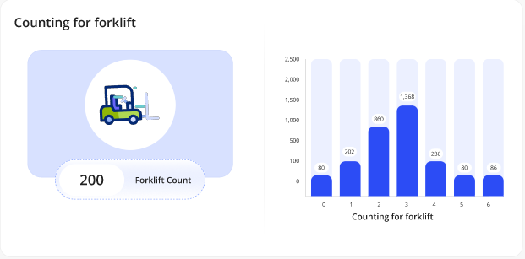
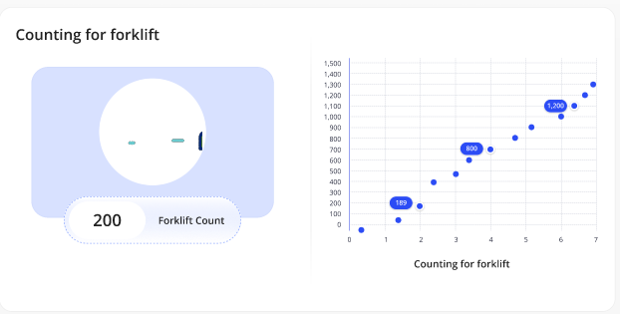
  - Queue Events for Forklift:
- This report will display the counts of total detected forklifts in the queue.
- It will be generated from the configured camera in the system only.
- It will provide only 3 charts with 2*1 option. By default, the system will display 1*1 only.
- Pleased find the attached screenshot below for your reference:
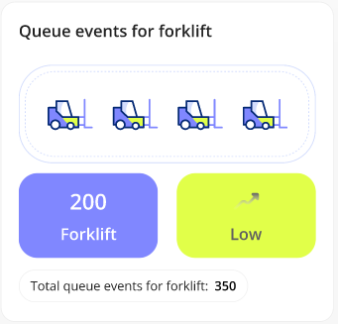
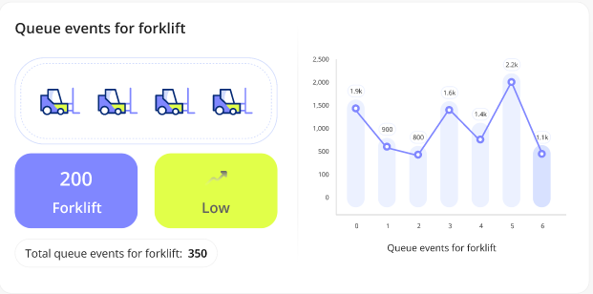

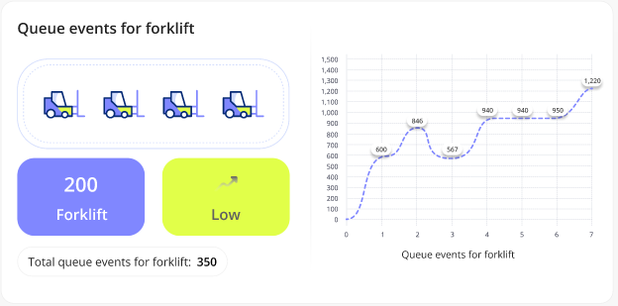
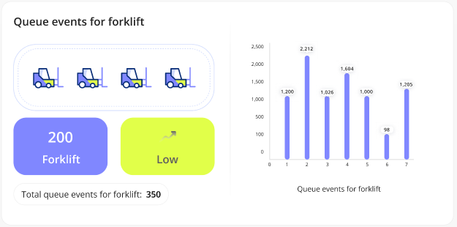
  - Vehicle Detection Heatmap:
- This report will display the heatmap for the detected vehicles.
- It will be generated from the configured camera in the system only.
- It will provide only 1 charts with 2*1 option. By default, the system will display 1*1 only.
- Pleased find the attached screenshot below for your reference:
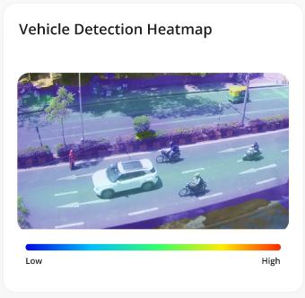
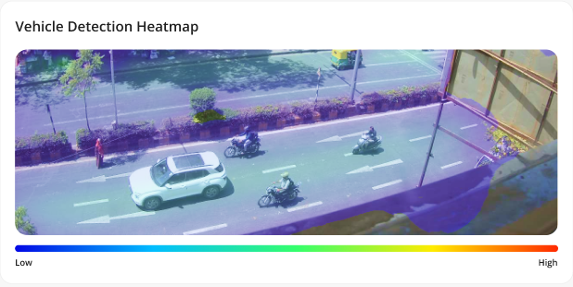
  - Forklift Heatmap:
- This report will display the heatmap for the detected forklifts.
- It will be generated from the configured camera in the system only.
- It will provide only 1 charts with 2*1 option. By default, the system will display 1*1 only.
- Pleased find the attached screenshot below for your reference:
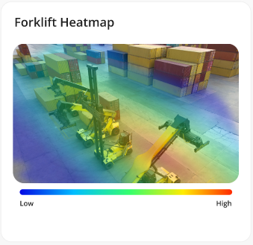
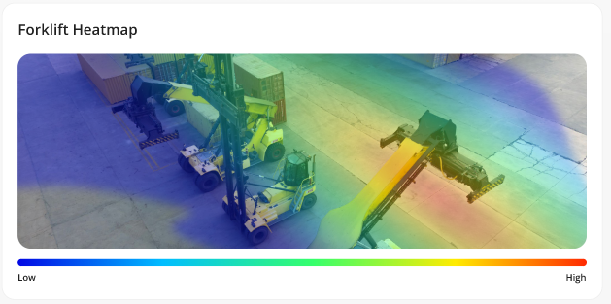
  - Detected Forklifts:
- This report will display the counts of total detected forklifts & proximately of forklifts.
- It will be generated from the configured camera in the system only.
- It will provide only 3 charts with 2*1 option. By default, the system will display 1*1 only.
- Pleased find the attached screenshot below for your reference:
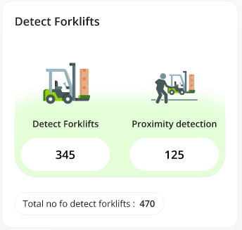
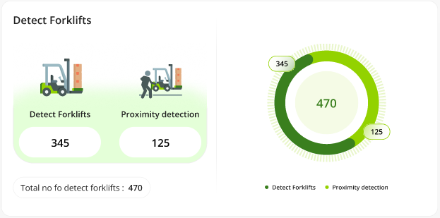

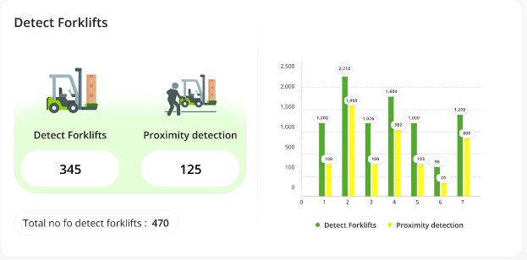
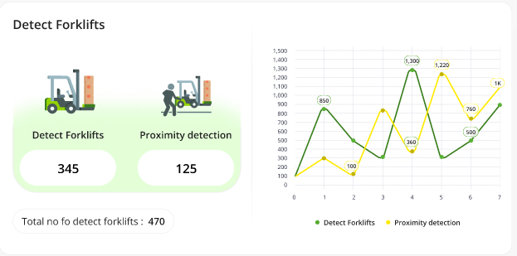
  - Shopping Cart Heatmap:
- This report will display the heatmap of detected shopping carts.
- It will be generated from the configured camera in the system only.
- It will provide only 1 charts with 2*1 option. By default, the system will display 1*1 only.
- Pleased find the attached screenshot below for your reference:
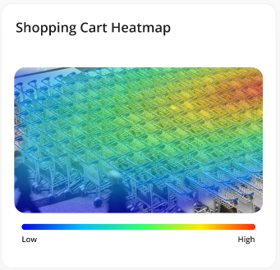
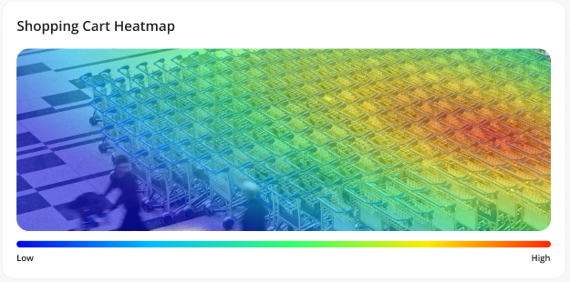
  - Forklift Speed Detection:
- This widget will display the counts of total speed violation by detected forklifts.
- It will be generated from the configured camera in the system only.
- It will provide only 2 charts with 2*1 option. By default, the system will display 1*1 only.
- Pleased find the attached screenshot below for your reference:
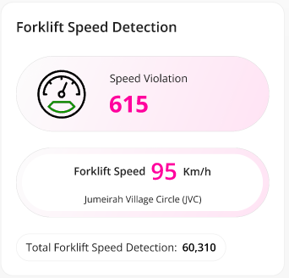
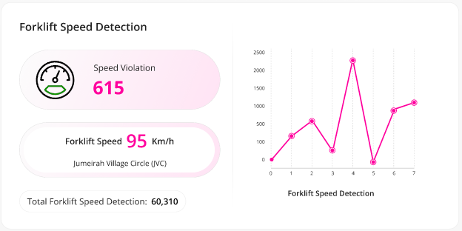

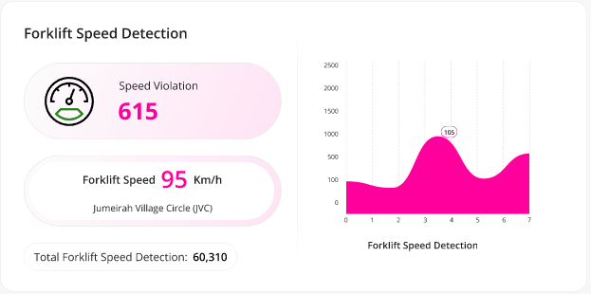
  - Map Plan:
- This widget will display the counts on the map based on the selected features.
- It will be generated from the configured camera in the system only.
- Pleased find the attached screenshot below for your reference:
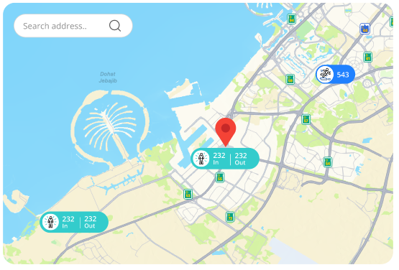

  - Floor Plan:
- This report will display the counts on the floor plan image based on the selected features.
- It will be generated from the configured camera in the system only.
- Pleased find the attached screenshot below for your reference:
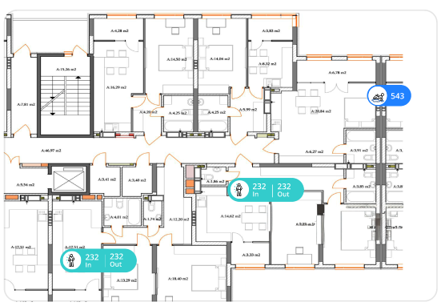

Business Rules:
- The authorized users will be able to configure up to 40 [Refer 3.18.1] widget in the specific dashboard from the system.
- The authorized users will be able to perform following actions on each widget:
  - Can apply duration filter to view the data on the chart.
  - Can expand the widget.
  - Can Delete the added widget.
  - Can export it as CSV.
  - Can Setup the widget preview.
  - Can move added widget from one place to another place as per their needs within the dashboard area.
- The system will allow users to perform above-mentioned actions based on the assigned permission to them.
- The system will display following features only under the dropdown list:
  - People In & Out Count
  - Slip & Fall Count
  - Vehicle In & Out Count
  - Pedestrian Detection Count
  - Vehicle Queue Analysis Count
  - Speed Violation by Vehicle Count
  - Traffic Jam by Day
  - Shopping Cart Count
  - Forklift Count

Data Dictionary:

Dashboards > Dashboard Page > Widget > Setup Page

The system provides a feature for authorized users to setup widget preview as per their needs through the BI Dashboard Web Application.

This option will be available under each widget which are configured / added under the specific dashboard only.

Prototype:
- The screen below illustrates a sample setup page, including options to select Size and Expanded view:
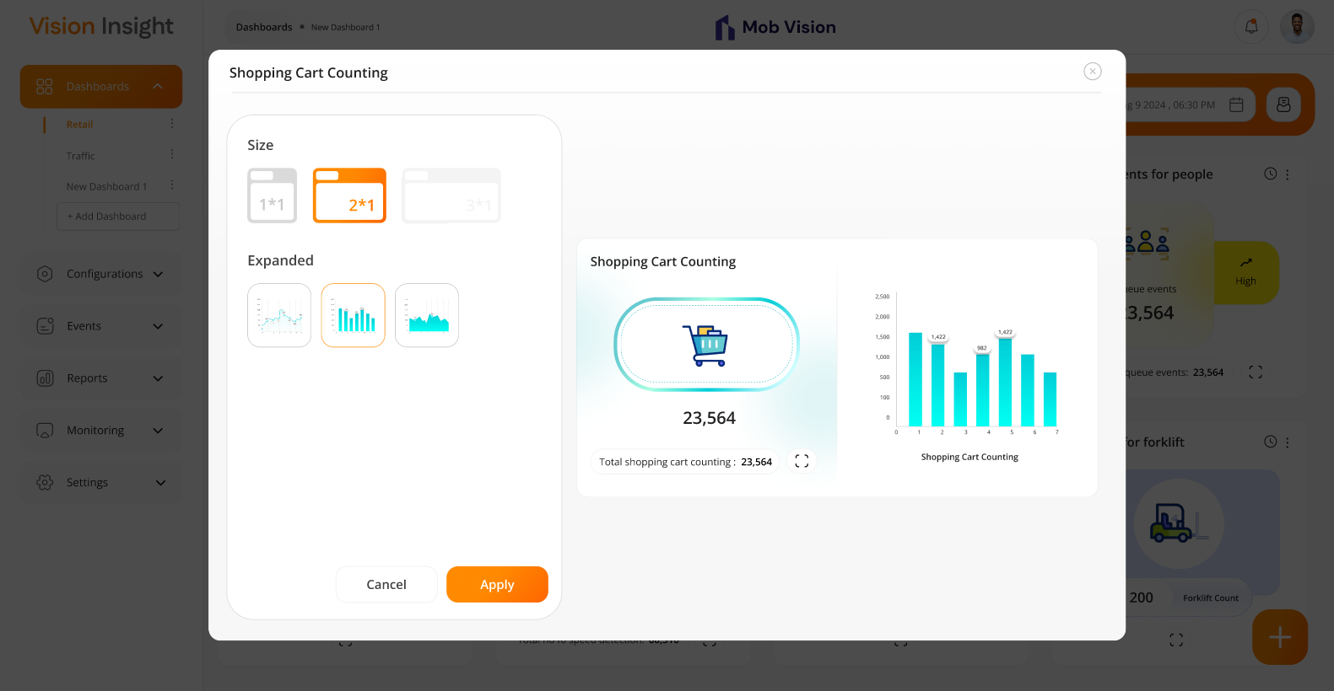

Business Rules:
- The system will allow authorized users to access this option.
- The system will open setup popup once user clicks on the “Setup” option located under each widget which are configured on the specific dashboard.
- Under that popup, the users will be able to view & configure followings:
  - Size
    - It is the size of the selected widget.
    - It will provide following options:
      - 1*1
      - 2*1
      - 3*1
    - The system will enable or disable any above option based on the predefined design for each widget implemented in the attached Figma.
  - Expanded
    - This option will provide up to 3 charts option based on the needs.
    - This option will get appeared when user will select the 2×1 or 3×1 option from the above size.
    - The system will display preview at right-hand side section based on the selected options under the same popup.
- The system will render the actual data & display that specific widget on the dashboard screen based on the selected setup.
- The users must have to click on “Apply” button to reflect the updated changes in the setup popup to specific dashboard.
- Users can re-setup the things by clicking on the same “Setup” option.

Data Dictionary:

- The system will utilize below highlighted column for the setup configurations:

Dashboards > Dashboard Page > Widget > Export as CSV Option

The system provides a feature for authorized users to export a report in .csv format based on the selected time frame & date range through the BI Dashboard Web Application.

This option will be available under each widget (whenever it's applicable only) which are configured / added under the specific dashboard only.

Prototype:
- The screen below illustrates the option to select a duration and export the report as CSV format only based on the selected time range:
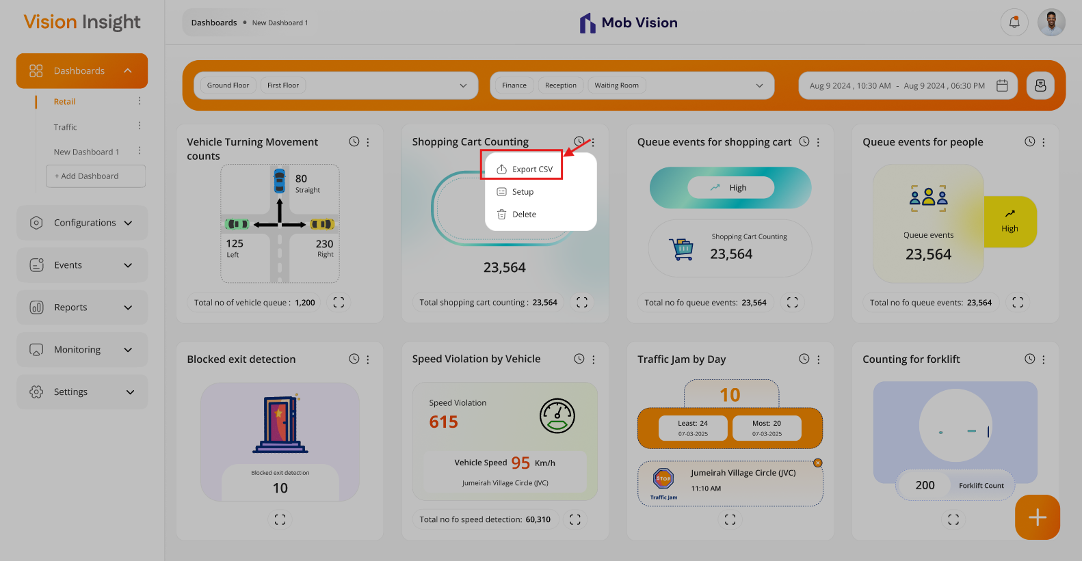

Business Rules:
- The system will allow authorized users to access this option.
- Once user clicks on the “Export CSV” option located under each widget which are configured on the specific dashboard.
- The CSV will include following information in the exported report:
  - Exported By
  - Exported On (Date & Time)
  - Selected Date Range & Time
  - Data of all the selected widgets with whatever filters they have applied on the specific widget & showcased on the specific dashboard.

Dashboards > Dashboard Page > Widget > Duration Selection Filter Option

The system provides a feature for authorized users to filter out the data based on the selected duration (time) through the BI Dashboard Web Application.

This option will be available under each widget (whenever it's applicable only) which are configured / added under the specific dashboard only.

Prototype:
- The screen below illustrates the option to select a duration, based on which the system will dynamically update the chart data:
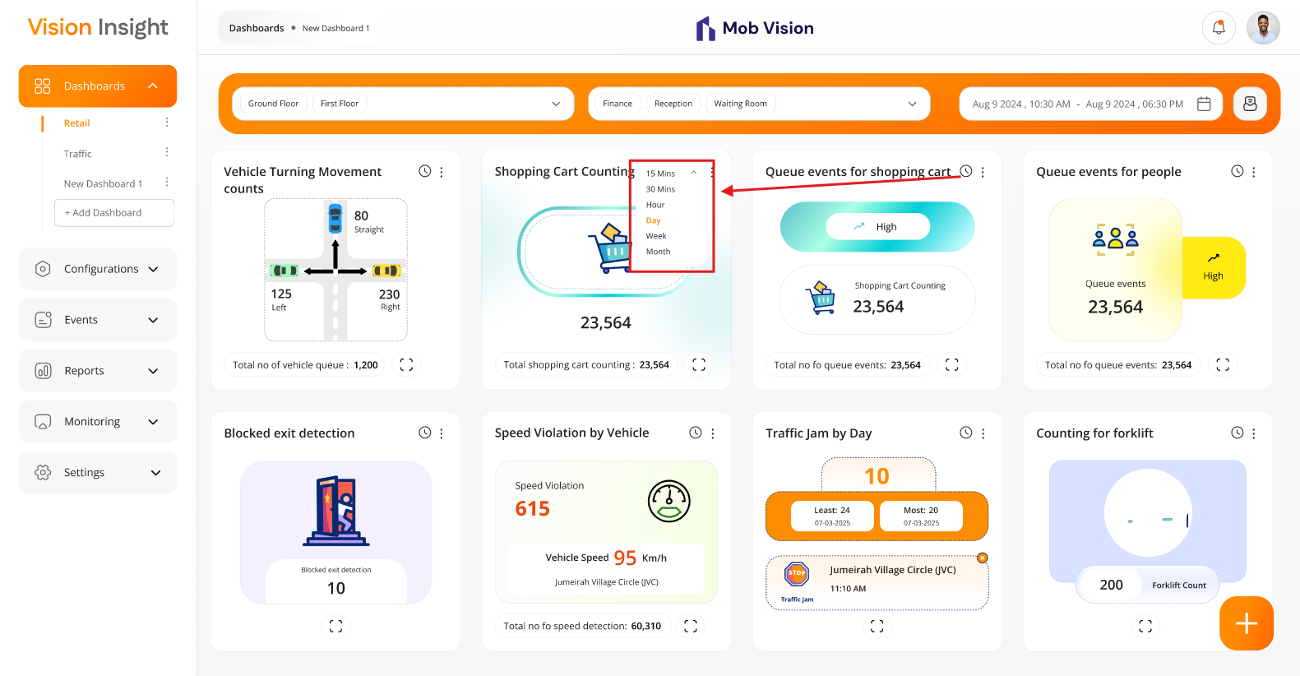

Business Rules:
- The system will allow users to select the following duration filter located under each configured widget on the dashboard:
  - 15 Mins
  - 30 Mins
  - Hour
  - Day
  - Week
  - Month
- The system will manage & hide or show the respective filter options based on the selected date range on the specific dashboard only.
- The charts which are associated with specific widget will render & display the data based on the selected time filter option.
- System will automatically select the default from these options based on the selected date range.
- Users can also change & select any enabled value from this filter option.

Dashboards > Dashboard Page > Widget > Expand Option

The system provides a feature for authorized users to expand the view of any widget associated / configured under the specific dashboard through the BI Dashboard Web Application.

This option will be available under each widget (whenever it's applicable only) which are configured / added under the specific dashboard only.

Prototype:
- The screen below illustrates the option to open a configured widget preview in an expanded view when the widget is set to 1*1 size:
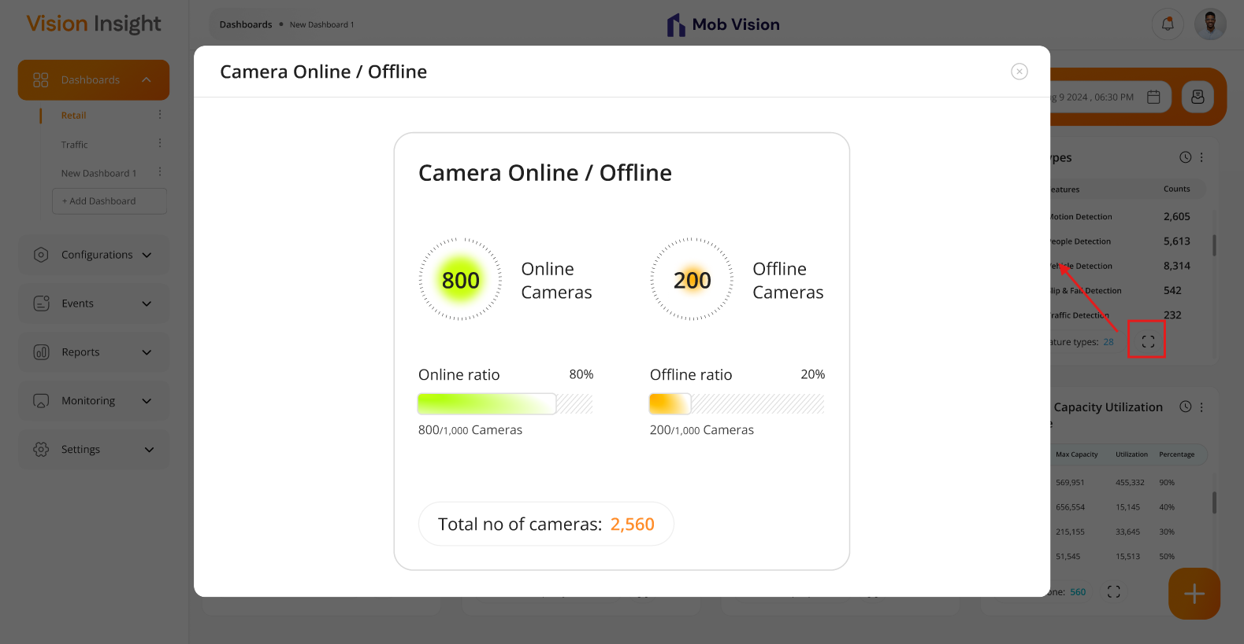

- The screen below illustrates the option to open a configured widget preview in an expanded view when the widget is set to 2*1 size:
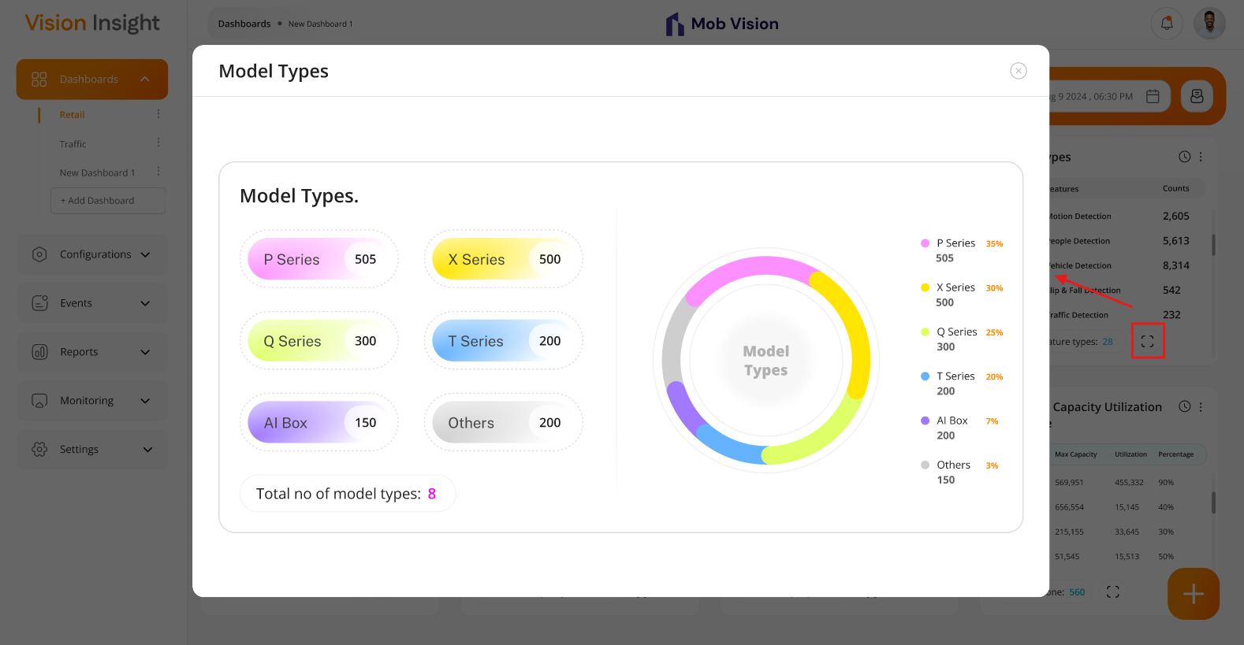
- The screen below illustrates the option to open a configured widget preview in an expanded view when the widget is set to 3*1 size:
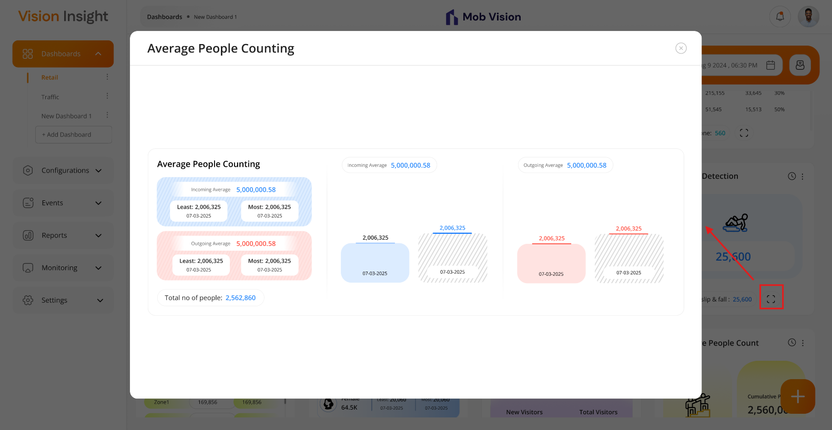

Business Rules:
- The system will open popup when users will click on the “Expand” icon.
- Under that popup, the users will be able to see widget in expanded view.
- There will be option to close the popup window.

System Architecture

- The image below represents the flow of the entire system architecture, including all applications such as the Bi Dashboard Web Application, BI Dashboard Web Application, and the backend middleware for both applications:

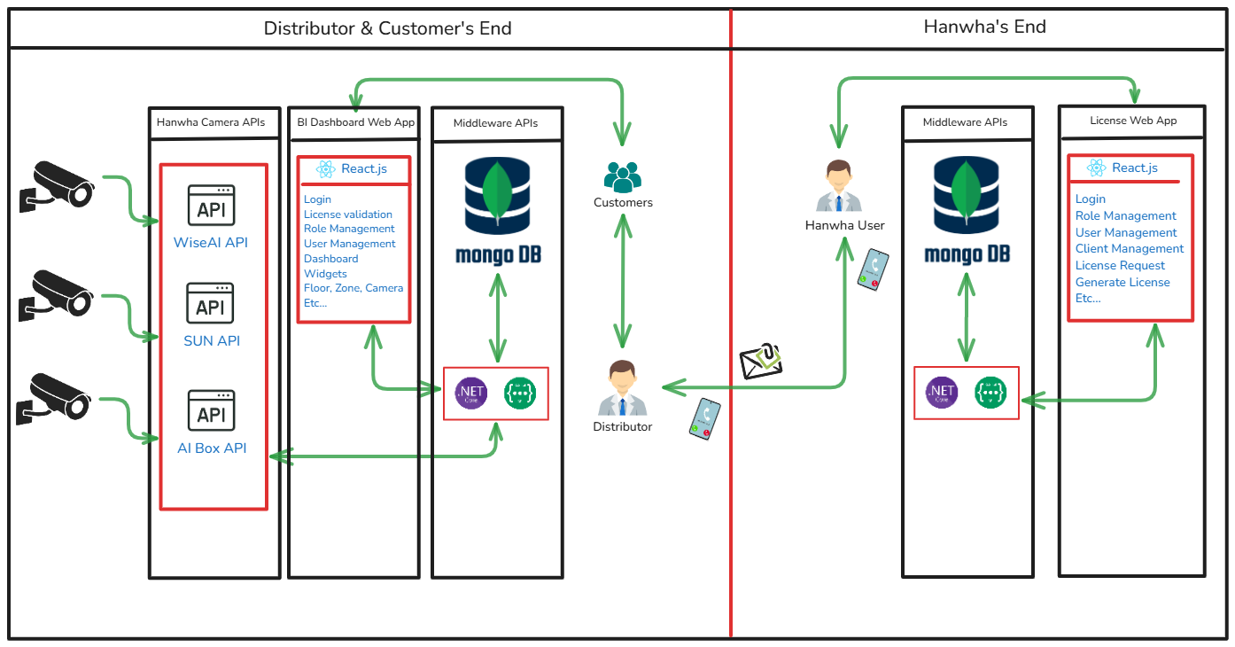

- The architecture below represents the flow of Backend Development Using .NET Core + Web API:

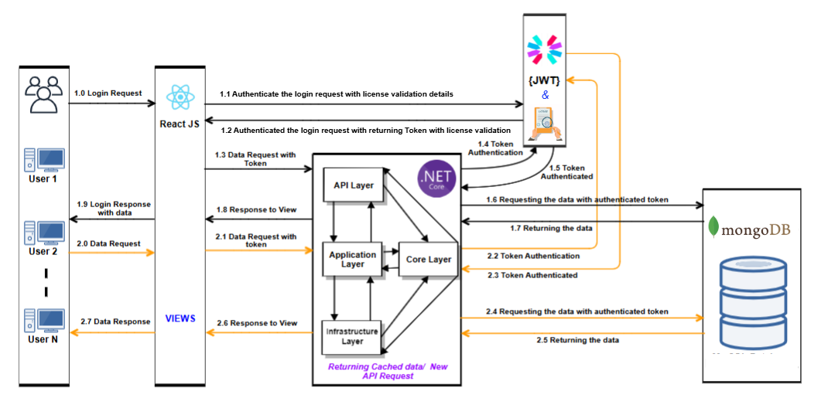
- The architecture below represents the flow of Frontend Development Using React.js Technology:

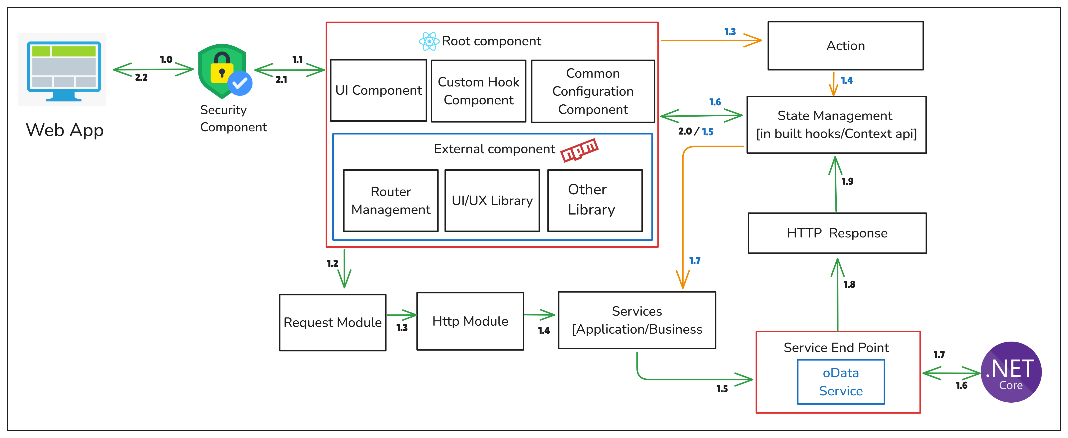

Assumptions, Dependencies and Constraints

- The above attached screenshots in the document are taken from the Figma design. Please note that there may be minor variations in the UI during actual implementation. However, the structure, content, and data presented will remain consistent with the screenshots provided.
- Any type of Server hosting fees, license cost, any other 3rd party API/SDK fees are not part of
development cost and will be procured and paid by client.
  - SPEC will have no liability for hardware failure deployed when running the proposed solution. Hence, the client should only take up relevant issues with the provider for the respective system.
  - Designs showcased in this SRS document as well as the ones shown to the client during the project query discussion calls will be considered as the final designs.
  - SPEC INDIA will not be responsible for any sort of server setup on the client’s UAT or Production Environment.
  - Database administration activities will not fall under the responsibility of SPEC INDIA team.
  - Once the application is live in Production, the database maintenance plan must be configured from the client’s end.
  - SPEC INDIA will not be responsible for any Point-in-Time Database Recovery/DR Drill/Database Upgrade/ Maintenance tasks etc.
  - The details are prepared based on the client's discussion; hence, changes may be made after completing the requirements study, which may require discussions under the change management process.
  - Any delay in the project schedule due to decision-making, data gathering, or approvals from the client side should be handled at the client's side. SPEC INDIA won’t be responsible for adding more resources for early completion in such scenarios.
  - The warranty period will automatically start ten days after the UAT rollout of both the applications (Client Web App & License Web App) & the warranty period will be 3 months.
  - After warranty completion, extra charges will be charged for knowledge transfer or documentation for/to another vendor.
  - The client will own the developed product and source code submitted after the final milestone payment.
  - A delay during any phase of the project by the customer will not be considered a delay by SPEC INDIA, and any payment milestone will not be delayed due to it.
  - Any delay in providing feedback or required dependency for more than two weeks will be escalated by SPEC INDIA.

---- end of document ----

